Lacrosse Info 2022-2023 – Pin Oak Middle School
Head Coach: Austin St. Denis
Team Parents: Mickie Turner, Dana George, Lars Thestrup

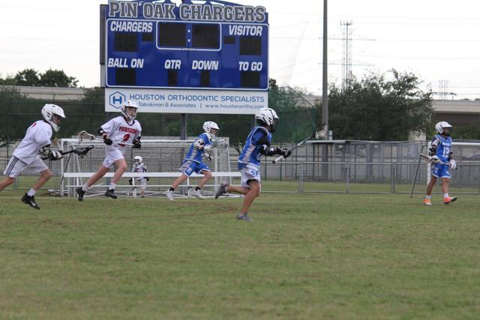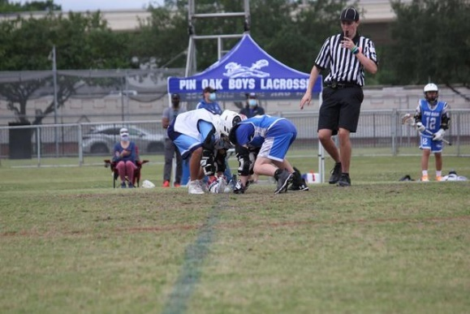

Team Philosophy: Have Fun, Work Hard, and Get Better.

- The goal for our A team: Be competitive. On this team, coaches will provide a high level of coaching to develop strong players who can be competitive in Middle School. The paramount focus is for the players to also be well prepared as they move toward playing High School lacrosse. Playing time is not guaranteed, it is earned through practice, performance in games, impact as a leader on the team, and reinforcement of the team goals. The coach makes every attempt to have the boys touch the field during every game, although playing time might not be equal.

- The goal for our B/7th and 6th grade teams: Introduce new players to the game of lacrosse while also offering an opportunity to more experienced players to continue their development. The goal is for all players to get better from their starting point through participation in practices and game opportunities. The coaching of this team strives to allow all the boys playing time in games as much as possible to help them develop their confidence as a player.

Fall Camp/Tryout
The Pin Oak Fall Camp series is a handful of practices serving multiple purposes. First, it’s an opportunity for new players to come out and try the sport of lacrosse. Next, it’s a good time for players to pick up their sticks that have been sitting in the closet or garage and knock of the cobwebs for the upcoming Spring season. Finally, the latter part of the camp is used by coaches to evaluate players for placement on team(s). Camp will start Friday, October 28th.
New Player Only - This year we have a “New Player Only” series of practices just for players who are inexperienced.
Sessions – This year there will also be two sessions of Fall camp to limit the number of players and increase the amount of attention the players get. Coach will send Fall camp assignments ASAP and definitely the week before the new player camp.
The Fall Camp series is as follows:
Friday, October 28th | 6:45-8:30 @ POMS | *New Players Only*  New Player Camp
Sunday, October 30th | 4:00-6:00 @ POMS | *New Players Only*  New Player Camp
Friday, November 4th | 6:45-8:30 @ POMS | Fall Camp Session 1
Sunday, November 6th | 4:00-6:00 @ POMS | Fall Camp Session 1
Friday, November 11th | 6:45-8:30 @ POMS | Fall Camp Session 1
Sunday, November 13th | 4:00-6:00 @ POMS | Fall Camp Session 1
Friday, December 2nd | 6:45-8:30 @ POMS | Fall Camp Session 2
Sunday, December 4th | 4:00-6:00 @ POMS | Fall Camp Session 2
Friday, December 9th | 6:45-8:30 @ POMS | Fall Camp Session 2
Sunday, December 11th | 4:00-6:00 @ POMS | Fall Camp Session 2
Friday, December 16th | 6:45-8:30 @ POMS | Tryout 6th / 7th
Sunday, December 18th | 4:00-6:00 @ POMS | Tryout 8th

Tryout/Evaluation:
Coaches will use the time spent at Fall Camp to evaluate players for placement onto the A team, B team, and 6th grade team. After the conclusion of camp, team selection and additional information about registration and uniform sizing will be communicated via email to parents and players.
Please note….. There is a limited number of spots on the A (8th), B (7th), and 6th grade teams (roughly 18-22). At the conclusion of tryouts, players will receive notification about their status. Players will receive one of the following notifications:
- Player has been selected for a spot on the boy’s lacrosse team (6th, 7th, or 8th teams).
- Player has not been selected but is encouraged to continue the sport with a local club program called HYLAX.

Practices
Practice is held at Pin Oak on Wednesdays, Fridays (7:00-8:30) and Sundays (4:00-6:00).
*this is an ongoing conversation so if there is a change to practice time and day I will communicate that*
Games
Games will take place during the week on various days after school and on the weekend. Players and parents are asked to please make games a priority during the season. Once the schedule is finalized, you’ll be provided a copy and we ask that you and your player note the commitment dates on your calendar. The spring is busy with other sports and activities. If you are going to miss a game, contact to the coach is required and appreciated as the coaches work to develop a game plan/roster in advance.
*HISD does NOT provide transportation. You will have to arrange for pickup and drop-off of your player*
Fees
The registration link for Fall and Spring will be communicated via email and on the team website. We want all registrations completed by game 1. The fee below includes uniform.
Spring Season Fee $ 350
Fall Free
Questions / Concerns
Questions and concerns about the team are best expressed through email. If the question is something the coach needs to address, email is the best way to get in touch. If an in-person meeting is requested, this must be done through email and the coach can set up a meeting before practice.
Interest Form
Interested in playing lacrosse? Please complete the Google Form that was sent out in the Charger Chatter. If you missed it, send me an email and I can get you the link: austin.stdenis@houstonisd.org

CONTACT INFO FOR COACH ST.DENIS:
Room #- B103 Email- austin.stdenis@houstonisd.org
Thank you for your interest in Pin Oak Boys Lacrosse!

