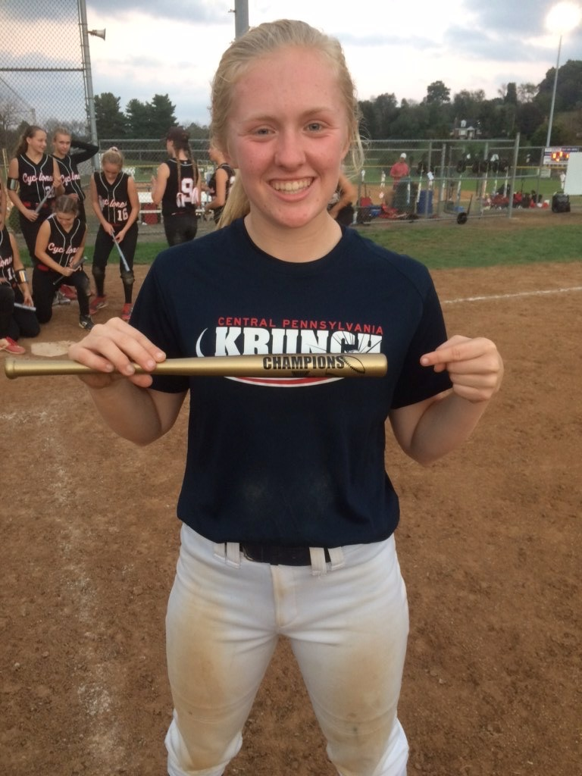

Insert Picture Here

Name: Megan E. Klose  
  
Grad Year: **2021**  
Position: **3B/P**  
GPA: **4.0**

### SAT: **N/A**

Intended Major: **Undecided**

**2018 Statistics**

|  |  |  |  |
| --- | --- | --- | --- |
| BAT AVG | SLG% | OB% | Home to 1st |
| .404 | .412 | .600 | 3.12 |

Address: 595 South 60th Street

City: Harrisburg

State: PA   
Zip: 17111

Phone: 717-329-4850

Email: megklose6@gmail.com

High School: Central Dauphin East High School

DOB: March 1, 2003  
Weight: 135

Height: 5’5

Bats: Right

Throws: Right

# Major Softball Awards and Achievement

* HS Varsity Starting Pitcher
* Mid-Penn Conference Keystone Division 2nd Team All-Stars
* 2017 Hot Stove Classic 18u Champion
* 2017 Midway Monster Ball 18u Champion

# Non-Softball Activities

**2016 - 2017 2017 - 2018**

Yearbook Club Editor Varsity and JV Field Hockey

Jazz Band Club Awarded Varsity Letter as Freshman

National Junior Honors Society Wind Ensemble

Choir Distinguished Honor Roll

Student Council Representative High School Varsity Softball Team

Middle School Field Hockey Saxophone Quartet

Distinguished Honor Roll National Latin Honors Society

County Band Festival Participant Outstanding Freshman of the Year in Band

Honors Choir Festival Participant Mid-Penn Conference Keystone Division 2nd Team All-Star