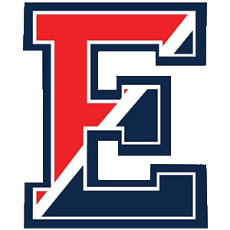

2026 Memorial Football Scholarships
Brandon Boger, Colby Umbrell, Dr. Paul Coverdale, and Kyle D. Bernard

Student Name: _______________________________________
Address: ____________________________________________
____________________________________________________
Email address: ________________________________________
Telephone #: _______________________________________
Graduating Class: CB East Class of 2026

For consideration, please submit the following information:
- This Completed Application Form
- An Essay describing “How Football Has Influenced Your Life”
- List of colleges/universities or trade school to be attended in Fall of 2026
- Separate Coach and Teacher Recommendation Letters using the supplied forms.

Applications, Essays, School Lists, and Coach & Teacher Recommendation Letters are to be mailed directly to:

CBE Football Parents Club
PO Box 521
Buckingham, PA 18912

- Applicants MUST provide pre-addressed, stamped envelope to the coach and teacher evaluators.

- COMPLETED EVALUATION FORMS ALONG WITH THE COMPLETED APPLICATION, ESSAY AND LISTS MUST BE RECEIVED BY APRIL 15th, 2026.

