INDUCTEE
Suzanne Smith ’76
Suzanne Smith is a director and producer for CBS Sports and CBS Sports Network and has been with the Network since 1983. She has been a trail blazer in the industry since her start, working on Super Bowls, Masters, NCAA Men’s Division 1 Basketball Championships and everything in between. Looked at as a mentor to many, she entered the industry at a time when there was not a road map for a young, female, gay production assistant. So, she mapped her own way, leading the way for those to come | 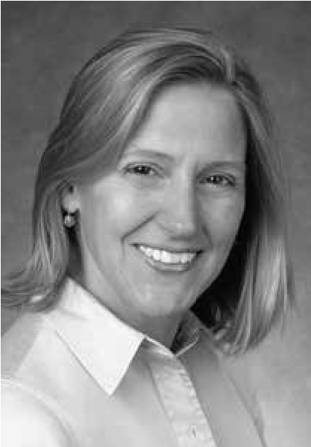
after her and becoming an industry pioneer.
Smith is a director for THE NFL ON CBS and currently the only woman, for any network, either producing or directing NFL games. She also directs college basketball, including the NCAA Men’s Division I Basketball Championship since 1994, and is a member of the Network’s golf production team for the Masters. In addition to her live event assignments, Smith serves as Coordinating Producer and Director of WE NEED TO TALK, the first-ever nationally televised allfemale sports show, on CBS Sports Network.
The six-time Emmy Award-winner has been nationally recognized for her accomplishments in sports media and event productions. In 1989, Smith received a Directors Guild of America Award. In 2015, she was named Game Changer by Sports Business Journal and WISE Women of Inspiration. She was an honoree for AWM an organization that recognizes exceptional women in a historically male-dominated industry. In 2017, Smith received the annual Mary Garber Pioneer Award, which recognizes pioneers who serve as role models for women in sports media.
Smith joined CBS Sports as a production assistant and quickly moved up the ranks. As a production assistant, she worked the “Doug Flutie Hail Mary” game. Twenty-one years later, Smith directed Flutie’s last NFL game. Her first directing credit came in 1988 for coverage of the NCAA Men’s Volleyball Championships, where she implemented innovative style changes in coverage of how the game was broadcast by using end zone camera angles and moving the referee to a more suitable location for television coverage.
Smith’s wide-array of producing and directing experience at the Network is highlighted by her work on various Super Bowl assignments including replay director during Super Bowl XXXV and XXXVIII; studio director for Super Bowl XLVII on CBS Sports and CBS Sports Network; and producer of the “Baghdad Bowl” segment from Iraq for Super Bowl XLI pre-game show, THE SUPER BOWL TODAY. In addition to her Super Bowl assignments, she worked the infamous “Fog Bowl” game as well as various memorable games in Peyton Manning’s career including his first NFL game in 1998; when he broke the single season record of 50 touchdowns in 2013; and when he became the all-time passing yards leader in 2015. Smith has worked on a variety of other events including the U.S. Open Tennis Championships, the 1992, 1994, 1998 Olympic Winter Games and the 1996 Olympic Summer Games. She also has served as coordinating producer for CBS Sports’ Winter Sports and the Deer Valley Celebrity Ski event.
In addition to CBS Sports, Smith has directed the NBA Playoffs for Turner Sports. Along with her sports duties, she has directed the Live Academy Awards Special for WE Entertainment, a Holiday Special for Martha Stewart, and “Pavarotti in the Park,” a live concert in Central Park and documentary.
A graduate of Temple University, Smith received a bachelor’s degree in Radio, Television and Film. She received the first volleyball scholarship awarded by the University and was a member of the softball team. In November 2008, Smith was inducted into the Temple University School of Communications Hall of Fame and honored with the Excellence in Media Award.
In 2019, Smith was selected for induction into the Ardsley High School Sports Hall of Fame as a member of the inaugural class.
Smith has been a mentor with the Connecticut School Mentor Program and is a volunteer for PASE (Partnership for After School Education). She has sat on the Board for the Plancher Orthopaedic Foundation and served a term on the Board of the Empire State Pride Agenda. She formed a network of professional women known as “Girls Nite Productions,” an interactive social group for women from different networks in the television world.
Smith currently resides in Southport, Conn. with her wife, Cristina Bottegaro.

