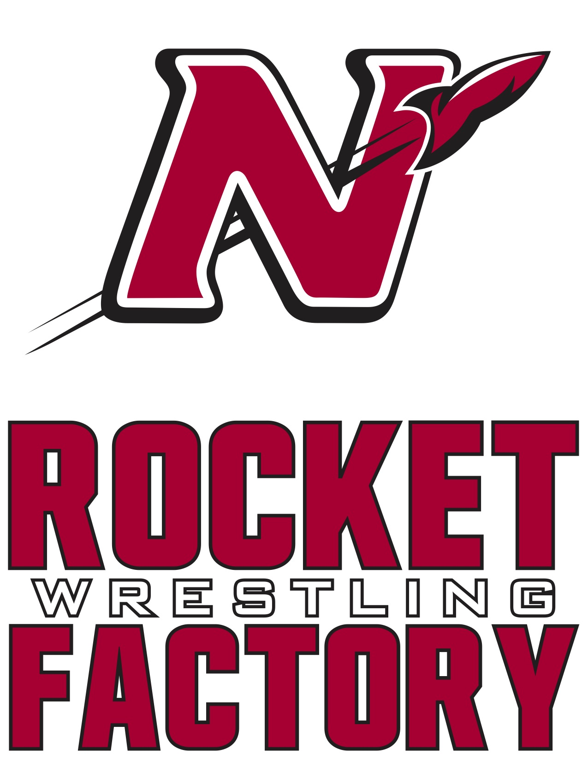

**2020-2021 Schedule**

**Date Meet/Opponent Start Time Location/Site**

Friday Nov 27th Thanksgiving Scrimmage 9:00 AM Denmark

High School

Thursday Dec 3rd Dual vs Hortonville 6:15 J.V. Hortonville

7:00 Varsity High School

Friday Dec 4th Kimberly Friday 5:30 PM Kimberly

JV Tournament High School

Thursday Dec 10th Dual vs Oshkosh West 6:15 J.V. Oshkosh West

7:00 Varsity High School

**Friday Dec 11th Neenah Varsity 4:00 PM Neenah**

**Individual Tournament High School**

Saturday Dec 12th Port Washington 9:00 A.M. Port Washington

J.V. Invitational High School

Thursday Dec 17th Dual vs Appleton North 6:15 J.V. Appleton North

7:00 Varsity High School

Saturday Dec 19th Badger State 10:00 A.M. Alliant Energy

Depart 1:00 Fri 18th Varsity Invitational Center

hosted by Stoughton Madison, WI

**Tuesday Dec 22nd Dual vs Kimberly 6:15 J.V. Pickard**

**Rumble at the Rocketorium 7:00 Varsity Auditorium**

*Alumni Night*  **Neenah**

*Business Sponsorship Night*  **High School**

Tuesday Dec 29thOshkosh on the Water 9:30 Varsity Kolf Sports Center

Wednesday Dec 30th Varsity Invitational 9:00 Varsity Oshkosh, WI

Thursday Jan 7th Dual vs Appleton East 6:15 JV Appleton East

7:00 Varsity High School

**Saturday Jan 9th WWCA Challenge Series 9:30 A.M. Neenah**

**Regional Tournament High School**

**Varsity Reserve/J.V.**

**Sunday Jan 10th Neenah Youth Tournament 9:15 A.M. Neenah**

***\*\*\*HS Wrestlers required to work* High School**

Thursday Jan 14th FVA Double Duals Appleton North

Dual #1 vs Oshkosh North 6:00 High School

Dual #2 vs Fond du Lac 7:45

Friday January 15th Freedom JV Duals 5:00 PM Freedom

High School

Saturday Jan 16th Warhawk 10:30 Varsity Arrowhead Union

Varsity Duals High School

Thursday Jan 21st Dual vs Kaukauna 6:15 JV Kaukauna

7:00 Varsity High School

Friday Jan 22nd Highlander Friday Night 4:00 PM Homestead

Varsity Invitational High School

Saturday Jan 23rd WWCA Challenge Series 10:00 A.M. Wausau West

State Tournament High School

Qualifiers from 1/9

**Thursday Jan 28th Dual vs Appleton West 6:15 J.V. Neenah**

***\*Youth Night* 7:00 Varsity High School**

*\*Middle School Night*

*\*Senior Night*

*\*Parent Night*

**Saturday Jan 30th Mill City Melee 9:30 A.M. Shattuck**

**Middle School Duals Middle School**

Saturday Feb 6th FVA Conference 9:30 A.M. Kimberly

Varsity Tournament High School

Tuesday Feb 9th FVA Conference 4:15 P.M. Kaukauna

J.V. Tournament High School

**Saturday Feb 13th WIAA Regional 9:30 A.M. Kaukauna**

**Wrestling Tournament High School**

**Tuesday Feb 16th WIAA Team Sectional 7:00 P.M. Appleton North**

**Dual High School**

**Saturday Feb 20th WIAA Sectional 10:00 A.M. Ashwaubenon**

**Wrestling Tournament High School**

**Thur, Fri, Sat WIAA State Individual TBD Kohl Center**

**Feb 25th, 26th, 27th  Wrestling Tournament Madison WI**

**Friday March 5th WIAA Team State TBD UW Fieldhouse**

**Saturday March 6th Wrestling Tournament Madison WI**

**Home Duals and Tournaments in RED**