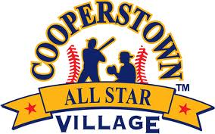
Cooperstown All-Star Village
Homerun Derby 52-66
All teams on Field 36
August 7th- 13th
Week 10

# | Team Name | Player Name | Outs | Homeruns
52 | Rome River Rats, NY | JJ Oritz | 5 | 1
53 | Middletown Lions Black, NJ | Cole Cerminars | 5 | 2
54 | Marin Baseball 12u Grey, CA | Hunter Stein | 5 | 1
55 | Levittown NorthStar’s, NY | Ethan Shapiro | 5 | 0
56 | Elmhurst Extreme Navy, IL | Nick Hantosh | 5 | 0
57 | Thousand Oaks Bulldogs, CA | Tyson Seidman | 5 | 0
58 | Long Island Storm, NY | Stellan Zangan | 5 | 6
59 | Champlin Rebels, MN | Leo Biwa | 5 | 2
60 | Storm Troopers, CA | Riley Spradliu | 5 | 6
61 | Vestal LL, NY | Landon Pancoast | 5 | 1
62 | Fairless Hills Steel, PA | Chase Smith | 5 | 1
63 | Monmouth Liberty Baseball Club, NJ | Finnbar Dufficy | 5 | 0
64 | Taconic Rangers, NY | Ethan Vieva | 5 | 7
65 | Boston Patriots South, MA | Noah Feldunary | 5 | 1
66 | Aliso Viejo Samurai, CA | Dylan Bright | 5 | 0

