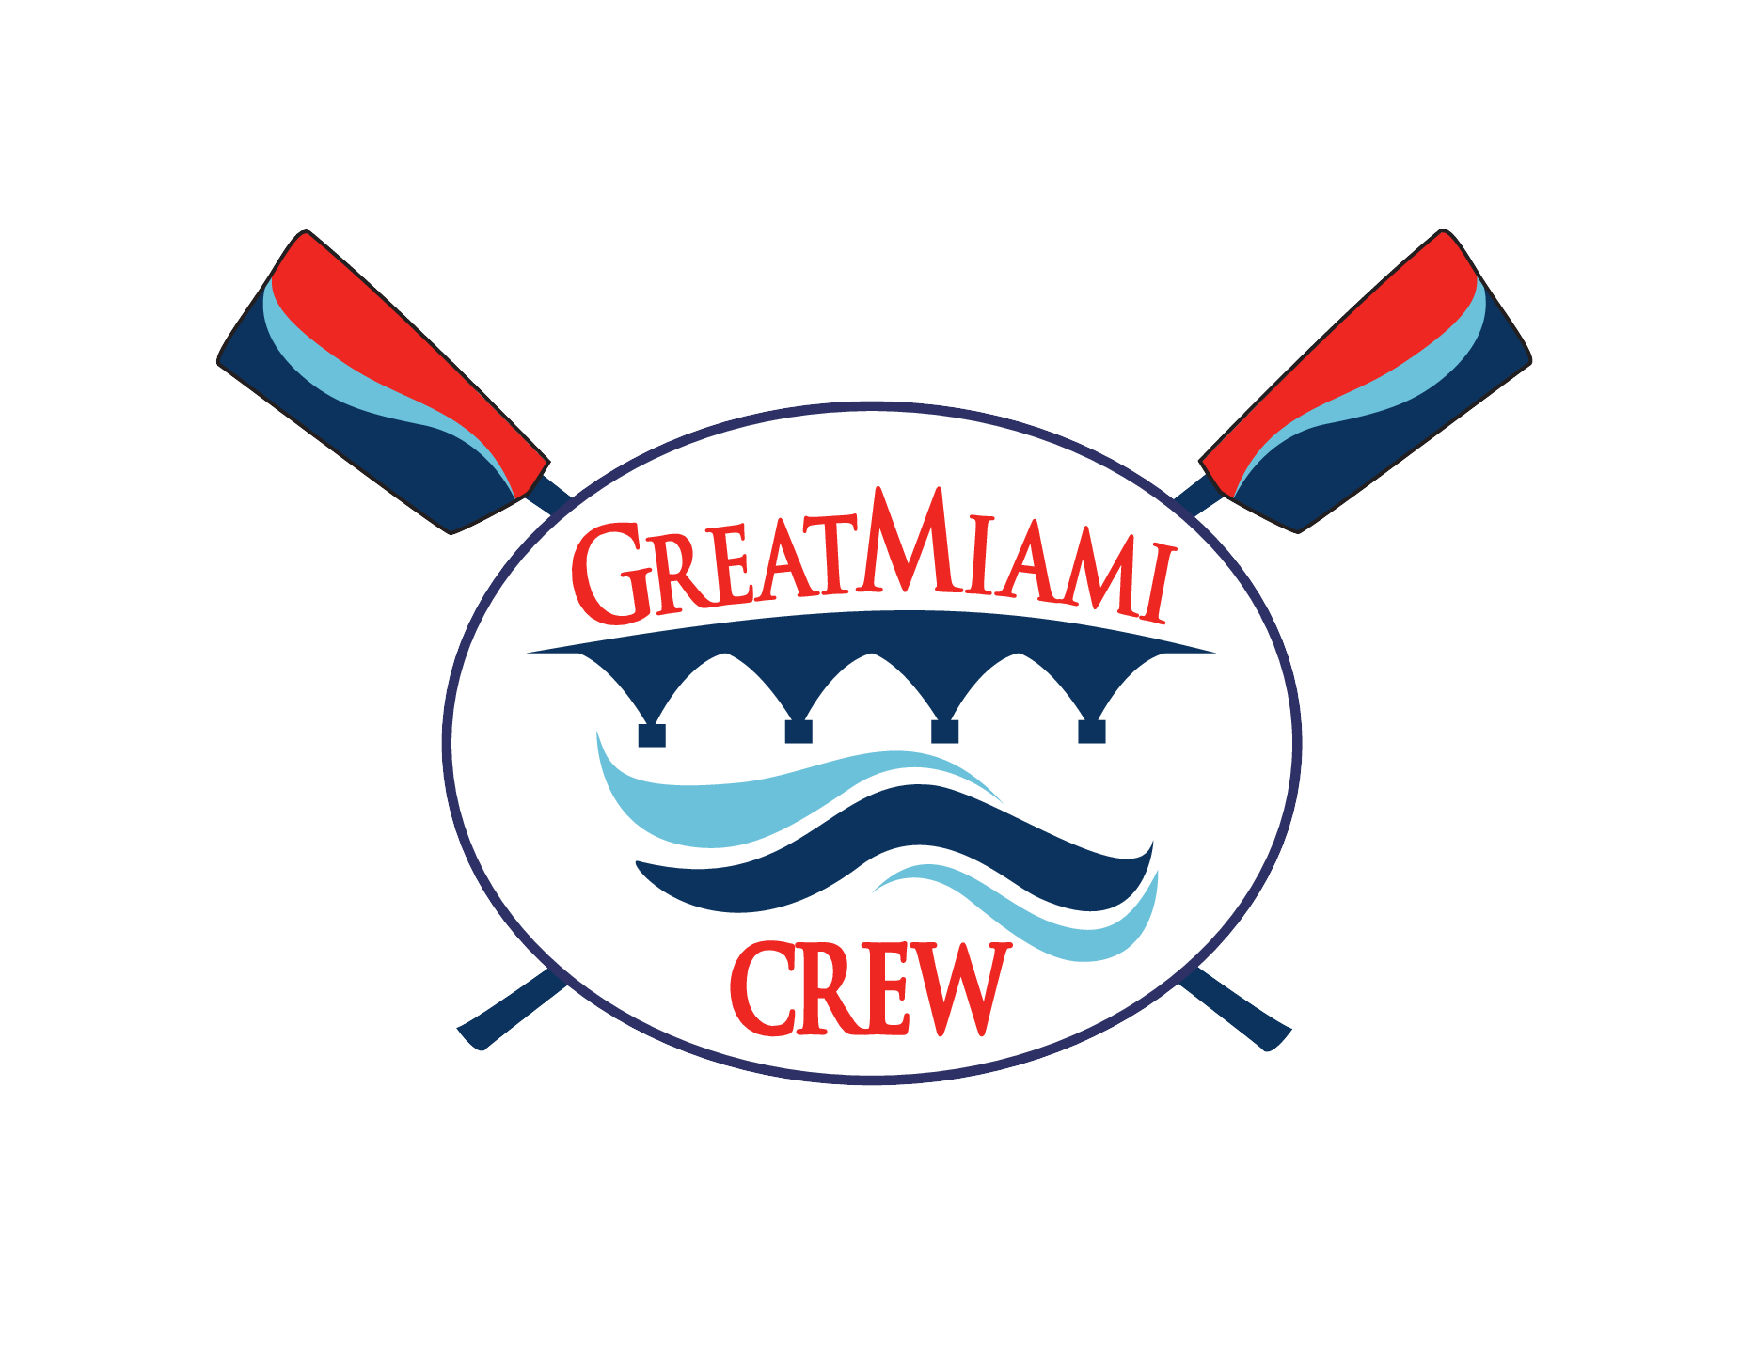

Athlete and Parent Code of Conduct
I understand that violation of any provision of Great Miami Rowing Center’s Code of Conduct is grounds for suspension from the team and, depending on the severity of the violation or multiple violations, dismissal from the club. Registration fees for the Season will not be refunded.
I have read and accepted the rules and regulations set forth and presented in the Great Miami Rowing Center Athletic Code of Conduct.

Print Rower’s Name:​
___________________________________________________
Signature:​
___________________________________________________
Print Parent/Guardian Name:​
___________________________________________________
Parent / Guardian Signature:​
______________________________________________________

Date:​ __________________________________

