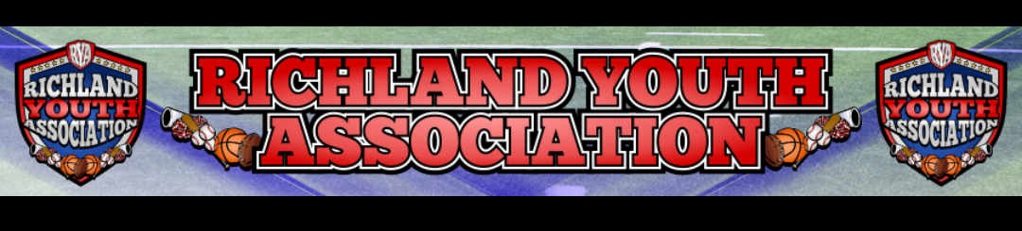
RYA March 2023 BOARD MEETING
Meeting Date: March 1, 2023 – 6:45pm
Board Member Attendees: Mike Cowan, Kevin Vorpahl, Richard Stutheit, Lisa Willis, Emily Standifer, Eric Gomez
Absent: Ben Earley, Blair Armfield, Erica Stutheit, Brandon Lewis
Non-Board Attendees: Thomas Schulz, Missy Schulz

General Board Items / Old News
- Fun Run at Smithfield Elementary is March 9th and sponsors are due on February 14th.
  - Flyers will go home with every student at end of day.
  - Waiting to confirm we have permission to set up a table at the Fun Run.
  - Need to send banner for school to hang up during the Fun Run.
- Holiday Heights Elementary School
  - March 7th PTA Spring Meeting
  - Potential to have RYA table setup for advertising purposes.
- Request for sponsorship for Birdville ISD Special Olympics came in.
  - Due to already donating to another event last month, not able to sponsor this event currently.
- Volunteer stepped forward to possibly fill Secretary or Treasurer/Accounting positions, Mike will follow up with the volunteer to see about adding her to board.
- No current payments from convicted individual.

Basketball: Blair Armfield (absent)
- End-of-season tournament this Saturday, March 4th
  - Bracket for tournament posted on website under the Basketball page.
- $665 from America’s Best Photography for Basketball fundraisers after picture day.

Rec Baseball: Richard Stutheit
- Baseball registrations closed with 338 registered among various age groups.
  - Six teams for 4u, 6u, and 8u. Four teams for 10u and 12u. One team for 14u.
  - Three 14u players were refunded due to a lack of interest for a second team and too many players for the single team to handle.
  - Largest registration turnout for Rec Baseball since Spring 2018.
- Player Look for 10u, 12u, and 14u went very well. Good turnout and good number of volunteers.
- Schedules are done for 4u, 6u, 8u, 10u, and 12u.
  - Interlock schedules for 10u and 12u have been approved by JYSA and HSA.
  - Currently, RYA is set to host the 10u and 12u end-of-season tournaments on May 27th.
  - Schedules will be uploaded to SportsEngine by this Saturday.
- Star Sports in Keller will be used for our Spring Fan Store and they are finalizing designs this week.
  - Richard will follow up with vendor tomorrow and we plan to have store open by Friday.
  - Fan Store to remain open for one week and RYA will receive 10% of sales back from the vendor after the store has been closed.
- Uniform Items:
  - Socks and belts have been received from Game On Socks & Belts.
  - Jerseys and hats should be received no later than the Monday prior to Opening Day.
  - Late order for jerseys and hats submitted to Zexez this week with the Assistant Coach Jersey order. RYA receiving $5 back from each assistant coach jersey ordered.
- Backstop on Richfield Park #2 has been fixed and field is operational.
- Baseball practices began today at Richfield and Cross Timbers.

Premier/Tournament Baseball: Kevin Vorpahl
- March tournament did not make, cancelled for this month.
- May tournament has large 8u, 9/10u, 11/12u, and 13u registration already.
  - Kevin speaking to city about confirming that CT1 and CT2 are 8u compatible
  - Requesting access to CT3 for the 13u/14u tournament brackets.
- Premier League games start next Tuesday.

Football: Eric Gomez
- Football registrations opened – 23 players signed up on first day.
  - Registration Fees:
    - $90 for early Flag / $150 for early Tackle
    - $110 for regular Flag / $175 for regular Tackle
  - Issue with collecting payments – not sure why, but parents have registered without having to make payments. RYA will have to contact registered parents to collect money. Need this issue to be resolved.
- NWTX annual meeting was last month.
  - Merging for one-year with MYFA proposal on table
    - Going to move MYFA to age-pure
    - 16 team playoffs for most age levels
    - Merger will reduce travel on parents, teams split in geographical divisions.
  - Reduced to 3 referees per game for 6u+ and 2 referees per game on 5u.
  - 2023 Gate Fees - $4 seniors and $6 adults

Cheer: Lisa Willis
- Tiera Alterations for Cheer uniforms - $100 per uniform
  - After kids are registered, they will be able to go to vendor directly to get sizing done and vendor will start working on their uniforms.
  - Vendor requesting payments every two weeks once they start alterations/sizing.
  - Lisa will pickup all uniforms and distribute to parents after confirming no payments are outstanding.
- Registrations:
  - $175 early registration / $200 regular registration / $225 late registration
  - Payment plan is $75 down / $50 on each of the next two payments.
  - Request has been submitted to SportsEngine for creating registration and waiting.
    - Erica doesn’t have access to create registrations that require payments.
  - Kids will get backpacks, poms, uniforms, and bows in registration.
- Almost all the Cheer coaches have confirmed they will come back for the 2023 season.
- Waiting to see if they have enough interest for a 5/6u Cheer team.
- Trying to add a Cheer board position to NWTX Board
  - Lisa compiling list of all individual Cheer directors from NWTX member associations
- Possibly doing a Cheer Clinic this Summer
  - Looking for a gym rental or possibly doing clinic outside at park

Marketing: Brandon Lewis (absent)
- No information this month.

Communications: Erica Stutheit (absent)
- Flyer designed for Smithfield Elementary Fun Run – will be sent to Golden Rule Printing.
  - Thomas Schulz will print off grayscale flyers to go out during Basketball tournament this weekend also. (Thomas.schulz@henryschein.com)
  - Cheer ages are 4 to 13, should be corrected on the flyer prior to mass order being placed.
  - Estimated 600 flyers to be ordered from Golden Rule for the SES Fun Run.
- Needs access to create registrations in SportsEngine that require payments. Had to submit work order through SportsEngine for them to create Cheer registration since Erica doesn’t have proper access.

Special Events: Emily Standifer
- Baseball Opening Day – March 25th
  - First Pitch – Councilman Kelvin Dupree
  - Guest Speaker – NRH Parks & Recreation
  - NRHPD Honor Guard
  - National Anthem – NRMS or Watauga Elementary
  - Food Trucks – Still awaiting confirmation on two food trucks
  - Bounce Houses – Need to get paid; Mike will get invoice paid tomorrow.
- Baseball End-of-Season Tournaments – May 27th

RYA Bank Accounts totaled $36,953.29 and $824.86 – combined total of $37,778.15

Meeting adjourned at 8:26 pm

