Mikasa Volleyball Cleaning Guidelines

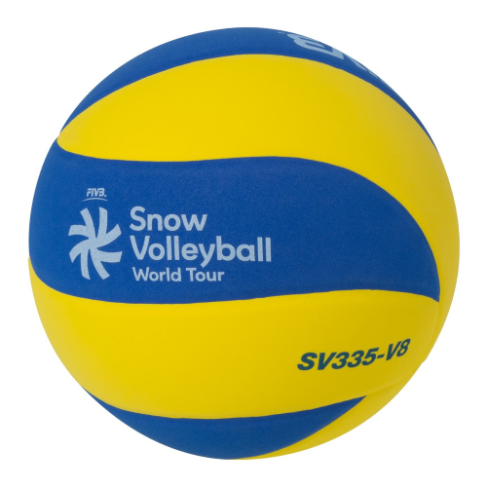 Laminated ball (New material type)
This is a type of a ball of which the panels are laminated onto ball’s carcass. The improved soft surface material is used for lamination to generate the soft feeling which we never had before by conventional, artificial or natural leather process.
Applicable ball: MIkasa | SV335-V8 Snow Volleyball
Ball care after using ball
- Please wipe the surface of the ball with a soft cloth.
- If you are unable to remove dirt with water, please wipe the ball with a cloth moistened with a water-diluted mild detergent.
- If you are unable to remove dirt easily, please wipe the ball with a moistened cloth.
- If you use a mild detergent to clean the ball, please wipe off any remaining detergent thoroughly to ensure that it does not remain on the ball surface (detergent may cause ball discoloration)
- If you use water to clean the ball, please wipe the ball afterwards with a dry cloth.
- Please dry the ball out of direct sunlight in a well-ventilated place.
- If the ball has been soaked in rain, please wipe away moisture and dirt using a cloth, then dry the ball out of direct sunlight in a well-ventilated place.
- Please do not wipe the ball with solvents such as benzene. (This may damage the cover material.)
When the ball gets wet
- Panels for a laminated ball are bonded by glue on the ball’s carcass.
The excessive moisture and heat to the ball brings a decrease of adhesion force, and the panels may peel off or may have discoloration.
- If you use water to clean the ball, please wipe the ball afterwards with a dry cloth.
- Please dry the ball out of direct sunlight in a well-ventilated place.
- Please do not use the dryer to dry the ball out.
Precaution
- Please store and carry the ball with adequate air pressure because the storage and carriage by deflated conditions may cause wrinkles on the ball surface.
- Please avoid leaving balls in a place that is exposed to direct sunlight.
- Please avoid storing balls in hot or humid places.
- Please store balls in a well-ventilated place.
- Please dry balls regularly in a well-ventilated place out of direct sunlight

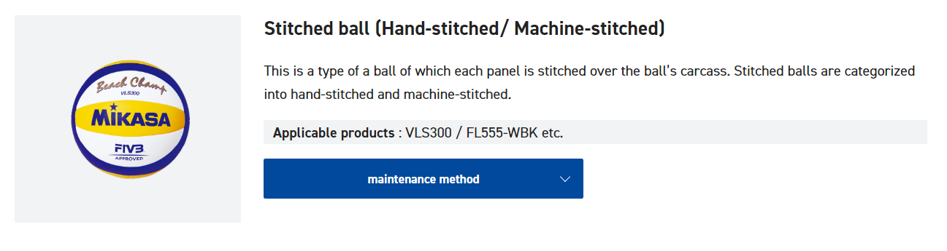

Stitched ball (Hand-stitched/ Machine-stitched)
This is a type of a ball of which each panel is stitched over the ball’s carcass. Stitched balls are categorized into hand-stitched and machine-stitched.
Applicable products : VLS300 / FL555-WBK etc.

Ball care after using ball
- After use, please remove any dirt or sand that may be lodged in the ball stitching part,using a rush or similar tool.
- Please wipe the surface of the ball with a soft cloth.
- If you are unable to remove dirt easily, please wipe the ball with a moistened cloth.
- If you are unable to remove dirt with water, please wipe the ball with a cloth moistened with a water-diluted mild detergent.
- If you use a mild detergent to clean the ball, please wipe off any remaining detergent thoroughly to ensure that it does not remain on the ball surface (detergent may cause ball discoloration)
- If you use water to clean the ball, please wipe the ball afterwards with a dry cloth.
- Please dry the ball out of direct sunlight in a well-ventilated place.
- If the ball has been soaked in rain, please wipe away moisture and dirt using a cloth, then dry the ball out of direct sunlight in a well-ventilated place.
- Please do not wipe the ball with solvents such as benzene. (This may damage the cover material.)
- Please remove air after use, if the same air pressure remains in the ball after use, the ball may expand or distort.

Precaution
- Please avoid leaving balls in a place that is exposed to direct sunlight.
- Please avoid storing balls in hot or humid places.
- Please store balls in a well-ventilated place.
- Please dry balls regularly in a well-ventilated place out of direct sunlight.

Laminated ball (Synthetic leather / Natural leather type)

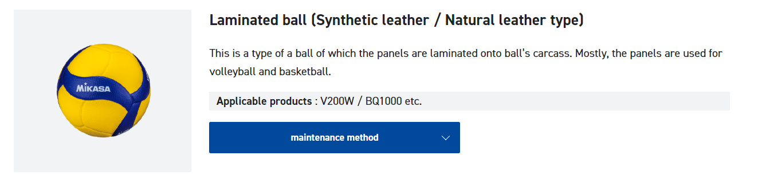

This is a type of a ball of which the panels are laminated onto ball’s carcass. Mostly, the panels are used for volleyball and basketball.
Applicable products : MVA200 / V200W, V200W-OVA, BQ1000 etc.

Ball care after using ball
- Please wipe the surface of the ball with a soft cloth.
- If you are unable to remove dirt easily, please wipe the ball with a moistened cloth.
- If you are unable to remove dirt with water, please wipe the ball with a cloth moistened with a water-diluted mild detergent.
- If you use mild detergent to clean the ball, please wipe off any remaining detergent thoroughly to ensure that it does not remain on the ball surface (detergent may cause ball discoloration)
- If you use water to clean the ball, please wipe the ball afterwards with a dry cloth.
- Please dry the ball out of direct sunlight in a well-ventilated place.
- If the ball has been soaked in rain, please wipe away moisture and dirt using a cloth, then dry the ball out of direct sunlight in a well-ventilated place.
- Please do not wipe the ball with solvents such as benzene. (This may damage the cover material)

When the ball gets wet
Panels for a laminated ball are bonded by glue on the ball’s carcass. The excessive moisture and heat to the ball brings a decrease of adhesion force, and the panels may peel off or may have discoloration.
- If you use water to clean the ball, please wipe the ball afterwards with a dry cloth.
- Please dry the ball out of direct sunlight in a well-ventilated place.
- Please do not use the dryer to dry the ball out.

Precaution
- Please avoid leaving balls in a place that is exposed to direct sunlight.
- Please avoid storing balls in hot or humid places.
- Please store balls in a well-ventilated place.
- Please dry balls regularly in a well-ventilated place out of direct sunlight.

For more information on other Mikasa volleyball types, please visit their website by clicking here: https://mikasasports.co.jp/e/support/maintenance/#:~:text=If%20you%20are%20unable%20to,ball%20with%20a%20moistened%20cloth.&text=If%20you%20use%20water%20to,afterwards%20with%20a%20dry%20cloth

