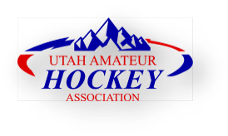

OUTSTANDING DEBT LIST
Players can be added to the ODL during the current season. The last day to make additions to the list for the prior season is the second day after USA Hockey Nationals concludes each year.
Reference: UAHA “Outstanding Debt List” UAHA P&Ps and USAH Bylaw 10.D.3.j
** Please add any additional documentation (player contact, invoices, communications) to this form, sending a complete file for review to the UAHA VP of Discipline.

1. Player Name

2. DOB

3. Contact information (phone, email, mailing address) for the player being added

4. Member association making the request

5. Dollar amount owed to a member association or team

6. Description and/or timeline of collection attempts

7. Copies of all correspondence between the parties

