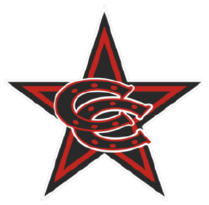

**Fall 2025 11U Select Team Roster**

|  |
| --- |
| **Coppell Cowboys**  Coach Porter |
| 1. Andrew Morchower 2. Artham Goyal 3. Brayden Porter 4. Connor Newton 5. Easton Turner 6. Henry Brown 7. Isaac Martinson 8. McKai Morningstar 9. Nikhil Rao 10. Om Kadam 11. Paul Behrens |