Portland Interscholastic League

**PILYSP Scholarship Application**

The Portland Interscholastic League Youth Sports Program’s (PILYSP) main goal is to serve our communities by offering an opportunity for all youth to participate in athletics. The fees associated with participating in these activities have been established to help cover the cost to operate the youth organization.

This scholarship application has been created to help alleviate financial hardships for families in our communities. Your application will be reviewed by the District Athletic Office and will be assessed based on multiple criteria. There is a limited number of scholarship funds available but we are making every effort to ensure as many athletes as possible have an opportunity to participate in the PILYSP.

In an effort to support as many athletes as possible, the PIL offers partial scholarships only. It is required that families pay a portion of their student’s athletic fee. 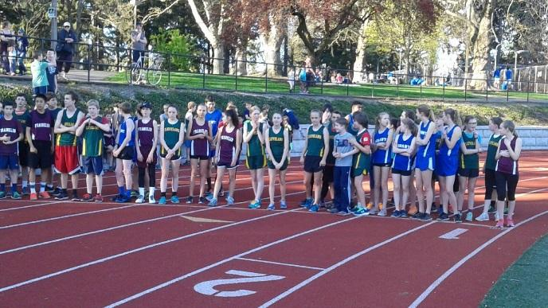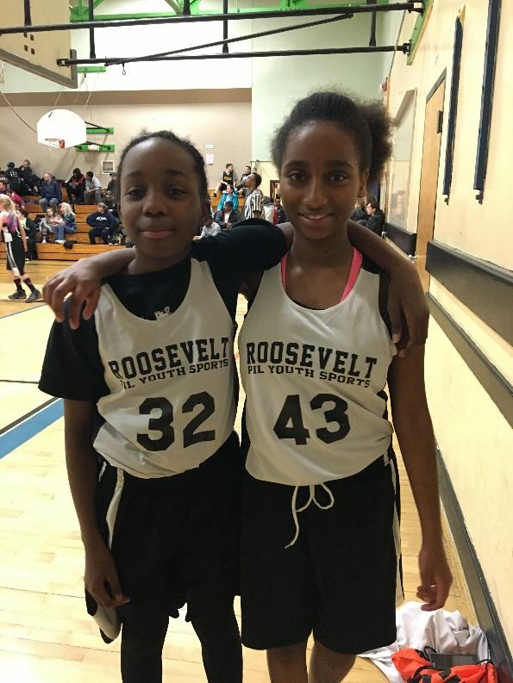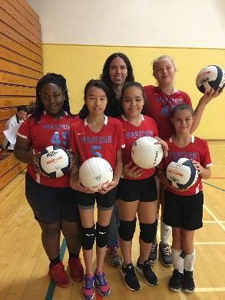

**PILYSP Scholarship Application Form**

Please complete the following application, sign and return to your Cluster Coordinator. The District Athletic Office will review your application. Please make sure all information is complete and correct. Any personal information that you are required to provide will be kept confidential.



Participant(s) First Name: _____________________________

Parent Email Address: ________________________________

School/Cluster: _____________________________________

Athlete Birth Date: __________________________________

Mother First Name: __________________________________

Father First Name: __________________________________

How many children in the household under 18? ___________

What is the amount you can contribute toward the PILYSP Registration Fee? ______________________________________________

How many years have you participated in the PILYSP Program? ⃝ New Applicant ⃝ 1 Year ⃝ 2 Years ⃝ 3+ Years

Are there additional extenuating circumstances or other information that we should consider in processing your request (attached additional pages if needed)? ________________________________________________________________________________________________________________________________________________________________________________________________________________________________________________________________________________________________________________________________________________________________________________________________________________________________________________

Please include a letter of support for a PILYSP Scholarship from a coach, cluster coordinator or other in order to support this application.

**Parent/Guardian Understanding and Acknowledgment:**

* Filling out a scholarship application **does not guarantee a child will be approved**. The DAO will take all applications into consideration and will let applicants know their status as soon as possible. Scholarship dollars will depend on different factors, including but not limited to money in reserve for scholarships, number of scholarship applicants, and financial needs of the family.
* Scholarships cover partial registration fees. A payment plan may be set up with the Cluster Coordinator in order to pay for the remaining balance due. Any unpaid balances will result in fees being added to the student’s account.

I certify that this information is true and that the applicant meets all the stated scholarship requirements. I also understand that my signature authorizes the District Athletic Office to obtain verification of all the information on this application and that additional information may be necessary for approval of this application.

Parent/Legal Guardian Signature: ______________________________________ Date: ___________________________

