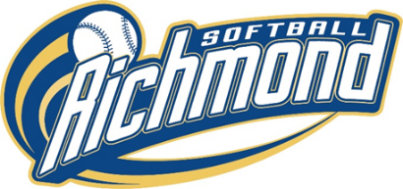Annual General Meeting
AGENDA
Wednesday, October 23, 2024 at 7:00 PM
Held Virtually by Zoom
- CALL TO ORDER and INTRODUCTIONS of RGSA BOARD – 7:00 pm

- ADDITIONS TO THE AGENDA

- APPROVAL OF THE AGENDA

- APPROVAL OF THE MINUTES of October 3, 2023, AGM – minutes reviewed at this meeting.

- SCHOLARSHIP AWARDS – Michelle Akizuki.

- PRESIDENTS SUMMARY REPORT – David Yam

- 1st VICE PRESIDENT REPORT – Barry Riva

- FINANCIAL REPORT – Karen Campbell

- EXECUTIVE DIRECTOR REPORT – Al Groff

- NAME CHANGE – David Yam
MOTION that RGSA be officially be changed to RSA and the new logo be adopted:
- Executive has been discussing name and logo change for a while. Last March we introduced a new logo (see above) for our spirit wear and was well received. We want to officially change to this new logo and at the same time change our association name from Richmond Girls Softball Association to Richmond Softball Association. The current Islanders logo will continue to be use by Rep teams.

- ELECTION OF EXECUTIVE AND VOLUNTEERS

See tables over page.

- ADJOURNMENT

ELECTION OF VOTING EXECUTIVE (all two-year terms except as noted)

1st Vice – President

Secretary

Registrar
U5/7 Coordinator

U9 Coordinator (1 year)

U11 Coordinator

Equipment Coordinator

RGSA NON-VOTING VOLUTEER POSITIONS

Tournament Director

1st Member – Fields

2nd Member – Ball Throw / Photos
3rd Member – Trophies
Field Scheduler

Gym Allocator

Scheduler

Rep Uniforms
House Uniforms
House Committee Chair
Communications Director
Web Master

Social Media

Umpire in Chief
Assistant Tournament Director
Rep Committee | (To be selected by Rep Chair and ratified by the Executive)

