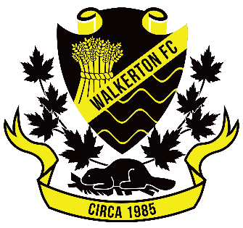

The Role of the Tournament/Festival Coordinator

Tournament/Festival Coordinator
- Work with President to book tournaments and festivals
- Work with Referee Coordinator and Head Referee to book match officials for games
- Confirm schedules with Lakeshore Soccer League Rep and/or Saugeen Mixed League Rep
- Organize information at the event
- Convene or appoint a convener for the event
- Communicate with local businesses and clubs

