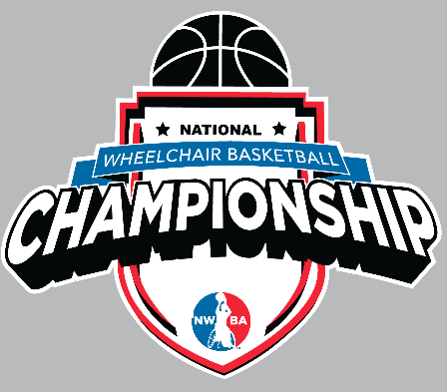

The National Wheelchair Basketball Association is accepting Request for Proposals to host and serve as the Local Organizing Committee (LOC) for events part of the NWBA National Championship Series.
These events may be bid as separate events, though preference of events to be hosted together is listed above.

Adult Division I
Adult Division II
Adult Division III
(preference to be hosted together)

Varsity
Varsity Invitational Tournament
Prep
(preference to be hosted together)

Women’s
Military
(preference to be hosted together)

Intercollegiate Women’s
Intercollegiate Men’s
(preference to be hosted together)

Attendance
Adult Divisions: 48 teams per event, ~600 athletes per event, ~600 spectators per event
Junior Divisions: 48 teams per event ~700 athletes per event; ~1000 spectators per event
Women’s Division: 16 teams, ~200 athletes, ~400 spectators
Military Division: 8 teams, ~100 athletes, ~100 spectators
Intercollegiate Women: 6 teams, ~75 athletes, ~300 spectators
Intercollegiate Men: 12 teams, ~150 athletes, ~600 spectators
Hotels
10 Hotel Rooms per Team x 3 Nights = ~480 Hotel Rooms per tournament just for athletes

Bid Requirements
LOC responsible for securing venue(s) at no cost to the NWBA
LOC to collaborate with NWBA on sponsorship and partnership opportunities in the community
All event expenses that are responsibility of LOC are outlined in sample budget*
Submissions are requested to be provided by due by December 20, 2025, for all events (available for bid) for 2027 and beyond.

To submit event bids and review other important information on these events are available at:

https://www.nwba.org/rfpnationals

