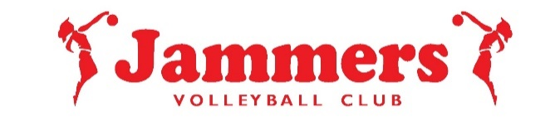
Jammers Sponsorship Program 2021-2022 Season

Dear Potential Sponsor,
Jammers Volleyball Club strives to maintain competitive volleyball programs while providing the highest level of coaching at some of the lowest price points in the Triangle area. Even so, the cost can be prohibitive for many families in our area. To help counteract the high cost of travel ball and expand the availability of playing options to all young athletes in our area, we created the Jammers Volleyball Club Sponsorship Program. With the financial support of businesses such as yours, this program raised over $25,000 in donations last year. This enabled many young ladies an opportunity to follow their dreams of playing volleyball at a higher level, some even as college scholar athletes. This year, we are seeking your contribution and continuing to offer three levels of sponsorship as follows:

_______LEVEL ONE Minimum of $150 Donation
At this level, your business name will be printed on the back of a practice shirt for the athlete’s team, to be worn locally, at regional and out of state tournaments for moderate exposure in our community. $130 will go directly towards the player’s dues.

_______LEVEL TWO Minimum of $300 Donation
At this level, you will receive a high-quality picture plaque that includes a picture of the athlete’s team. Your business name will be printed on the back of a practice shirt for the athlete’s team, to be worn locally, at regional and out of state tournaments. This level gives you a higher level of exposure in our community. $250 will go directly towards the player’s dues.

_______LEVEL THREE Minimum of $600 Donation
At this level, we will add your business information to our website, you will receive a high-quality picture plaque that includes a picture of the athlete’s team. Your business name will be printed on the back of the practice shirt for the athlete’s team, to be worn locally, at regional and out of state tournaments. This level gives you the ultimate amount of exposure in our community. $500 will go directly towards the player’s dues.

Jammers Volleyball Club is a 501 c3 non-profit organization, Tax ID#: 20-8047275. Please use this form along with your cancelled check as your receipt for tax purposes. Please make all checks out to Jammers Volleyball Club, then add the Athlete’s Name and Team Name in the MEMO section of your check before giving it to the Jammers Parent or Athlete who contacted you. Athlete’s Name_____________________ Athlete’s Team_______________
Jammers athletes work hard, give their best, and represent our local communities in the best way possible. We thank you in advance for any support you can extend to the young ladies of Jammers Volleyball Club! GO JAMMERS!

Sincerely,
The Athletes, Parents and Coaches of Jammers Volleyball Club

Please do NOT mail donations to the address below. Contact Diane Stone 919-215-0677 with any questions.
Jammers Volleyball Club: 15 Stillhouse Place, Durham, NC 27704

