Pool Play/Warm-ups
Gym opens at 7:40 a.m. Coaches: There is not a coaches’ meeting but please inform the admissions desk of your arrival and court directions. All courts will begin their first match at 8:10 a.m. There will be a 10 minute (2 minutes shared-4 minutes serving team-4 minutes receiving team) warm-up for the first two rounds, only. All warm-up after will be 4 minutes (2-2). All pool play matches are 2 sets to 25 no cap (there is NOT a 3rd set in pool play). Please bring your own balls and teams will not switch sides during pool play. Game balls will be provided.
Bracket Play
Brackets will start within 30 minutes after pool play. Top four overall teams from each pool will go to the Gold Bracket, the next four overall teams from each pool will go to the Silver Bracket, and all remaining teams will be in the Bronze Bracket. Sets 1 and 2 will be to 25 no cap. If needed, the 3rd and deciding game of a playoff match is to 15 points no cap. We will not switch sides during bracket play.. Champions in the Gold bracket will receive a prize. We will not wait to start a match according to the time it is scheduled. Bracket matches will begin immediately after completion of the prior match. Please keep your eye on the official scoreboard near concessions.
Bracket/Seed breakdown and placement in brackets will be decided by:
- Win/Loss 2. Head to Head, then H-to-H Point Differential 3. Overall Point Differential 4. Coin Flip
Officiating
All teams are responsible for providing an officiating team and their own equipment. A coach needs to be the R2 within all age groups. For brackets: some rounds the winning team officiates the next match and some rounds the losing team does. Read your bracket carefully!! Please check with the site director before you leave to make sure your team has no further officiating duties if you are not sure. The officiating team must provide a Coach as the second referee, players for scorekeeper, libero tracker, scoreboard operator, and two line judges.
12s Division: A lighter ball (7-8 oz) will be used. Players are allowed to step one foot over the service line. If two feet are over the line, it will be a foot fault. Net height will be set at 7 feet.
Food
There are no coolers or team meals allowed. Concessions will be available all day serving breakfast and lunch options. Please keep food and drink in the cafeteria and clean up after yourself for others to use.
Miscellaneous
There is no trainer on site. Please provide your own to your team as needed. Ice will be available to use for any injuries, but no other materials. Outside chairs are not permitted. Cushions and bleacher seats are allowed.
Admissions/Parking
Admission is $10 for Adult fans. Admission for seniors (60+) and students is $5. Coaches, players, and ages 4 and under are free. Cash only. Everyone should enter through one of the three entrances (X). There is parking in the front of the school, south of the school, and at the elementary.
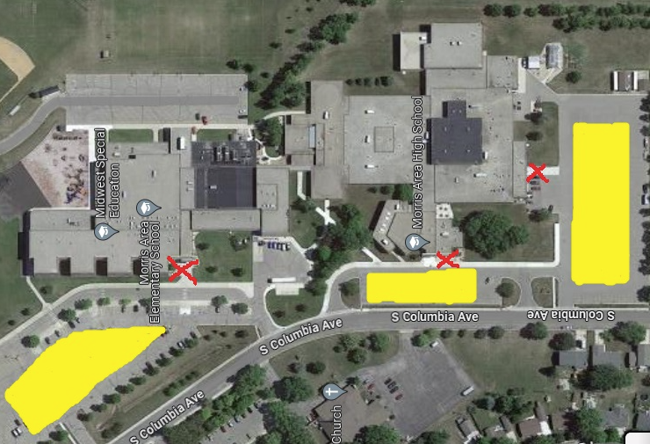

Pool A | Pool B
Court 1: ES | Court 2: ES
1. MAVA 12’s | 1. MVC 12’s
2.LCVC | 2. Sauk Centre
3. MVC 11’s | 3. Benson 12-1
4. Benson 12-2 | 4. Marshall Black
Elementary School Gym
Time | Court 1 | Court 2 | REF
8:10 AM | MAVA vs. MVC 11 | MVC 12 vs. Benson 1 | 2
9:10 AM | LCVC vs. Benson 12-2 | Sauk Centre vs. Marshall | 1
10:10 AM | MAVA vs. Benson 12- 2 | MVC 12 vs. Marshall | 3
11:10 AM | LCVC vs. MVC 11 | Sauk Centre vs. Benson 1 | 1
12:10 PM | MVC 11 vs. Benson 12-2 | Benson 1 vs. Marshall | 2
1:10 PM | MAVA vs. LCVC | MVC 12 vs. Sauk Centre | 4

Warm-up (8:00 AM Start)
10 Min
10 Min
10 min
10 Min
10 Min
10 Min
4 Min
4 Min
4 Min

