Tyngsboro Sports Center

Policies and Procedures

Summer 2026

Updated: April 16, 2026

Staff Background Information Policy p. 3-5

Staff Orientation Plan p. 5

Prevention of Abuse and Neglect p. 6

Camp Discipline and Guidance Policy p. 9

Fire Drills p. 10

In Case of Fire p. 10

Diagram of Fire Exits p.11

Disaster Plan p. 12

Lost Camper Plan p. 12

Traffic Control Plan p. 12

Special Contingency Plan p. 13

Health Care Policies and Guidelines p. 14-28

Important Information p. 29

COVID-19 Isolation and Quarantine p. 30-31

Protocol to Handle Unrecognized Persons at Camp p. 32

Required Ratio of Staff to Campers p. 32

Camp Dismissal p. 33

Tobacco Use p.33

Alcohol and Marijuana Use p.33

Additional Campground Requirements p.33

Staff Background Information Policy and Procedures
Policy/Procedure (105 CMR 430.090):
The Tyngsboro Sports Center (TSC) will perform a background check of each staff person and volunteer. All staff and volunteers will have a background free of conduct that bears adversely upon his or her ability to provide for the safety and well-being of the campers. TSC will determine whether each staff person’s and volunteer conduct, criminal or otherwise, shall disqualify that person from employment or service at the camp. In making this determination, TSC will consider at a minimum that information required under 105 CMR 430.090 (C) and (D).
At a minimum TSC will require for each camping season, the following with regards to each staff person.
MA Resident:
- Prior work history, including name, address, and telephone number of a contact person at each place of employment or volunteer service for the previous five years.
- Three (3) positive reference checks from individuals not related to the staff person.
- Self-reporting of any felony conviction.
- Obtain a sex offender registry information check from the Massachusetts Sex Offenders Registry Board.
- Obtain a CORI/Juvenile report from the Massachusetts Criminal History Systems Board.
Out of state Resident (staff person whose permanent residence is outside MA):
- Prior work history, including name, address, and telephone number of a contact person at each place of employment or volunteer service for the previous five years.
- Three (3) positive reference checks from individuals not related to the staff person.
- Self-reporting of any felony conviction.
- Obtain CORI/Juvenile report from the Massachusetts Criminal History Systems Board.
- Obtain a sex offender registry information check from the Massachusetts Sex Offenders Registry Board.
- Obtain a criminal record check, or equivalent where applicable *, from the staff person’s state of residence. Information can be obtained from the state’s criminal information system, local chief of police, or other local authority with relevant information. The availability and process for obtaining criminal history information from the other states can be found at www.state.ma.us/chsb/table_states.html
International Resident (staff person who currently lives outside the U.S):
- Prior work history, including name, address, and telephone number of a contact person at each place of employment or volunteer service for the previous five years.
- Three (3) positive reference checks from individuals not related to the staff person.
- Self-reporting of any felony conviction.
- Obtain CORI/Juvenile report from the Massachusetts Criminal History Systems Board.
- International staff who have previously been in the U.A.: obtain a sex offender registry information check from the Massachusetts Sex Offenders Registry Board.
- Obtain a criminal record check, or equivalent where applicable *, from the staff person’s country of residence. Information can be obtained from the country’s criminal information system, local chief of police, or other local authority with relevant information.
* Where practicable means, if the out of state or foreign jurisdiction notifies the camp in writing that no criminal background check or recognized equivalent is available from the jurisdiction, then the prospective staff person/volunteer, if s/he has completed all other requirements of 105 CMR 430.090, is deemed to be in compliance with 105 CMR 430.090.
All records will be kept for a minimum of three years from the start of service.
All Volunteers:
- Prior work or volunteer history for the previous five (5) years, including name, address, and telephone number of a contact person at each place of employment or volunteer service.
- Obtain a sex offender registry information check from the Massachusetts Sex Offenders Registry Board.
- Obtain a CORI/Juvenile report from the Massachusetts Criminal History Systems Board.

Camp Counselor and Junior Counselor Requirements (105 CMR 430.100)
All counselors will have at least four weeks of experience in a structured group camping environment, as a junior counselor, or in a supervisory role with children, and will complete a counselor orientation and training program prior to the arrival of campers.
(A) Each counselor must:
- Have at least four weeks of experience in one of the following:
  - As a junior counselor
  - In structured group camping
  - In a supervisory role with children
- Have completed counselor orientation and training per 105 CMR 430.091 prior to camper arrival
(B) Each junior counselor must:
- Complete a junior counselor orientation program prior to camper arrival. All junior counselors will complete an orientation program before the start of camp, in accordance with state requirements.
(C) Age Requirements for Sports Camps:
- Counselors must be at least 18 years old or high school graduates
- Junior Counselors must be 16 years or older
- All counselors and junior counselors must be at least 3 years older than the campers they supervise
Maintenance of Records
All camper, staff, and volunteer records are maintained by the camp for a minimum of three (3) years as required by 105 CMR 430.145. Records are stored securely to protect confidentiality. When records are no longer needed, they are destroyed in a manner that protects individual privacy, such as shredding or secure digital deletion. All Criminal Offender Record Information (CORI) and CORI Acknowledgment Forms are destroyed in accordance with 803 CMR 2.15.
Institutional Abuse/Criminal Activity:
No form of corporal punishment or restraint will be permitted or tolerated at TSC. Substantiated instances by a staff member of slapping, spanking, shaking, pinching, or other physical modes of punishment will be cause for dismissal of the staff member. The use of sarcasm, mocking, embarrassment, scapegoat, or other forms of verbal abuse, if substantiated, will be cause for dismissal of such staff member. When a staff member or volunteer is suspected of abuse, the Camp Director will work through the following procedure. Immediately upon the Camp Director’s notification of the alleged incident of abuse, the Director will remove the staff member from direct contact with the children at TSC until a further investigation has been completed. The parents of the camper will be made aware of the incident. If the results of the investigation prove to be true, the staff member will be dismissed immediately and a report to the local Police department will be pursued.
Contact Information:
Criminal History Systems Board
617-660-4640
www.state.ma.us/chsb/cori/cori.html
Sex Offender Registry Board
978-740-6400
www.state.ma.us/sorb/

Revision History:
- V1.1: Document created, 5/1/2011, by Darryl Wickens.
- Edited on 06/03/2025 by Sue Ryan

Staff Orientation Plan

Policy/Procedure (105 CMR 430.091):
Staff orientation will be conducted no later than one week prior to the start of the camp session. All counselors are REQUIRED TO ATTEND and to sign the form indicating attendance and understanding. TSC will maintain attendance records and training documentation for all staff and volunteers in accordance with 105 CMR 430.145. The session will be conducted by the Staff Director or Assistant Director. No staff or volunteer will be permitted to supervise campers or other staff until they have completed the required orientation and safety training in full.
Camp Philosophy:
The Tyngsboro Sports Center camps are designed and conducted to provide maximum physical benefit to the children while providing a “learning through play” methodology. TSC believes that children learn many valuable life lessons through playing games and activities with other children and it is our intent to help campers learn to work/play together, respect each other’s abilities and talents and to learn to “win” AND to “lose” with gracefully.
Camp Organization:
The camp is directed each day by the on-site Director or Assistant Director. Each counselor reports directly to these managers.
Camp Policies and Procedures:
As part of orientation, staff will receive training on the camp’s infection control procedures, including how to implement these procedures in accordance with the health care policy.
Each counselor is expected to:
- Come to camp 15 minutes prior to the start of camp and be ready to provide guidance, a safe environment and FUN for the campers.
- Respect each camper for who they are.
- Work with the other counselors to provide fun, safe and games/activities that the camper can learn from and be active.
- Understand and follow these procedures:
- Abuse and neglect procedure
- Fire evacuation and fire drills
- Lost Camper
- Sick Camper
- Discipline Policy
- Disaster/Emergency Plans
- Health Care
- Concussion Awareness*
*All staff and volunteers must complete an annual online head injury safety training program, such as the CDC’s Heads-Up course, before supervising campers.
- Staff assigned to campers with physical or behavioral needs will receive additional training specific to those needs prior to the start of camp.
Revision History:
- V1.0: Document created, 5/25/2011, by Darryl Wickens.
- Edited on 06/03/2025 by Sue Ryan

Prevention of Abuse and Neglect

Policy/Procedure (105 CMR 430.093):
The Tyngsboro Sports Center (TSC) Procedure for the protection of campers from abuse and neglect while in the camp’s care and custody. Also contained in this policy if the procedure for reporting abuse or neglect Lost Camper plan is in accordance to 105 CMR 430.093.
- The Tyngsboro Sports Center is committed to the protection of campers from abuse and neglect while in the custody of TSC.
- A complete CORI background check is completed for all staff members.
- Reference checks are completed on all camp counselors.
- Camp management oversees all activities and monitors for possible physical or verbal abuse.

B) The Tyngsboro Sports Center is committed to the reporting of any suspected abuse or neglect to the appropriate managers and state and local agencies. The following are the procedures:
- All staff shall immediately report any suspected child abuse or neglect. The report shall be made to the camp director.
- The camp director shall immediately report suspected abuse or neglect to the Massachusetts Department of Children and Families at 978-353-3600.
- If a report is filed under M.G.L. c. 119, § 51A alleging abuse or neglect of a camper while in the care of the camp, the Camp Director shall notify both the Massachusetts Department of Public Health and the local Board of Health in writing. The 51A report itself shall not be forwarded.
- TSC will fully cooperate in all official investigations of abuse or neglect, including assisting the Department of Children and Families and identifying parents or guardians of campers who may have interacted with the subject of the investigation.
- Any staff member or volunteer alleged to have committed abuse or neglect will not have unsupervised contact with campers until the investigation by the Department of Children and Families is complete.

Addendum:

The following are the policy provided to each counselor and staff member and reviewed with them:
- Since much of the value of our indoor sports camps is due to the caring atmosphere between campers and staff, we understand the need for appropriate physical gestures of support (pat on the back, high five, etc). BE AWARE!! Use your best judgment on when and where this entirely appropriate action should be used. Remember, ALL sexual behavior, both verbal and non-verbal, is entirely inappropriate and illegal.
- When with a camper, stay in public view of others. Make use of the buddy system and do not let yourself get into a position which could be misinterpreted.
- Use common sense when dealing with our campers. We want you and our campers to have a fun and meaningful experience at camp. Because of the commitment to our campers, we will take any and every action necessary to protect them. Anyone accused of abuse will be prosecuted to the fullest extent of the law, if such accusation proves to be true.
- Absolutely no physical punishment is allowed. Verbal abuse is more difficult to detect but is not tolerated.
- LISTEN to campers – they will not usually lie about child abuse.

The above may seem obvious and/or harsh but given the magnitude and harm this issue causes we weigh this heavily and recognize these matters are very serious. We appreciate your understanding and conformity to this policy.

Revision History:
- V1.0: Document created, 3/31/11, by Darryl Wickens
- Updated 5/25 to add DSS number
- Edited on 06/03/2025 by Sue Ryan

Camp Discipline and Guidance Policy
Policy (CMR 105 430.191):
The Tyngsboro Sports Center (TSC) Discipline and Guidance Policy shall be consistent and based upon an understanding of the individual needs and development of a child. TSC will direct discipline to the goal of maximizing the growth and development of the children and for protecting the group of individuals within it. This policy will be reviewed with all camp staff prior to the start of camp. TSC’s discipline policy is consistent with the guidance of the American Academy of Pediatrics on effective child discipline, and based on an understanding of individual child development.
AT TSC, we have some basic rules for the health and safety of children. We practice consistency in discipline based on an understanding of the child’s individual needs and development level.
Procedures:
Group discussions are used to introduce behavioral standards. These are done with the campers at the beginning of each camp. Children learn what is expected of them by talking about which behaviors are appropriate and which are inappropriate. Discipline practices include praise and positive reinforcement as well as reminders about the rules. During the camp, a short separation from the group or sitting with a counselor talking is the most often method of discipline. When conflicts develop over rights and property of others, our goal is to work with the individual children and resolve the conflict through effective communication. If conflicts continue, parents may be asked to intervene and provide ideas or solutions.
No child shall be subjected to the following types of discipline:
- Corporal punishment, including spanking is prohibited.
- No camper shall be subjected to crude or severe punishment, humiliation or verbal abuse.
- No camper shall be denied food, water and shelter as a form of punishment.
- No child shall be punished for soiling, wetting or not using the toilet.
Revision History:
- V1.0: Document created, 5/1/2011, by Darryl Wickens.
- Edited on 06/03/2025 by Sue Ryan

Fire Drills

Policy/Procedure (105 CMR 430(210(A)):
The Tyngsboro Sports Center has developed a comprehensive emergency Guide which contains a section for fire evacuations. Please refer to that document attached in this section.
A fire drill will be conducted within the first 24 hours of the beginning of each camp session, with additional drills occurring at least once per month thereafter. Ongoing fire drills with staff will be completed at least once per month thereafter.

Revision History:
- V1.0: Document updated 5/25/2011, by Darryl Wickens.

In Case of Fire
  - If you think you can safely extinguish a SMALL, CONTAINED FIRE, do so with an extinguisher, making sure to leave an escape route open in case you are unsuccessful.
  - Extinguishers are located: at all exits, near office and in concession stand.
  - If you manage to extinguish the fire, call the fire department at 911 to report it and then fill out the incident report.
  - If the fire is unmanageable:
  - Leave the area immediately, closing doors behind you if possible, and pull a fire alarm. If there is no alarm system, call out an alarm, i.e., “FIRE!”
  - Phone 911.
  - Evacuate the building as soon as the alarm sounds, checking for and assisting handicapped individuals. See Appendix C for Evacuation plan
  - Warn others upon exiting.
  - Close all windows and doors (if possible).
  - Once outside, move far away from the building.
  - Do not re-enter the building until instructed to do so by emergency responders.
  - Fire evacuation routes are shown below:

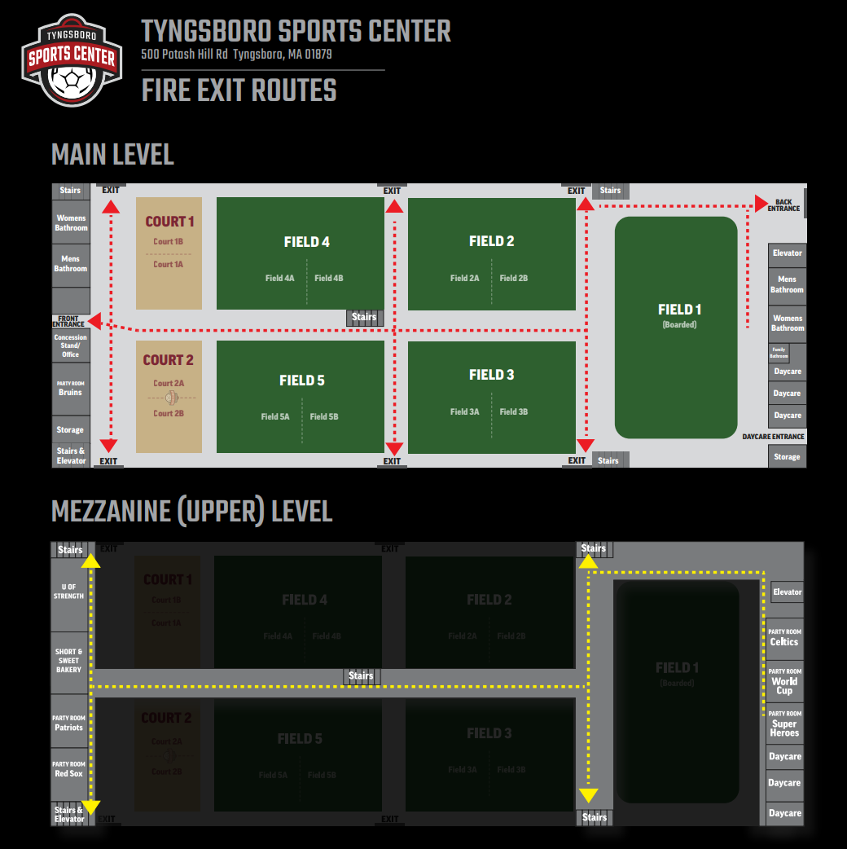

Disaster/Emergency Plans

Policy (105 CMR 430.210(B)):

The Tyngsboro Sports Center (TSC) conforms to the above procedure with the following:
- If advised by authorities to evacuate an area, do so immediately.
- Campers and staff will be notified to evacuate or retreat to shelter, e.g., intercom, alarms, etc. •

Parents of campers will be contacted to make arrangements for transporting individuals from the camp to emergency or other facilities, including, but not limited to, emergency shelters.

Lost Camper Plan

Policy/Procedure (105 CMR 430(210(C)):
The camp staff is trained to monitor attendance after each event in the camp to ensure all campers are accounted for. If a camper is lost, the Camp Director will be in charge of the search to avoid confusion and wasted time. The staff shall provide the following information to the Camp Director upon learning a camper is lost:
- Camper’s name and age
- Last place the camper was seen
- What the camper was wearing
- Other information that may be helpful
- TSC will use a three short whistle bursts as a signal to the staff that a camper is lost. At that time all staff and campers will report to the Turf arena to perform an accurate roll call.
- A check of office records will be done to ensure the camper wasn’t picked up by his/her parents. TSC will contact the camper’s parents/guardians to determine if the camper was picked up without notifying the camp office.
- A search will be conducted of the bathrooms, locker rooms, showers, and other camp areas.
- Each member of the staff will be given a designated search area to sweep the facility and grounds.
- If the camper is not found immediately or the camper requires emergency medical intervention, the Camp Director will notify emergency personnel (911).
- The search will continue until all campers are accounted for.

Revision History:
1. V1.0: Document created, 5/1/2011, by Darryl Wickens.

Traffic Control Plan

Policy/Procedure (105 CMR 430(210(D)):
- The Tyngsboro Sports Center camps are conducted indoors and outside on the turf field when weather permits. There is ample parking at the facility and campers use one of two entrances/exits to get into the facility. The left (northerly) entrance/exit has accommodations for ample parking as does the front/main entrance.
- The vehicle traffic enters a single entrance to the center and exits the same means and may elect to proceed right or left at the entrance to park for coming into the facility from the front or left side.
- The flow of pedestrian traffic in the building will require anyone entering TSC to enter through the front door and exit through the door on the left side of the building.

Revision History:
- V1.0: Document created, 5/4/2011, by Darryl Wickens.

Special Contingency Plan

Policy/Procedure (105 CMR 430.211)
This policy address special contingency plans in the event a) children who are registered but fail to arrive for a given day’s activities, b) children fail to arrive at the point of pickup following the given day’s activities and c) children who appear at camp without having registered and without prior notification. The Tyngsboro Sports Center (TSC) will review this policy with the staff prior to each camp.

Procedures:
- For children who fail to arrive in the morning (via parent drop off):
  - Verify attendance and/or roll call.
  - Call parents/guardians or other contact name provided on the camper’s application form.
- For children missing from the point of pick-up at the end of the day:
  - Double check attendance and/or roll call.
  - Check with the Camp Director to see if the camper was picked up by parents.
  - Check facility in accordance with your Lost Camper Plan.
- For unregistered children arriving at camp:
  - Verify the camp has sufficient space based on staff ratio requirement.
  - Require parent or guardian dropping off to provide all required documentation.
  - Add child to attendance roll.

Revision History:
1. Document created, 5/1/2011, by Darryl Wickens.

Health Care Policies and Guidelines

Policy (105 CMR 430.159(B)):
The Tyngsboro Sports Center (TSC) is pleased to have Dr. Russell Coleman of Pediatrics West in Westford, MA as our Heath Care Consultant. Dr. Coleman has assisted in setting our health policies and his office is always available to advise us in both acute and chronic medical situations.
Health Care Consultant Approval:
As per Massachusetts State Law, the undersigned is a licensed physician contracted to serve as the camp’s health care consultant in summer. The Health Care Consultant will:
• Assist in the development of the camp's health care policy as described in 105 CMR 430.159(B);
• Review and approve the policy initially and at least annually thereafter;
• Approve any changes in the policy;
• Review and approve the first aid training of staff;
• Be available for consultation at all times;
• Develop and sign written orders, including for prescription medication administration, to be followed by the on-site camp health care supervisor in the administration of his or her health-related duties; and
• Provide trainings as required by 105 CMR 430.160 to the health care supervisor(s) and other camp staff.

________________________________________ ___________________
Health Care Consultant Date
Russell Coleman, MD

Revision History:
1. Section added, 5/21/2024, by Sarah Fink.

Healthcare Supervisor Training
In addition to attending an approved CPR, AED, and First Aid training, the following trainings will occur.
The Health Care Supervisor is trained in:
• diabetes management (symptoms, blood sugar checks, and supervision of self-administration).
• recognition of allergy and administration of EpiPen.
• administration and recording of prescription medication.

Other designated employees are trained in:
• recognition of allergy and administration of EpiPen.
• administration and recording of prescription medication.

[ ] Advanced Practice Registered Nurse on Site
[ ] Registered Nurse on Site
[ ] Licensed Professional Nurse on Site

Revision History:
1. Section added, 5/21/2024, by Sarah Fink.

Physical Examinations by Physician and Certificate of Immunization

Required Immunizations

Written documentation of immunization in accordance with the most current Department immunization schedules developed pursuant to recommendations of the Centers for Disease Control and Prevention shall be required for all campers and staff.

Revision History:
1. Section added, 5/21/2024, by Sarah Fink.

Policy (105 CMR 430.151):
The Tyngsboro Sports Center (TSC) conforms to the above procedure with the following:
- Every camper and full-time staff person shall prior to attending or after receiving a conditional offer of employment from a residential, travel, sports or trip camp, furnish the following prepared and signed by a licensed health care provided:
  - A current medical history which lists allergies, required medications and any health conditions or impairments which may affect the individual’s activities while attending camp.
  - A report of a physical examination conducted during the preceding 18 months and
  - A certificate of immunization
- Every camper and full-time staff person shall prior to attending or after receiving a conditional offer of employment from a day camp, furnish the following to the camp:
  - A current medical history, which lists all allergies, required medications and any health conditions or impairments which may affect the individual’s activities while attending the camp. The medical history shall be signed by a parent or guardian or by a licensed health care provider; however, in the case of a staff member 18 years of age or older, the staff member’s signature shall be sufficient.
  - A certificate of immunization
- No person known to be suffering from tuberculosis in a communicable form, or having evidence of symptoms thereof, shall be allowed to work or attend a recreational camp for children in any capacity which might bring him or her into contact with any camper at such camp. Screening and testing for tuberculosis shall be in accordance with guidance issued by the Department.

Revision History:
V1.0: Document created, 5/1/11, by Darryl Wickens.
As part of our health care policy, TSC cannot accept any child with a diagnosed communicable disease (measles, mumps, chicken pox, etc.). Please do not send your child to TSC if he/she shows signs of possible contagious diseases (new cold, sore throat, fever, rashes, diarrhea, vomiting, etc.). A parent should not bring their child to the facility if he/she is too ill to participate in activities, if the child requires special individual attention due to their illness, or if signs of poor health are evident. The health of all children and staff is in jeopardy if an ill child is allowed to attend camp. Parents must notify the staff if their child has been exposed to an infectious disease so we can alert the families of the other children attending the program.
For mildly ill campers, the procedure is to allow them to rest in the designated infirmary in the care of the health supervisor and be provided comfort with first aid (ice, cold compress, etc). If the camper’s situation improves, and the health supervisor agrees, the camper will be allowed to resume activities. The issue will be logged in the record book.
If during the day the TSC staff notices that a child is unable to participate in activities due to poor health, the parent will be called to come and pick up the child. If a parent cannot be reached, an emergency contact will be called. It is the responsibility of the parent to notify TSC if there should be any changes regarding emergency contacts or their numbers.
If the parent decides to keep the child home, they are asked to call TSC at 978-649-9393 and inform the center of the absence.
Each child must be examined by a physician prior to enrollment, as required by the Commonwealth of Massachusetts. Included with this physical is an immunization history. Each child must be immunized prior to entrance at the Tyngsboro Sports Center from the following (required):
Please be sure that your child's immunizations are up to date at the time of entrance into the camp program. If the Tyngsboro Sports Center does not have your child's physical and immunization records at the start of the camp week, entrance will be denied until records are received. Tyngsboro Sports Center will not give refunds if this situation occurs.
Physical Examination or Immunization Exemptions Religious Exemption.
If a camper or staff member has religious objections to physical examinations or immunizations, the camper or staff member shall submit a written statement, signed by a parent or legal guardian of the camper or staff member if a minor, stating that the individual is in good health and stating the general reason for such objections.
Immunization Contraindicated. Any immunization specified in 105 CMR 430.152 shall not be required if the health history required by 105 CMR 430.151 includes a certification by a physician certifying they have examined the individual and in the physician's opinion the physical condition of the individual is such that their health would be endangered by such immunization.
Exclusion. In situations when one or more cases of a vaccine-preventable or any other communicable disease are present in a camp, all susceptible children, including those with medical or religious exemptions, are subject to exclusion as described in 105 CMR 300.000: Reportable Diseases, Surveillance, and Isolation and Quarantine Requirements.

Revision History:
1. Section added, 5/21/2024, by Sarah Fink.

Required Immunizations

Policy (105 CMR 430.152):
The Tyngsboro Sports Center (TSC) conforms to the above procedure with the following.
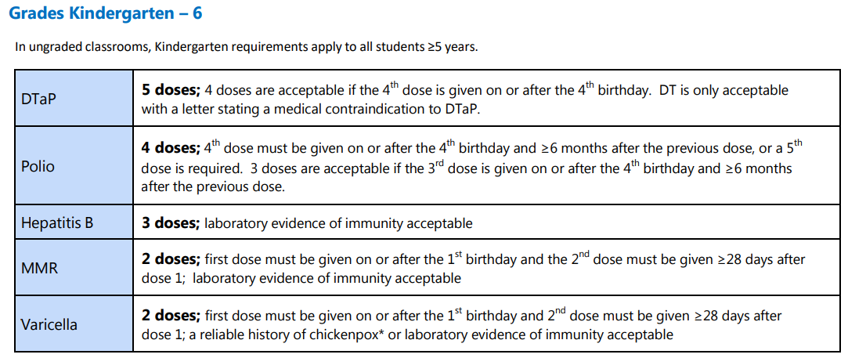

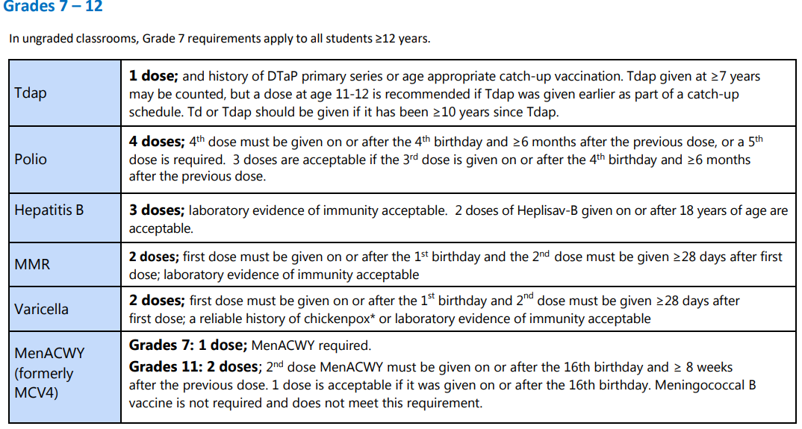

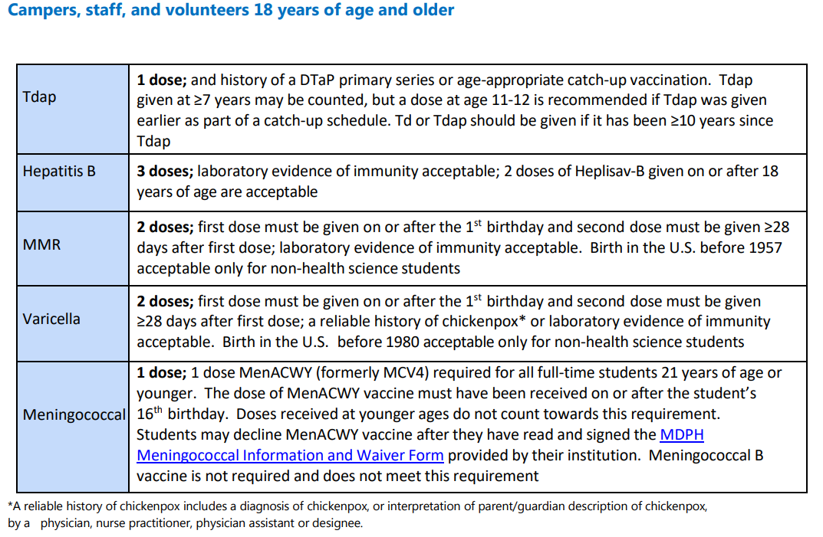

Revision History:
1. Section added, 5/21/2024, by Sarah Fink.

Health Records

Policy (105 CMR 430.150):
The Tyngsboro Sports Center (TSC) conforms to the above procedure with the following:
- Each recreational camp for children shall maintain a health record for each camper and for each staff person who is younger than 18 years old. Camps shall maintain written authorization for emergency medical care for all adult staff and volunteers. The health record shall be always readily available in electronic or hard copy form that is secure from unauthorized access and shall include at least the following:
  - The camper’s or staff member’s name and home address
  - The name, address and telephone number of the camper’s or staff member’s parent(s) or guardian(s).
  - A written authorization for emergency medical care signed by the parent or guardian.
  - The travel location(s) and telephone number(s) of the camper’s or staff member’s parent(s) or guardian(s) in the parent(s) or guardian(s) will be travelling during the camping season.
  - The name, address and contact information of the camper’s or staff member’s family health care provider or health maintenance organization, if any.
  - If the camper or staff member brings a prescribed medication from home, a written authorization to administer the medication signed by the parent or guardian.
  - Copies of injury reports, if any, as required by 105 CMR 430.154
  - A certificate of immunization indicating compliance with 105 CMR 430.152(A)
  - A copy of the health history and report of physical examination required by CMR 105 430.151
- Each recreational camp for children shall maintain a health record for each camper and for each staff person who is 18 years of age or older, that shall include at least the following:
  - The camper’s or staff member’s name and home address
  - The name, address and telephone number of an individual, if any, to be contacted in the case of emergency.
  - The name, address and contact information of the camper’s or staff member’s family health care provider, if any.
  - Copies of injury reports, if any, as required by 105 CMR 430.154
  - A certificate of immunization indicating compliance with 105 CMR 430.152(A)
  - A copy of the health history and report of physical examination required by CMR 105 430.151

Revision History:
- V1.0: Document created, 5/1/11, by Darryl Wickens.

Revision History:
V1.0: Document updated, 7/17/20, by Sue Ryan.

Medical Log
Policy/Procedure (105 CMR 430.155):
Each recreational camp for children shall maintain a medical log which shall contain a record of all camper and staff health complaints and treatment. The medical log shall list the date and time, name of patient, complaint, and treatment for each incident and shall include information on all medication administration errors, whether or not resulting in injury. The medical log shall be maintained in a readily available format and shall be signed by an authorized staff person.
All health records and medical logs shall be readily available to the health care supervisor, camp nurse or camp doctor or other health personnel.
All health records and medical logs shall be made available upon request to the authorized representatives of the Department and of the Board of Health which licenses the camp. The Department and the Board of Health shall maintain the confidentiality of information relating to individual campers and staff.

Protection from the Sun
Policy/Procedure (105 CMR 430.163):
TSC shall always encourage campers and staff to reduce exposure to ultraviolet exposure from the sun. Such measures shall include, but need not be limited to, encouraging the use of wide brim hats, long sleeve shirts, long pants, screens with a solar protection factor of 25 or greater and lip balm. Campers and their parents will provide sunscreen to be worn by each child TSC shall establish written procedures for the topical application of sunscreen, including parent or legal guardian authorization.

Revision History:
1. Section added, 5/21/2024, by Sarah Fink.

Procedures:
First Aid
First aid supplies shall be readily available to the staff wherever the health care consultant deems necessary and shall be part of the written orders required by 105 CMR 430.159(A). First aid kits shall meet American National Standards Institute Z308.1-2015 requirements including, at a minimum, one Class B Kit and one or more Class A Kits, as necessary.
All supervisory staff members are certified in emergency procedures including CPR/AED and First Aid.
If a camper requires first aid, a trained staff member will administer. When any type of medical care is provided, a note is logged into the medical log book. This is maintained by the Health Supervisor with entries made in ink only and dated daily. Parents are notified by the Health Supervisor of any medical attention given to their camper during the camp day.
A “Recreational Camp Injury Report Form” must be filed within 7 days of serious injury and illness occurrences to: MDPH.
If a camper requires further medical treatment or attention, 911 will be called. We will notify the parent/guardian immediately. If they cannot be reached, the emergency contact person will be notified. If the camper needs to be taken to the hospital by ambulance, one qualified staff person will accompany the camper to the hospital. The qualified staff person will also take the camper’s registration data with them to the hospital. EMS/ALS will determine the best facility for treatment. Every effort will be made to contact the parents in the event of an emergency requiring medical attention for the camper. However, if the parent cannot be reached the parent has provided TSC with authorization to contact emergency personnel and to authorize transport to a local hospital (Lowell General Hospital (Lowell, MA) or Saint Joseph’s Hospital (Nashua, NH), and to secure for the child the necessary medical treatment.
If a child requires further medical treatment or attention, 911 will be called. We will notify the parent/guardian immediately. If they cannot be reached, the emergency contact person will be notified. If the child needs to be taken to the hospital by ambulance, one qualified staff person will accompany the child to the hospital. The qualified staff person will also take the child’s registration data with them to the hospital. The two closest hospitals are St. Joseph’s Hospital in Nashua, NH and Lowell General Hospital in Lowell, MA however it is up to the emergency technicians where they will take the child for treatment. Every effort will be made to contact the parent in the event of an emergency requiring medical attention for the child.
Providing Emergency Healthcare – Life Threatening
Staff will initiate the appropriate first aid on scene per Red Cross protocol (including CPR if indicated), contact emergency medical services (911) and transport the camper to hospital by ambulance as soon as possible. After calling 911, notify camp director/camp nurse. The camp director will send the camper's medical records with the ambulance and contact the parent(s). The director, health care supervisor, or other designated staff member will accompany in ambulance or follow the camper to the hospital.
The need for urgent medical care is usually obvious in cases of poisoning or injuries/burns. The following are other signs that immediate medical consultation is needed. Get medical help immediately if any of the following signs are present:
• Acute allergic reaction: Bee stings or food allergies with symptoms of anaphylaxis
• Asthma attack
• Breathing problem - severe
• Bleeding - severe
• Burns (serious or covering large area)
• Head, neck or injury
• Concern about heart problem
• Poisoning
• Unconsciousness
• Seizures (unless student is known to have seizures)
• Serious limb injury
• Penetrating injury or impalement
• Foreign object in throat

Revision History:
1. Section added, 5/21/2024, by Sarah Fink.
Providing Emergency Healthcare – Non-Life Threatening
Staff will initiate appropriate first aid on scene and notify Health Supervisor as soon as possible to continue care. Never leave an injured camper alone. A staff member will remain with the camper at all times and another should call for help. If a third staff member is available, they will lead the other campers away from the area. Staff will report all first aid procedures to the Director immediately and enter into the medical log. Director and/or health supervisor will contact parent(s).
If during the day the staff notices that a camper is unable to participate in activities due to poor health, the parent will be called to come and pick up the camper. If a parent cannot be reached, an emergency contact will be called. It is the responsibility of the parent to notify the camp if there should be any changes regarding emergency contacts or their numbers.
For mildly ill campers, the procedure is to allow them to rest in the designated infirmary in the care of the health supervisor and be provided comfort with first aid (ice, cold compress, etc). If the camper’s situation improves, and the health supervisor agrees, the camper will be allowed to resume activities. If it is decided that the camper should be sent home the parent/guardian will be contacted. The issue will be logged in the record book.

Revision History:
1. Section added, 5/21/2024, by Sarah Fink.
Storage and Administration of Medication
Storage:
Medication prescribed for campers shall be kept in original containers bearing the pharmacy label, which shows the date of filling, the pharmacy name and address, the filling pharmacists initials, the serial number of the prescription, the name of the patient, the name of the prescribing practitioner, the name of the prescribed medication, directions for use and cautionary statements, if any, contained in such prescription or required by law, and if the tablets or capsules, the number in the container. All over the counter medications for campers shall be kept in the original containers containing the original label, which shall include directions for use.
All medication prescribed for campers shall be kept in a secure manner (e.g. locked storage cabinet or in the controlled possession of the individual responsible for administering them, according to American Cam p Association Accreditation Process Guide) used exclusively for medication, which is kept locked except when opened to obtain medication. Medications requiring refrigeration shall be stored at temperatures of 36° to 46° in accordance with the Massachusetts Board of Registration in Pharmacy guidance regarding proper storage of refrigeration and frozen medication.

Revision History:
1. Section added, 5/21/2024, by Sarah Fink.
Administration:
Except as otherwise provided in 105 CMR 430.160(D), (E), and (H), medication shall only be administered by the health care supervisor or by a licensed health care provider authorized to administer prescription medications under M.G.L. c. 94C, § 9.
If the health care supervisor is not a licensed health care professional authorized to administer prescription medications, the administration of medications shall be under the professional oversight of the health care consultant. Medication prescribed for campers brought from home shall only be administered if it is from the original container, and there is written permission from the parent/guardian.
The health care consultant shall acknowledge in writing a list of all medications administered at the camp. The camp will, at least seven days prior to the start of each weekly session, provide the consultant a listing of all medications to be given to any campers. At a minimum, this information will include name, medication name, dosage, administration times, and reason for administration. Epinephrine auto-injector and albuterol sulfate are excluded from this requirement.
For medical specialty camps:
• The administration of medication for diabetes care shall be conducted or be under the direct supervision of a health care provider listed in 105 CMR 430.159(E); and
• Medical specialty camps authorized to administer medications for diabetes care pursuant to M.G.L. c. 94C shall comply with all registration requirements set forth in 105 CMR 700.000: Implementation of M.G.L. c. 94C and maintain documentation of current registration for the duration of the camp season.
All camps shall have a written policy for the administration of medications at the camp. This policy shall:
• List individuals at the camp who are:
o Health care consultants or designated health care supervisors authorized by scope of practice to administer medications;
o Qualified health care supervisors who are properly trained and designated to administer oral or topical medications by the health care consultant; o Authorized to administer epinephrine auto-injectors by the health care consultant;
o Authorized to administer medications for diabetes care at a medical specialty camp pursuant to 105 CMR 430.159(F).
• Require health care supervisors designated to administer prescription medications to be trained by the health care consultant to administer oral or topical medications in accordance with 105 CMR 430.160(I).
• Require individuals who are authorized to administer epinephrine auto-injectors under 105 CMR 430.160(F) to be specifically trained to administer epinephrine auto-injectors under the direction of the health care consultant in accordance with 105 CMR 430.160(I).
• Require individuals who are authorized to administer medications for diabetes care at a medical specialty camp under 105 CMR 430.159(F) to be specifically trained by the health care consultant to administer medications for diabetes care and shall only be administered under the direct supervision of a health care provider listed in 105 CMR 430.159(E)
Massachusetts State Law, TSC’s policy on the administration of medication is as follows:
  - Medication must arrive in the prescription container with date, dosage, and the doctor’s name.
  - A parent must sign the medication permission form, writing the purpose of the medication, the date and times of administration, and the amount given.
  - Medication must be handed directly to an administrator, not left in the child’s lunch box or equipment bag.
TSC will not administer the following:
- Non-prescription drugs (unless authorized by parent/guardian and a medication permission form is completed.
- Medication not contained in a prescription package. Single tablets or jarred liquid will not be administered and will therefore be sent home.
- Medication in any amount exceeding the dosage indicated on the prescription container.
Medication shall only be administered by the Health Supervisor. Because the Health Administrator at TSC is not a licensed health care professional authorized to administer medications, the administration of medications shall be under the oversight of Health Care Consultant. Health Care Consultant shall acknowledge in writing a list of all medications administered at the camp. Medications prescribed for campers brought from home shall be administered if it is from the original container, and there is written permission from the parent/guardian.
When no longer needed, medications shall be returned to a parent/guardian whenever possible. If the medication cannot be returned is should be destroyed by the health care consultant. The medication log shall be maintained for at least the last three years.
Campers may be allowed to do the following self-medication:
- If a child is capable of self-medicating using the prescribed Epi-pen or inhaler and the parent/guardian and the health care consultant give written approval, the camper may be allowed to carry these devices with him/her at all times in order to self-administer when necessary.
Required Training for Medication Administration.
• The required training for unlicensed health care supervisors designated to administer oral and topical prescription medications pursuant to 105 CMR 430.160(E)(2) shall:
o be provided by the health care consultant
o at a minimum, include content standards and test of competency developed and approved by the Department.
• The required training for unlicensed health care supervisors and other camp staff designated to administer an epinephrine auto-injector pursuant to 105 CMR 430.160(F)(2)(b) shall:
o be provided under the direction of the health care consultant
o at a minimum, include content standards and a test of competency developed and approved by the Department.
• The required training for unlicensed health care supervisors supporting a child's process of self-monitoring and/or self-administering medications for diabetes care shall:
o be provided by the health care consultant
o include the signs and symptoms of hypo- or hyperglycemia, and appropriate diabetic plan management.
• The required training for unlicensed individuals authorized to administer medications for diabetes care at a medical specialty camp pursuant to 105 CMR 430.159(F) shall:
o be provided by the health care consultant
o at a minimum, include content standards and a test of competency developed and approved by the Department.
The health care consultant shall:
• document the training and test of competency of unlicensed health care supervisor(s) designated to assume the responsibility for prescription medication administration
• provide a training review and informational updates at least annually for those camp staff authorized to administer an epinephrine auto-injector pursuant to 105 CMR 430.160(F);
• document the training and test of competency of unlicensed individuals authorized under 105 CMR 430.159(F) to administer medications for diabetes care at a medical specialty camp.
When no longer needed, medications shall be returned to a parent or guardian whenever possible. If the medication cannot be returned, it shall be disposed of as follows:
• Prescription medication shall be properly disposed of in accordance with state and federal laws and such disposal shall be documented in writing in a medication disposal log.
• The medication disposal log shall be maintained for at least three years following the date of the last entry.
Any hypodermic needles and syringes or any other medical waste shall be disposed of in accordance with 105 CMR 480.000: Minimum Requirements for the Management of Medical or Biological Waste.

Revision History:
1. Section added, 5/21/2024, by Sarah Fink.
Administration of Epinephrine Auto-injectors
Anaphylaxis is a medical condition, commonly caused by allergies (most often insect stings and foods), which results in generalized body inflammation. The most common symptoms are:
• Swelling of the tissues (lips, joints, tongue, etc)
• Hives or generalized skin rashes
• Wheezing or difficulty breathing
• Collapse of the circulation with collapse, coma, or even death

It is because of this last complication that IMMEDIATE action is lifesaving. The symptoms may rapidly progress from mild to severe. It is very important that you are prepared to use Epi-pen even if the symptoms start at a low level.
If anaphylaxis is suspected call 911 for an ambulance immediately. Have the patient lying down, except when they have severe respiratory difficulty, and raise their legs. Monitor vital signs when a nurse is available. When an Epi-pen is available and symptoms suggest its use, it should be given without delay.
To administer the dose of adrenalin with the appropriate size unit (Epi-pen junior for children under 30 kg (66 lbs.) and the regular Epi-pen for children and adults 30 kg or more (66 lbs.) pounds) push the Epi-pens tip first into the upper lateral part of the thigh until a click is felt. Hold the pen in position for a further 10 seconds so that all the medication is delivered. Repeat in 5 minutes if it has no effect.
To administer the dose of epinephrine with Neffy nasal spray the appropriate size unit must be utilized. Neffy 1 mg for children under 30 kg (66 lbs.) and Neffy 2 mg for children and adults 30 kg or more (66 lbs.) pounds). While holding the device with your thumb on the bottom of the plunger and a finger on either side of the nozzle, Insert the nozzle into a nostril until your fingers touch the nose. Keep the nozzle straight into the nose pointed toward child’s forehead. Press plunger up firmly until it snaps up and sprays liquid into the nostril.²
A camp may allow a camper who has a prescription for an epinephrine auto-injector for a known allergy or pre-existing medical condition to:
• Self-administer and possess an epinephrine auto-injector at all times for the purposes of self-administration if:
o the camper is capable of self-administration; and
o the health care consultant and camper's parent/guardian have given written approval.

• Receive an epinephrine auto-injection by the health care consultant, the health care supervisor, or any other camp staff if:
o the health care consultant and camper's parent/guardian have given written approval and, for any health care supervisor or other camp staff who are not a licensed health care provider, the camper's parent/guardian has given written informed consent for unlicensed staff to administer an epinephrine auto-injector to the camper as needed; and
o the unlicensed health care supervisor and other camp staff who may administer epinephrine auto-injectors have completed a training developed by the camp's health care consultant in accordance with the requirements in 105 CMR 430.160(I).

Administration of Medications for Diabetes Care

A camp may allow a camper or individual authorized under 105 CMR 430.159(F), to monitor blood sugar or administer medication for diabetes care, including insulin injections. If a diabetic camper requires their blood sugar be monitored, or requires medication for diabetes care, the camp may:
• Allow a camper, if capable, to self-monitor and/or self-administer provided that:
o Blood monitoring activities such as insulin pump calibration, etc. and self-administration must take place in the presence of the properly trained health care supervisor or individual authorized under 105 CMR 430.159(F) who may support the camper's process of self-administration; and
o The health care consultant and camper's parent/guardian have given written informed consent for the camper to self-administer and self-monitor.
• Allow an individual authorized under 105 CMR 430.159(F) to monitor a camper's blood sugar or administer medications for diabetes care if:
o the health care consultant and camper's parent/guardian have given written informed consent for an unlicensed individual authorized under 105 CMR 430.159(F) to monitor the camper's blood sugar and administer medications for diabetes care; and o the unlicensed individual authorized under 105 CMR 430.159(F) has completed training by the health care consultant in accordance with 105 CMR 430.160(I) to administer medications for diabetes care and monitor blood sugar and are under the direct supervision of a health care provider listed in 105 CMR 430.159(E).

Revision History:
- Section added, 5/21/2024, by Sarah Fink.
- Section added, 04/16/2026, by Sarah Fink

Use of Inhalers

A camp may allow a camper who has a prescription for an inhaler for a pre-existing medical condition to self-administer and possess an inhaler at all times for the purposes of self-administration if:
• the camper is capable of self-administration; and
• the health care consultant and camper’s parent/guardian have given written approval.

Revision History:
1. Section added, 5/21/2024, by Sarah Fink.
Injury and Incident Reports
A report shall be completed on a form available from the Department for each fatality or serious injury or incident that results in a camper, staff person, or volunteer being sent home or brought to the hospital or treated by a health care provider, and where a positive diagnosis is made. A copy of each injury or incident report shall be sent to the Department, as well as the Board of Health, as soon as possible but no later than seven calendar days after the occurrence of the injury or incident. Such injuries or incidents shall include, but not be limited to:
• cuts or lacerations for which suturing is required
• when resuscitation or other life saving measures are required
• fracture or dislocation
• concussion
• administration of an epinephrine auto-injector
• those resulting from errors in the administration of medications including diabetes care.

Any operator of a camp that has a challenge course or climbing wall operating at the camp and is subject to licensure pursuant to 520 CMR 5.00: Amusement Devices shall comply with the reporting requirements in 520 CMR 5.00 for each fatality or serious injury, as defined in 520 CMR 5.00, related to the challenge course or climbing wall.
The health care provider who meets the requirements of 105 CMR 430.159(E) or the camp director shall comply with all applicable reporting requirements of M.G.L. c. 94C as well as 105 CMR 700.000: Implementation of M.G.L. c. 94C, including reporting any administration of prescription medication in a manner inconsistent with the individual's prescription or in violation of 105 CMR 700.000 to the Department, as well as the Board of Health, within seven calendar days of the incident. Any incident resulting in the administration of glucagon shall be considered a serious injury and must be included in the injury or incident report.

Revision History:
1. Section added, 5/21/2024, by Sarah Fink.
Emergency/Medical Facilities and Equipment
The operator of each residential camp and each day camp shall provide a single facility identified as an infirmary or first aid facility. Such facility in a residential camp shall be easily recognizable and accessible during the day and the night.
In accordance with guidance from the Department, every residential camp shall have designated space for isolation of a child ill with a communicable disease or suspected of such illness or otherwise in need of quiet and rest, at a location suitably separated from the regular living and sleeping quarters so as to ensure both quiet to the patient and safety to other persons. The space shall be suitably equipped, including a ventilation system capable of providing negative pressure. An isolated child shall be provided with adequate adult supervision. Camps shall notify parents or guardians as soon as possible if their child is isolated. 430.161: continued

Reasons for Dismissal
• Temperature over 101F (oral temperature)
• Disruptive cough or cold with fever
• Suspected infection of eye, ear, nose, throat, skin or scalp
• Abdominal pain or headache
• Suspected communicable disease
• Suspected pediculosis (head lice)
• Suspected fractures or any severe or disabling injury
• Questionable need for sutures
• Vomiting or diarrhea
• Head injury with symptoms (headache, nausea, vomiting)
• Skin rashes

Revision History:
1. Section added, 5/21/2024, by Sarah Fink.

Universal Precautions

Measures recommended by OSHA must be followed to prevent transmission of blood born illnesses. Since it is impossible to identify infected individuals, precautions must be used for every individual. Blood-borne pathogen protection and clean-up kits are to be available to camp staff. Breathing barriers for CPR are located with the first aid kits.

The staff should be prepared to use the appropriate precautions and techniques to administer care. Proper hand washing, the use of barriers, appropriate disposal of waste products, and proper decontamination of spills are essential techniques of infection control.

By the following basic guidelines infection/contamination can be reduced when providing first aid.
• Avoid contact with body fluids, such as blood, whenever possible
• Place barriers, such as disposable gloves or a clean dry cloth, between the patient’s body fluids and yourself
• Cover any cuts, scrapes, and openings in your skin by wearing protective clothing and disposable gloves
• Use breathing barriers when doing CPR
• Wash your hands with soap and water for 20 seconds immediately before and after giving care, even if you wear gloves
• Do not eat or drink or touch your mouth, nose, or eyes when giving first aid
• Do not touch objects that may be soiled with blood, mucus, or other bodily substances without protective barriers such as gloves

Revision History:
1. Section added, 5/21/2024, by Sarah Fink.

Clean Up Procedure (blood/body fluid spills)
• For body fluid spills, the individual cleaning the spill will use the proper personal protective equipment (PPE) e.g., water impervious gloves, outerwear, goggles, etc.
• Use enough paper towels or other disposable absorbent materials to remove as much material as possible.
• Use commercially available disinfectant or make a disinfectant solution by pouring 1 oz. household bleach into 10 oz. water in a spray bottle. This will make a 1 to 10 ratio chlorine disinfectant.
• Used gloves and other material shall be thrown away in a lined, covered container. Staff to wash hands thoroughly with liquid antibacterial soap and water after cleaning up any bloodied area.
• Bloody clothing returned to the parent at the end of the day.

Revision History:
1. Section added, 5/21/2024, by Sarah Fink.

Communicable Disease Reporting and Parental Education Requirements

The operator of a recreational camp for children, in consultation with the camp’s health care consultant, shall immediately report each case of communicable disease listed as reportable under 105 CMR 300.000: Reportable Diseases, Surveillance and Isolation and Quarantine Requirements occurring in a Copyright 2024 Russell Coleman, MD. For exclusive use by camps with current year health care consultant agreements with author. camp to the Board of Health and the Department. Such report shall include the name and home address of any individual in the camp known to have or suspected of having such disease. Until action on such a case has been taken by the camp health care consultant, strict isolation of affected individuals shall be maintained.

The operator of a recreational camp for children, in consultation with the camp’s health care consultant, shall be responsible for ensuring each suspected case of food poisoning or any unusual prevalence of any illness in which fever, rash, diarrhea, sore throat, vomiting, or jaundice is a prominent symptom is reported immediately to the Board of Health and to the Department, by email or telephone. This report shall be made by the health care consultant, health care supervisor, or the camp director or operator.

Information regarding meningococcal disease and immunization shall be provided annually to the parent or legal guardian of each camper in accordance with M.G.L. c. 111, § 219.

Prior to admitting a child to the camp, the camp operator shall provide to parents and guardians a copy of the policy pertaining to the care of mildly ill campers, administration of medication and the procedures for providing emergency health care. A complete copy of the health care policy shall be furnished to parents and guardians upon their request.

The operator shall inform parents in writing at the time application forms are provided that they may request copies of background check, health care, and discipline policies as well as procedures for filing grievances.

Revision History:
1. Section added, 5/21/2024, by Sarah Fink.

Important Information:
Health Care Consultant:
- Dr. Coleman, Pediatrics West and Allergy West, 133 Littleton Road, Suite 101, Westford, MA 01886
Health Care Supervisor:
- Darryl Wickens, TSC Camp Director
- Susan Ryan, Assistant Camp Director

Emergency Telephone Numbers:
- Police: 911
- Fire/Rescue: 911
- Police (non-emergency): (978) 649-7504
- Fire (non-emergency): (978) 649-9554
- Poison Control: 1-800-222-1222
- Lowell General Hospital: 978-937-6000
- St. Joseph’s Hospital: 603-882-3000

_______________________________________
Printed Name of Health Care Consultant

_______________________________________ ___________

Authorized Signature of Health Care Consultant Date

Revision History:
- V1.0: Document created, 5/1/11, by Darryl Wickens.
- Updated 5/25 to add for mildly ill campers.

COVID-19 Isolation and Quarantine Guidance for Children in Child Care, K-12, Out-of-School Time (OST) and Recreational Camp/Program Settings

Overview
Effective May 25, 2022, children in child care, K-12, out-of-school time (OST) and recreational camp settings should follow the below protocols.¹ Staff in child care and school settings should adhere to protocols previously issued by EEC or DESE, depending on the setting.²
- A rapid antigen test, such as a self-test, is preferred to a PCR test in most situations for the purposes of exiting isolation or quarantine.
- To count days for quarantine and isolation, Day 0 is the date of exposure for close contacts, and for positive cases is the first day of symptoms OR the day the day positive test was taken, whichever is earlier.
- Masking is never required in these settings while the individual is eating, drinking, sleeping, or outside.
- These settings are not required to conduct contact tracing as a standard practice, but must continue to work with their Local Board of Health in the case of outbreaks.
- While masks are not required in these settings, any individual who wishes to continue to mask, including those who face higher risk from COVID-19, should be supported in that choice.

Isolation and quarantine guidance and protocols
Guidance for Children in Child Care, K-12, OST, and Recreational Camp Settings:
- Quarantine for asymptomatic exposed children, regardless of where the exposure occurred, is no longer required for these settings. Children who are identified as close contacts may continue to attend programming as long as they remain asymptomatic. Those who can mask should do so until Day 10. A test on Days 2 and 5 is recommended, but not required.
- Children who test positive must isolate for at least 5 days. If they are asymptomatic or symptoms are resolving and they have been fever free for 24 hours, they may return to programming after Day 5, provided:
  - If the child is able to mask, they must do so through Day 10.
  - If the child is unable to mask, they must have a negative test on Day 5 or later in order to return to programming prior to day 11.
- Symptomatic children can remain in their school or program if they are tested immediately onsite, and that test is negative. Best practice would also include wearing a mask, if possible, until symptoms are fully resolved.
  - If the symptomatic child cannot be tested immediately, they should be sent home and allowed to return to their program or school if they test negative, or they have been fever-free for 24 hours without the use of fever-reducing medication and their symptoms have resolved, or if a medical professional makes an alternative diagnosis. A negative test is strongly recommended for return if the latter two conditions are met.

Note: At this time, the US Food and Drug Administration (FDA) has not approved or authorized any at-home rapid antigen test for use in children under 2 years of age. However, at-home rapid antigen tests may be used off-label in children under 2 years of age for purposes of post-exposure, isolation, and symptomatic testing. It is recommended that parents or guardians deciding to test children under 2 years of age administer the at-home rapid antigen test themselves.

COVID-19 symptoms
- Fever (100.0° Fahrenheit or higher), chills, or shaking chills
- Difficulty breathing or shortness of breath
- New loss of taste or smell
- Muscle aches or body aches
- Cough (not due to other known cause, such as chronic cough)
- Sore throat, when in combination with other symptoms
- Nausea, vomiting, when in combination with other symptoms
- Headache, when in combination with other symptoms
- Fatigue, when in combination with other symptoms
- Nasal congestion or runny nose (not due to other known causes, such as allergies),
when in combination with other symptoms

Protocol to Handle Unrecognized Persons at Camp

Policy (105 CMR 430.190(E)):

The Tyngsboro Sports Center (TSC) conforms to the above procedure with the following:
- Unrecognized persons (i.e., non-campers, staff, volunteers, contractors, or parents or legal guardians) will be required to check in at the concession stand when entering TSC.
- Unrecognized persons in the facility must provide a picture ID.
- A picture ID is required to sign out a camper if the individual picking up the camper is different than the individual who dropped off the camper.

Required Ratio of Supervisory Staff or Counselors to Campers

Policy/Procedure (105 CMR 430.101):
The Tyngsboro Sports Center (TSC) conforms to the above procedure with the following.
- We will have one supervisory staff person for every 10 campers over the age of 6. There shall be one supervisory staff person or every 5 campers age six or under. Junior counselors may be included in meeting up to one half of the camper/staff ratio within each unit above but only if they have received training and supervision to verify their ability to handle camper groups.
- Counselors will be within line of sight or close proximity to campers at all times to ensure proper supervision.
- Junior counselors may count toward up to 50% of the required staff-to-camper ratio only if they have received appropriate training and are under the direct supervision of a counselor at all times.
- TSC will implement a staffing plan to ensure adequate supervision and support for any campers with mild or severe disabilities, in compliance with state regulations.

Revision History:
            - V1.0: Document created, 4/12/2011, by Darryl Wickens.
            - Edited on 06/03/2025 by Sue Ryan
Camp Dismissal

Policy:
The Tyngsboro Sports Center (TSC) will only dismiss each camper to their parent/guardian located on the registration form. If the parent/guardian is going to be late for pickup they are expected to make proper arrangements with the center for a late pickup or contact their emergency pick up person to make arrangements for timely pick up of their child(ren). TSC closes camp activities at 6:00PM. All parents and campers are expected to have exited the building by that time. Therefore, parents are expected to arrive prior to 6:00PM to pick up their child(ren).
Other than parents/guardians, only persons with prior written authorization will be allowed to pick up a child from a TSC camp. Anyone who is unfamiliar to the TSC staff, including authorized individuals, will be asked to present identification before a child is released to them. Children are not allowed to leave the facility only when accompanied by an authorized adult.
Tobacco Use
Tobacco use in any form, including nicotine delivery systems (e.g., electronic cigarettes) but excluding cessation products approved by the U.S. Food and Drug Administration, is prohibited at a recreational camp for children during camp operating hours.

Alcohol and Marijuana Use
Use of alcohol and recreational use of marijuana in any form is prohibited at a recreational camp for children during camp operating hours.

Revision History:
1. Section added, 5/21/2024, by Sarah Fink.
Additional Campground Requirements
Emergency Communication System Required (105 CMR 430.213)
Camps must have an operating emergency communication system to alert all campers and staff and initiate a predetermined response. Systems can include electronic devices, PA systems, bells, or voice signals.
The camp uses voice alert/bullhorn as its emergency communication system. All staff are trained on emergency response procedures to ensure a coordinated and immediate response.
Storage and Operation of Power Equipment (105 CMR 430.207)

All power equipment is stored in locked facilities inaccessible to campers. Campers may only use power tools or motorized equipment under the direct supervision of trained counselors.
Storage of Hazardous Materials (105 CMR 430.214)
All flammable substances and hazardous materials are clearly labeled and stored in locked, restricted-access locations away from campers and food areas. Campers do not have access to any hazardous storage areas.

Rodent and Insect Control (105 CMR 430.400)
All camp buildings are maintained to prevent rodent or insect infestation. Pest control measures comply with 333 CMR guidelines issued by the Massachusetts Department of Agriculture.
Weed and Noxious Plant Control (105 CMR 430.401)
The camp conducts regular maintenance of grass, brush, and wooded areas to reduce insect harborage. Poison ivy, ragweed, and other noxious plants are identified and removed routinely from camper-accessible areas.

Policy on Meals Provided from Home (430.335)
Campers are required to bring a bag lunch each day. All lunches are stored in a designated refrigerated area (or cooler with ice packs) to maintain safe food temperatures and prevent contamination. If a camper forgets to bring lunch, TSC will provide a nutritious alternative meal that meets basic dietary needs (e.g., a sandwich, fruit, and water).

Volunteer – any person who works in an unpaid capacity at a recreational camp for children

