Neenah Wrestling Business Sponsors
Accurate Fire Protection
All-Sport Trophy
Badger Laboratories
Ballard Marine Construction
Bee Hive
Business Lending Group
Century 21 Rocky Schafer
Clearly IP
CR Fochs Electrical Contractors
Damrow Dental
Dave VanLieshout Law Office
Down to Earth Greenscaping
Fluid System Components
Fox Communities Credit Union
Fredericksen Electric
Galloway
Gerard Machine LLC
Gordon Work Zones LLC
Great Northern Corporation
Greenes
Ground Round Sports Grill
Hoffman Strobel Builders
Lions Tail
Mathfab
MCC INC
Morton LTC Pharmacy
Neenah Family Chiropractic LLC
Neenah Paper
Nick Novak 3d Prints and Design
Nicolet National Bank
PAVCO of the Fox Valley
Pump and Munch
ProAMPac
Orthopedic and Sports Institute of the Fox Valley
RLJ Dental
SME
Styles by Design
Sunset Hill Stoneware
TMO Builds LLC
TNT Drywall and Plaster
VOE Power and Systems LLC
the Woodshed

2019-2020
Banquet Program

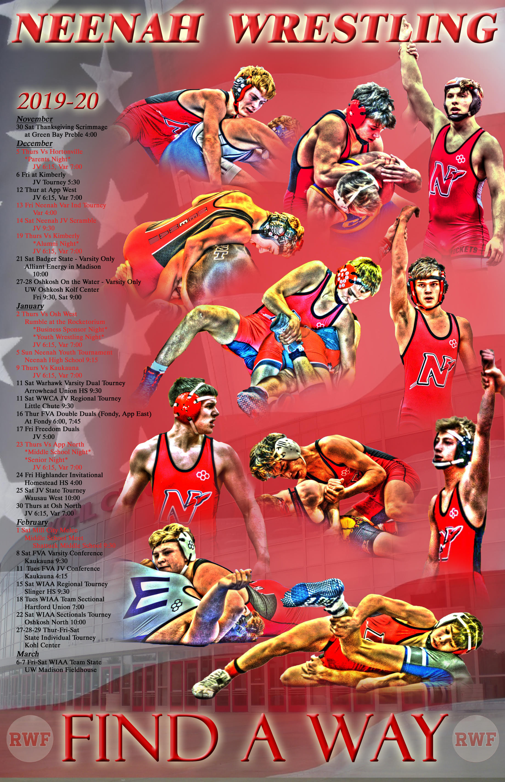

Thursday July 9th2020 6:00 pm
Bridgewood Hotel

2019-2020 Neenah Wrestling Team

Freshman (11): Eli Gast, Ben Hansen, Preston Hella, Nathan Heller, Zach Kramp, Kaiden Lambert, Tristan McConico, Nick Novak, Eric Schaufelberger, Roger Seelow, Jayden Sheppard

Sophomores (7): Charlie Alft, Bryce Fochs, Caleb Letson, Austin Lewis, Adam Meyers, Davin Munoz, William Rambert

Juniors (8): Tyler Beauchamp, Bryce Crook, Drake Hayward, Hannah McCormick, Evan Piechocki, Ethan Quella, Kenny Schaufelberger, Myles Steward

Seniors (3): Jennsey Fermin, Marshall Kools, Ramon Manka-Wigfall

Team Managers (5): McKenna Herm, Jordan Fitzgerald, Natalie Flom, Brianna Fochs, Lexi Novak

Head Coach: Kyle Kleuskens
Junior Varsity Coach: Chris Rundquist
Varsity Assistant Coach: Mark Cowling
Volunteer Assistants: Mason Bohm
Corey Knudsen
Kevin Beauchamp
Brian Piechocki
Ryan Robillard
Cory Zuberbier
Jason Kurszewski

Strength and Conditioning Jason Barber
Principal: Brian Wunderlich Athletic Director: Michael Elkin
Assistant AD: Lisa Dohr

2019-2020 Varsity Dual Meet Scores
Team | Score |  |  | Result
Hortonville | 42 | 32 |  | WIN
Appleton West | 72 | 3 |  | WIN
Kimberly | 32 | 33 |  | Loss
Oshkosh West | 54 | 18 |  | WIN
Kaukauna | 10 | 58 |  | Loss
Bay Port | 30 | 36 |  | Loss
Winneconnie | 51 | 27 |  | WIN
Hartland Arrowhead | 43 | 34 |  | WIN
Fond du Lac | 59 | 18 |  | WIN
Appleton East | 70 | 7 |  | WIN
Appleton North | 56 | 18 |  | WIN
Oshkosh North | 48 | 18 |  | WIN
West Bend East | 36 | 25 |  | WIN
Stoughton | 24 | 45 |  | Loss
 | W | L
Conference | 7 | 2
Non-Conference | 2 | 1
WIAA Series | 1 | 1
Total Record | 10 | 4
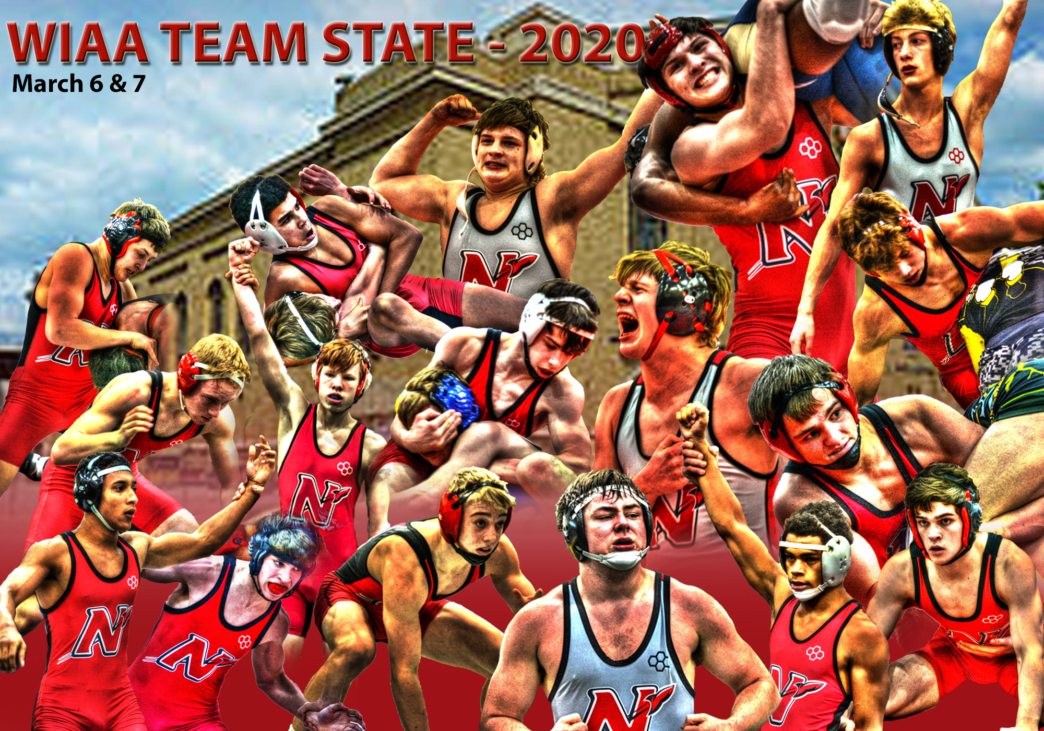

2019-2020 Notable Varsity Team Accomplishments
- 2019 Neenah Varsity Invite Champions (13 Teams)
- 2019 Badger State Invite 4th Place (22 Teams)
- 2019 Oshkosh on the Water 9th Place (67 Teams)
- 2020 Hartland Arrowhead Duals Runner-Up
- 2020 Highlander Invite 3rd Place (27 Teams)
- 2020 FVA Conference Tournament 3rd Place (10 Teams)
- 2020 WIAA Regional Champions (8 Teams)
- 2020 WIAA Team Sectional Champion
- 2020 WIAA Team State Qualifiers
- 11 WIAA Individual Sectional Qualifiers
- 5 WIAA Individual State Qualifiers
- Top 10 WIAA Individual State Team (10th)

2019-2020 J.V. Individual Accomplishments

Junior Varsity Season Records: (Min .250 Winning %)
Name Record Winning%
Charlie Alft 6-3 .667
Ben Hansen 9-8 .529
Preston Hella 9-9 .500
Nathan Heller 1-3 .250
Eli Gast 11-5 .688
Zach Kramp 8-8 .500
Tristan McConico 2-2 .500
Nick Novak 15-4 .789
Ethan Quella 3-8 .273
William Rambert 7-6 .538
Eric Schaufelberger 11-5 .688

JV Season Pins (Min: 5 Pins)
Name Pins
Eli Gast 10
Eric Schaufelberger 10
Preston Hella 8
Ben Hansen 8
Nick Novak 8
Zach Kramp 5

2019-2020 Varsity Individual Accomplishments

Varsity Season Records: (Min of 8 Matches)
Name Record Winning %
William Rambert 11-6 .647
Evan Piechocki 18-10 .643
Tyler Beauchamp 25-13 .658
Jayden Sheppard 29-13 .690
Charlie Alft 13-7 .650
Ramon Manka-Wigfall 24-16 .600
Austin Lewis 24-17 .585
Drake Hayward 39-8 .830
Myles Steward 3-8 .273
Jennsey Fermin 2-6 .250
Kenny Schaufelberger 14-21 .400
Bryce Crook 22-17 .564
Davin Munoz 21-20 .512
Marshall Kools 46-0 1.000
Caleb Letson 24-19 .558
Bryce Fochs 31-10 .756

Varsity Season Records Pins: Min of 8 Pins
Name Pins
Marshall Kools 29: School Record
Bryce Fochs 28: 2nd Most Single Season
Drake Hayward 21
Ramon Manka-Wigfall 16
Jayden Sheppard 14
Tyler Beauchamp 14
Caleb Letson 13
Kenny Schaufelberger 11
Davin Munoz 10
Austin Lewis 8

2019-2020 Notable Tournament Accomplishments

Kimberly Friday Night JV Invite 12/6/2019
Name Place WT
Preston Hella 1st 106
Ben Hansen 2nd 126

Neenah Varsity Invite 12/13/2019: Top 3 Medal
Name Place WT
Evan Piechocki 1st 106
Marshall Kools 1st 195
Tyler Beauchamp 2nd 113
Austin Lewis 2nd 138
Drake Hayward 2nd 145
Jayden Sheppard 3rd 120
William Rambert 3rd 106
Nick Novak 3rd 113
Charlie Alft 3rd 132
Ramon Manka-Wigfall 3rd 138
Bryce Crook 3rd 170
Davin Munoz 3rd 182

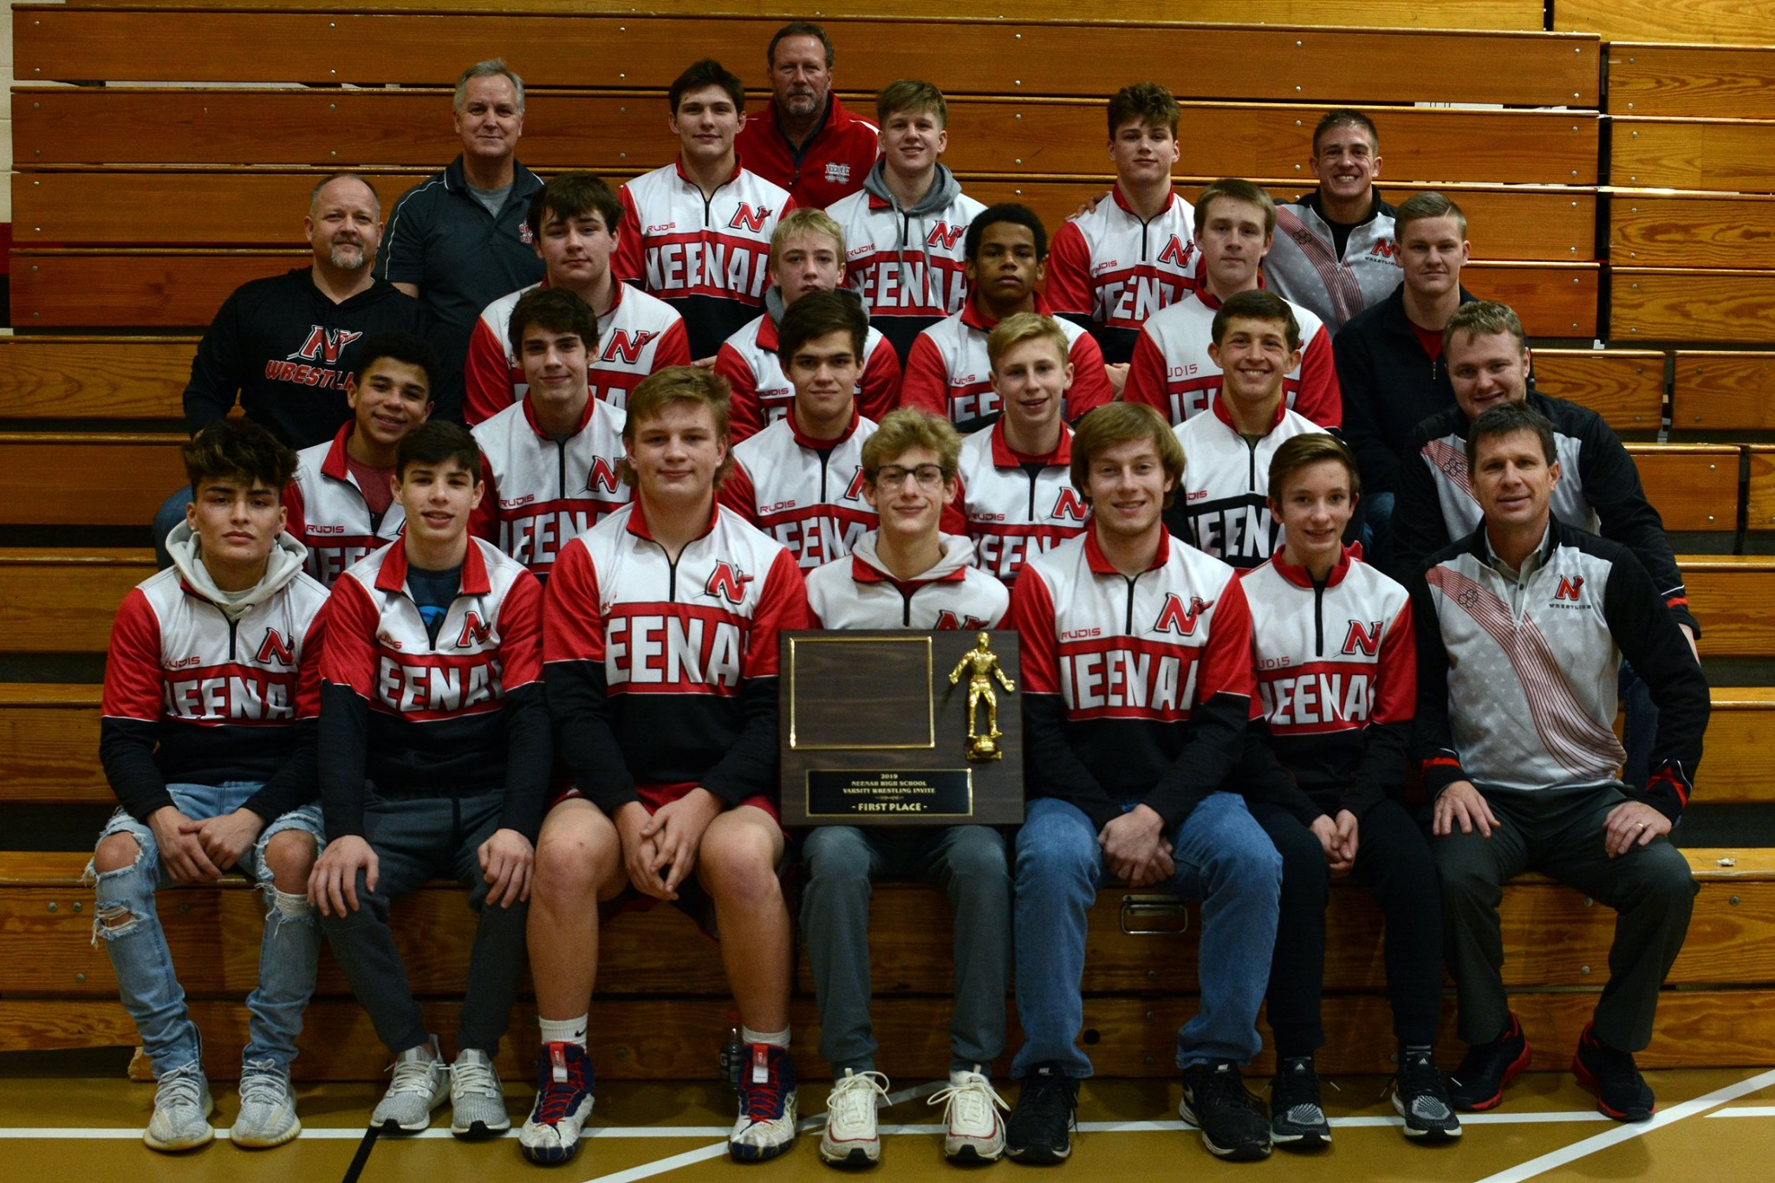

Neenah JV Scramble 12/14/2019 Top 3 Medal
Name Place WT
Eli Gast 2nd 160
Zach Kramp 3rd 120
Ben Hansen 3rd 126

Badger State Invitational 12/21/19 Top 8 Podium
Name Place WT
Marshall Kools 1st 195
Jayden Sheppard 3rd 120
Tyler Beauchamp 4th 113
Dante Caiani 4th 126
Evan Piechocki 5th 106
Drake Hayward 5th 145
Austin Lewis 6th 138
Caleb Letson 6th 285
Davin Munoz 7th 182
Ramon Manka-Wigfall Cons Champ 138
Bryce Fochs Cons Champ 220

Oshkosh on the Water 12/27-28/19 Top 12 Place
Name Place WT
Marshall Kools 1st 195
Drake Hayward 2nd 145
Evan Piechocki 8th 106
Tyler Beauchamp 11th 113

WWCA Regional @ Little Chute 1/12/2020
Top 3 JV State Qualifier
Name Place WT
Nick Novak 1st 113
Eric Schaufelberger 1st 220
Charlie Alft 3rd 126

Hartland Arrowhead Duals 1/11/2020
Name Record WT
Ramon Manka-Wigfall 3-0 132
Drake Hayward 3-0 145
Marshall Kools 3-0 195
Bryce Fochs 3-0 220/285

Highlander Invitational @ Homestead 1/24/20
Name Place WT
Marshall Kools 1st 195
Drake Hayward 2nd 145
Jayden Sheppard 3rd 120
Bryce Fochs 3rd 285
Tyler Beauchamp 5th 113
Ramon Manka-Wigfall 6th 132
Davin Munoz 7th 182
Caleb Letson 8th 220
Bryce Crook 9th 170

WWCA JV State @ Wausau West 1/25/20
Name Place WT
Nick Novak 6th 113
Eric Schaufelberger 8th 220
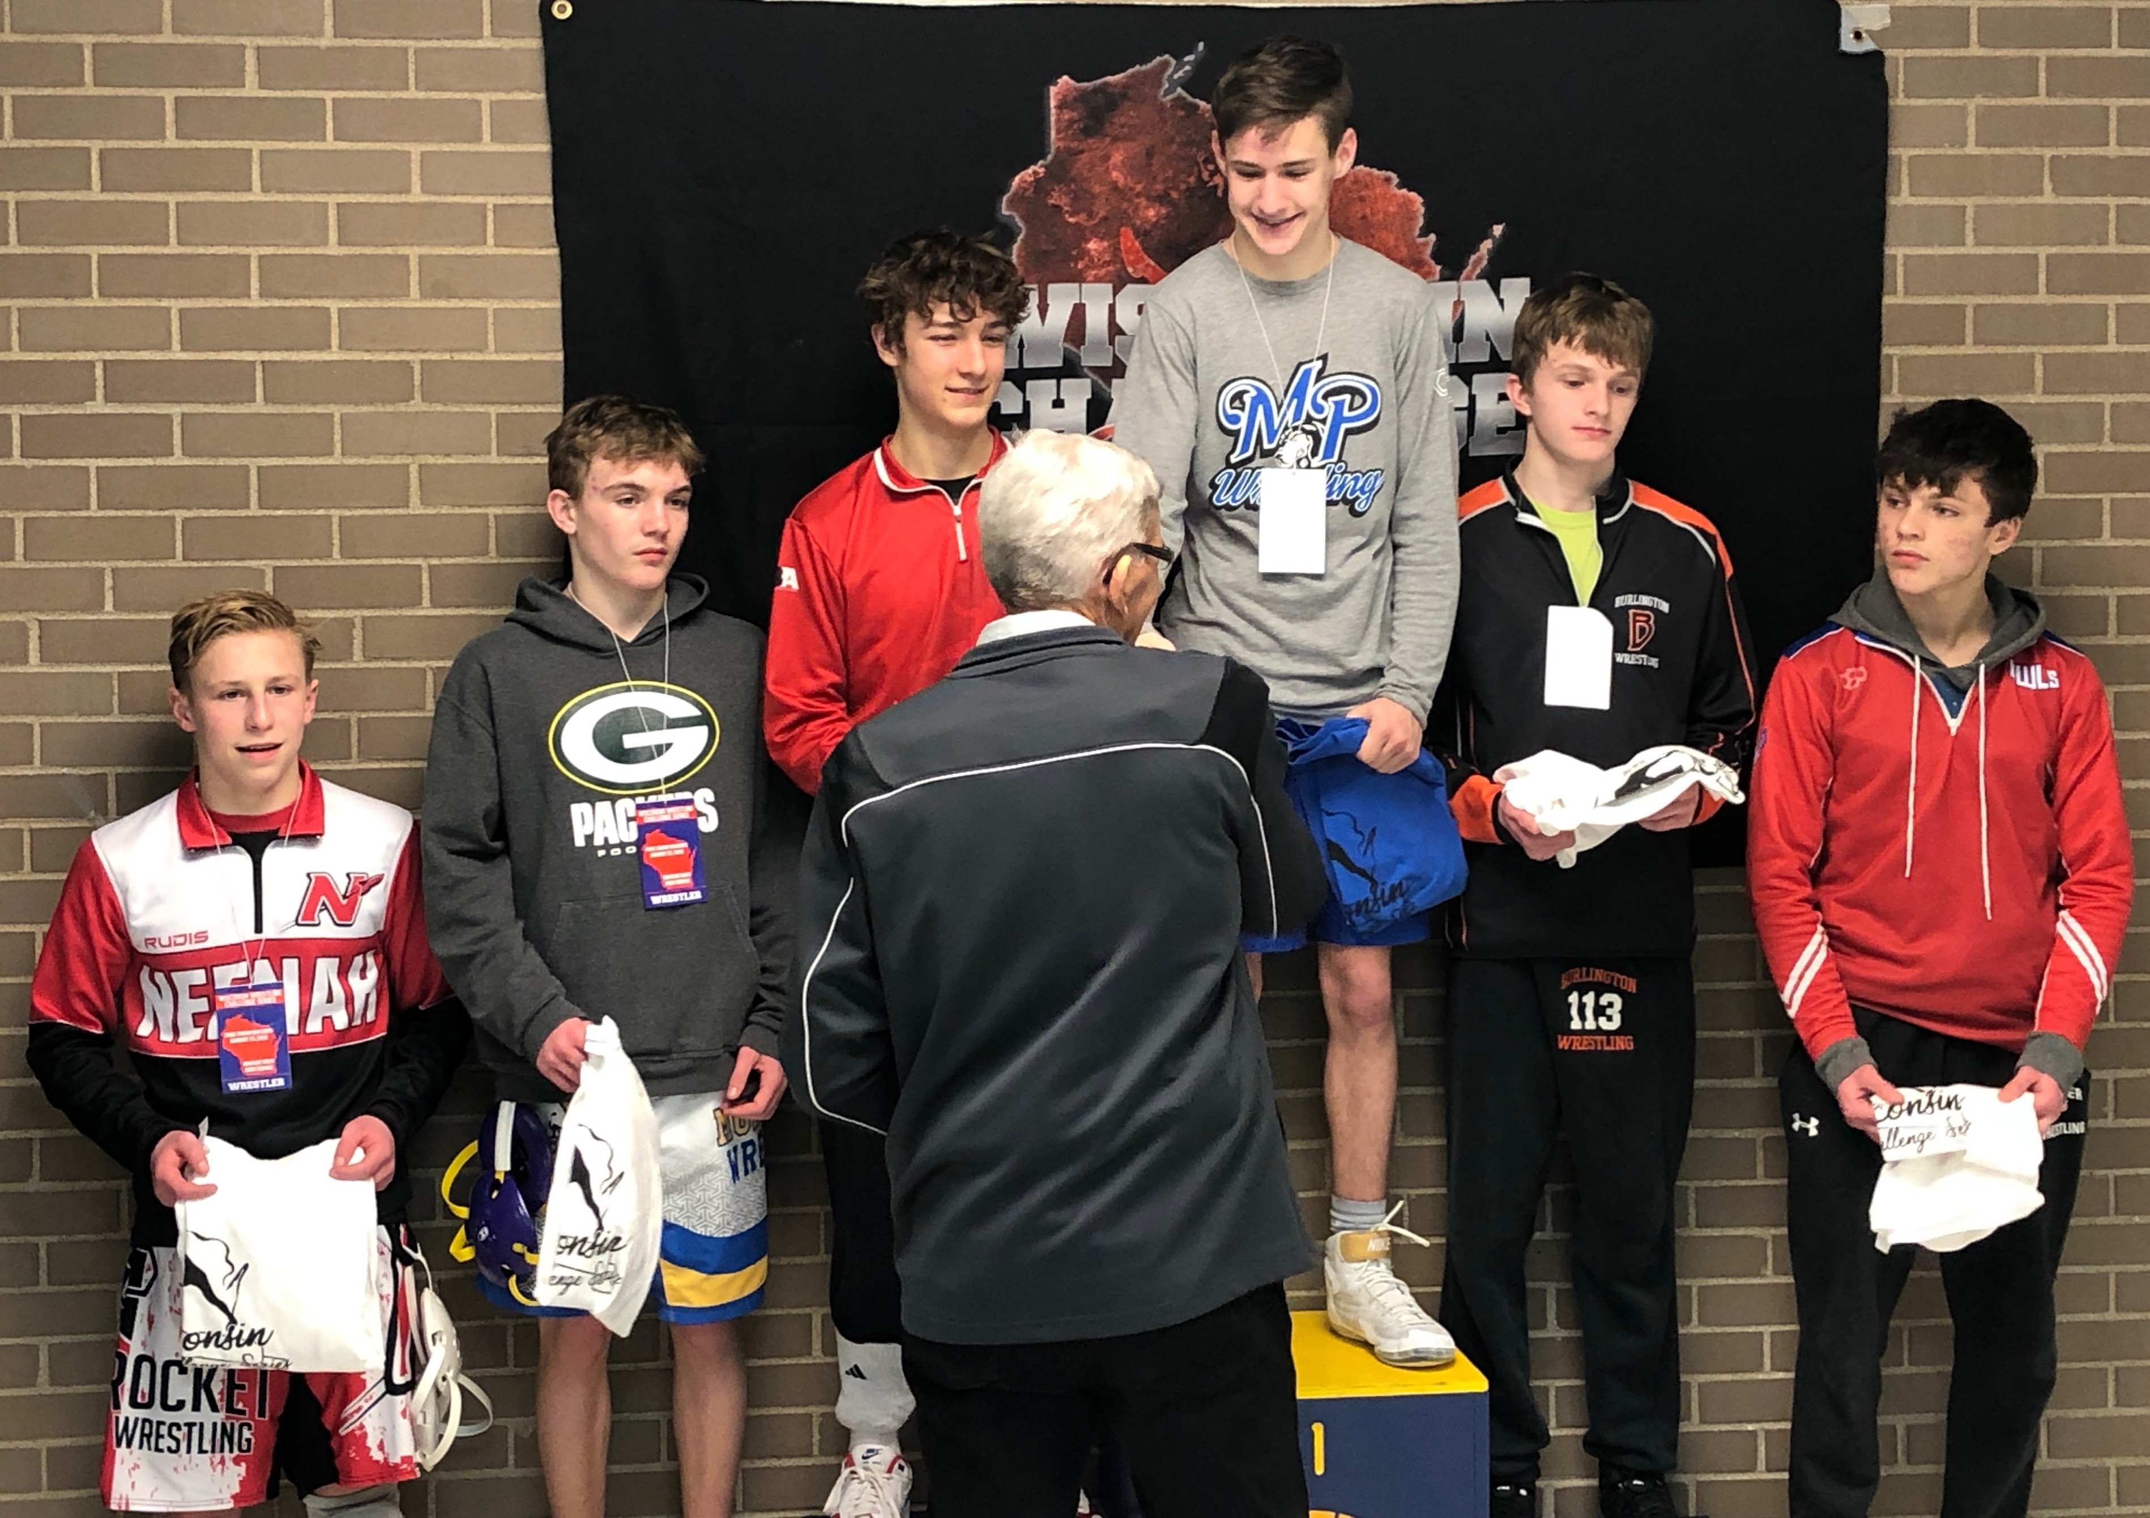

FVA Conference Tournament @ Kaukauna 2/8
Top 3 All FVA Conference
Name Place WT
Drake Hayward 1st 145
Marshall Kools 1st 195
Jayden Sheppard 2nd 120
Charlie Alft 3rd 126
Bryce Fochs 3rd 285
Evan Piechocki 4th 113
Ramon Manka-Wigfall 4th 132
Austin Lewis 4th 138
Caleb Letson 4th 220
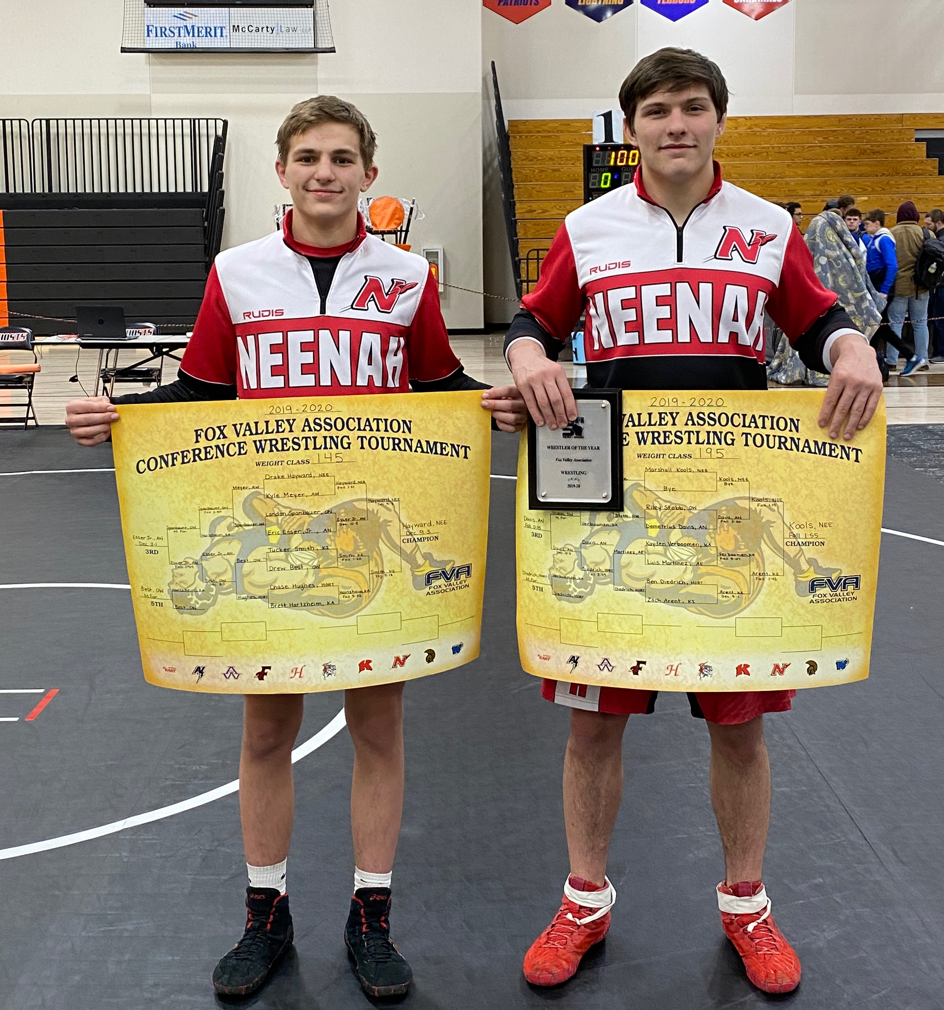

FVA J.V. Conference @ Kaukauna 2/11
Name Place WT
Nick Novak 1st 113
Eli Gast 1st 152
Jennsey Fermin 1st 152
Eric Schaufelberger 1st 220
Zach Kramp 2nd 120
Myles Steward 2nd 152
WIAA Regionals @ Slinger 2/15/2020
Top 4 Place-winners Qualify for WIAA Individual Sectionals
Name Place WT
Drake Hayward 1st 145
Bryce Crook 1st 170
Marshall Kools 1st 195
Caleb Letson 1st 220
Bryce Fochs 1st 285
Jayden Sheppard 2nd 120
Tyler Beauchamp 3rd 106
Evan Piechocki 3rd 113
Austin Lewis 3rd 152
Davin Munoz 3rd 182
Ramon Manka-Wigfall 4th 132

WIAA Sectionals @ Oshkosh North 2/22/2020
Top 2 Place-winners Qualify for WIAA Individual State
Name Place WT
Bryce Crook 1st 170
Marshall Kools 1st 195
Jayden Sheppard 2nd 120
Drake Hayward 2nd 145
Caleb Letson 2nd 220
Bryce Fochs 3rd 285
Tyler Beauchamp 4th 106
Davin Munoz 4th 182

WIAA Individual State Tournament
Top 6 Place-winners Podium
Name Place WT
Marshall Kools 1st 195
Drake Hayward 5th 145

WIAA TEAM STATE TOURNAMENT
Neenah 24 Stoughton 45

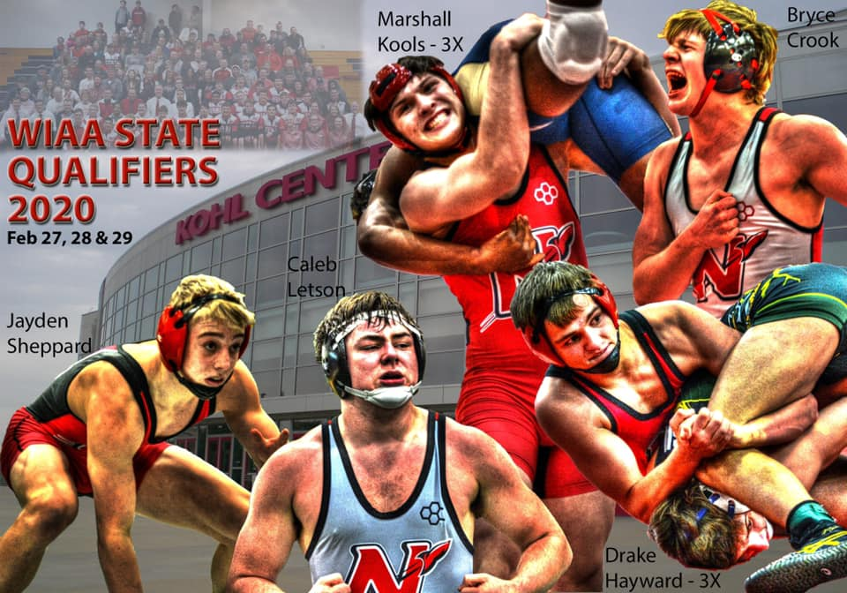

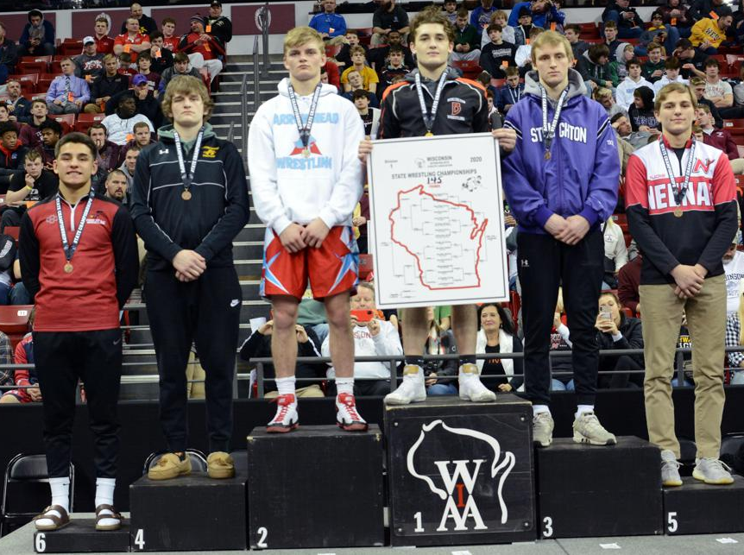

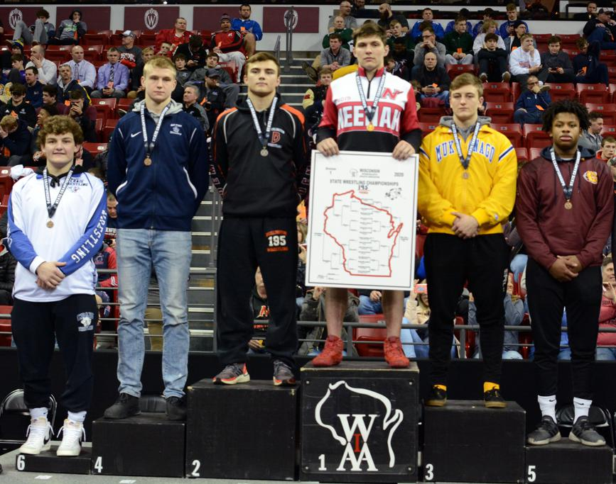

Fox Valley Association Conference (FVA)

Neenah Overall Place: 3rd Place

FVA Team Dual Record: 7-2
FVA Tournament Finish: 3rd

FVA Varsity Team Dual Standings
Team Record
Kaukauna 9-0
Kimberly 8-1
Neenah 7-2
Hortonville 5-4
Oshkosh North 5-4
Oshkosh West 5-4
Fond du Lac 3-6
Appleton North 2-7
Appleton West 1-8
Appleton East 0-9

FVA Varsity Tournament Standings
Team Points
Kaukauna 277.0
Kimberly 170.5
Neenah 160.5
Hortonville 117.5
Oshkosh West 109.5
Fond du Lac 105.0
Oshkosh North 101.0
Appleton North 89.0 Appleton West 63.0
Appleton East 2.0

Final FVA Overall Dual/Tournament Standings
Team Points
Kaukauna 23.5 Points
Kimberly 21.0 Points
Neenah 18.5 Points
Hortonville 14.5 Points
Oshkosh West 13.5 Points
Oshkosh North 11.5 Points
Fond du Lac 9.5 Points
Appleton North 6 Points
Appleton West 3.5 Points
Appleton East 1 Point
Neenah FVA All Conference Selections:
Name Team WT
Marshall Kools 1st 195
Drake Hayward 1st 145
Jayden Sheppard 2nd 120
Charlie Alft HM 126
Bryce Fochs HM 285

FVA Coach of the Year: Ben Engelland Kimberly
FVA Wrestler of the Year: Marshall Kools Neenah

All State Scholar Athletes
Name Grade
Jayden Sheppard 9
Charlie Alft 10
Bryce Fochs 10
Tyler Beauchamp (2X) 11
Drake Hayward (3X) 11
Evan Piechocki 11
Marshall Kools (3X) 12
Ramon Manka-Wigfall 12
Neenah Wrestling Academic Team
Above 3.0 GPA Fall Semester or 3.25 Cumulative
Tim McCarthy | 158 | 2000-2004
Marshall Kools | 148 | 2016-2020
Beau Yineman | 146 | 2014-2018
Sam Engelland | 146 | 2004-2008
Ben Engelland | 144 | 2002-2006
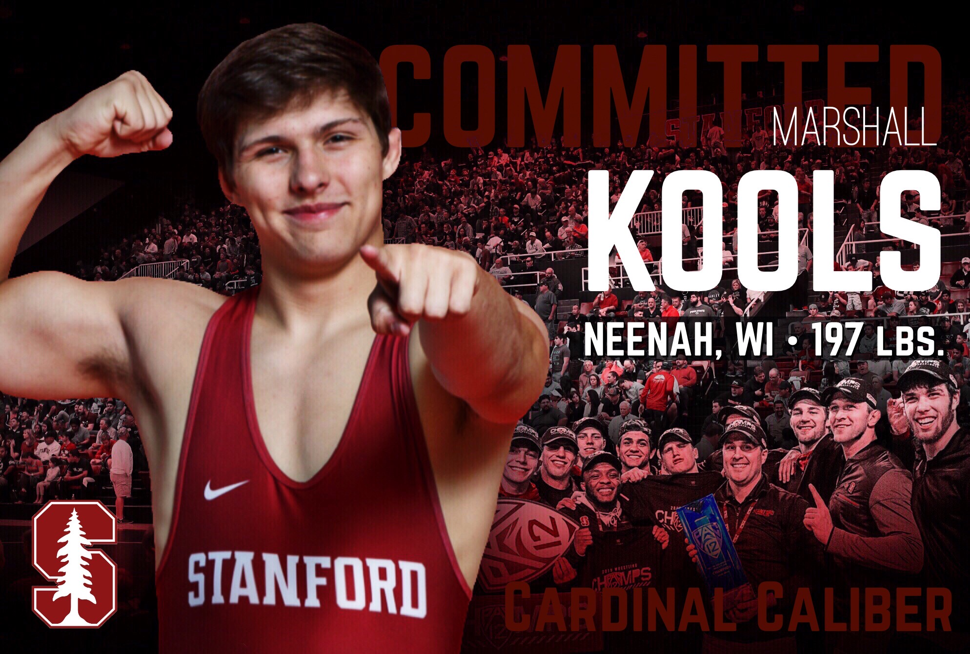
Name Gr.
Eli Gast ** 9
Ben Hansen ** 9
Preston Hella * 9
Nathan Heller 9
McKenna Herm** 9
Zach Kramp * 9
Nick Novak* 9
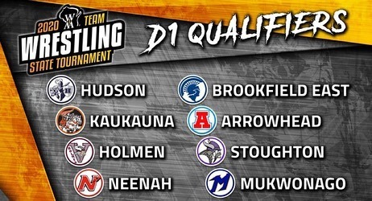
Eric Schaufelberger 9
Roger Seelow 9
Jayden Sheppard * 9
Charlie Alft * 10
Bryce Fochs * 10
Austin Lewis 10
Davin Munoz 10
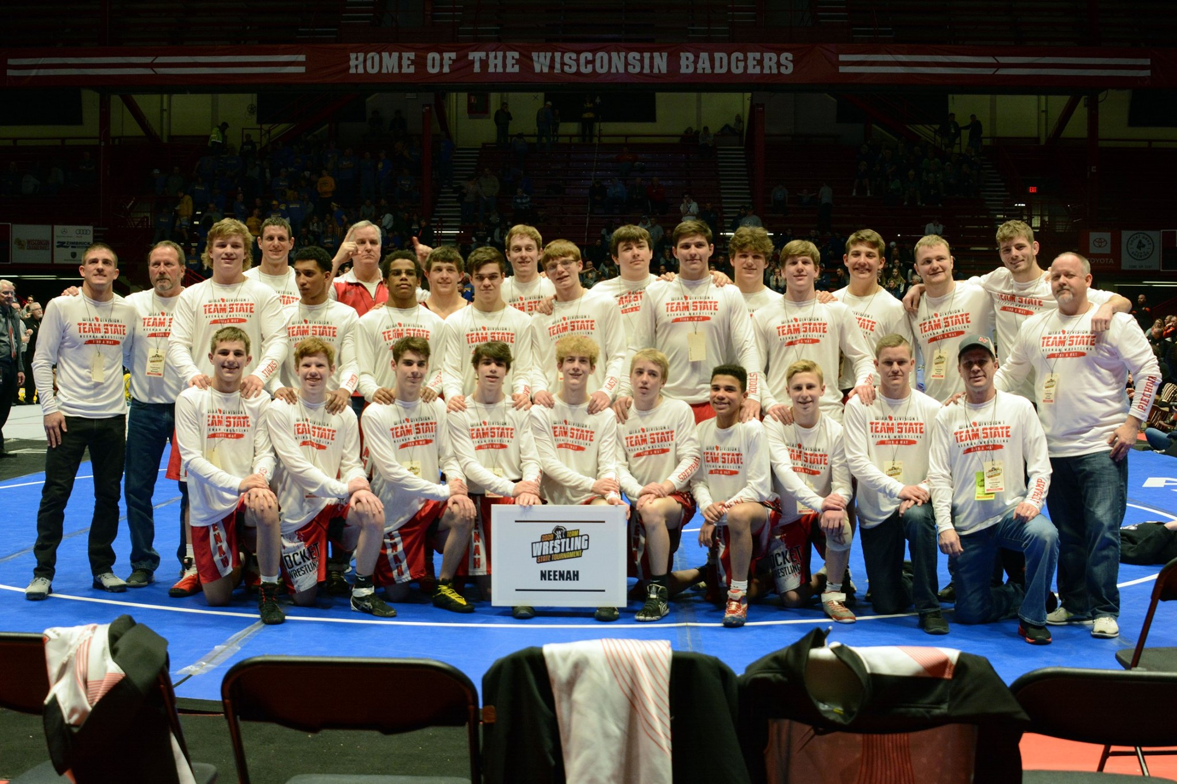
Tyler Beauchamp * 11
Jordan Fitzgerald 11
Natalie Flom * 11
Drake Hayward * 11
Hannah McCormick 11
Evan Piechocki 11
Kenny Schaufelberger * 11
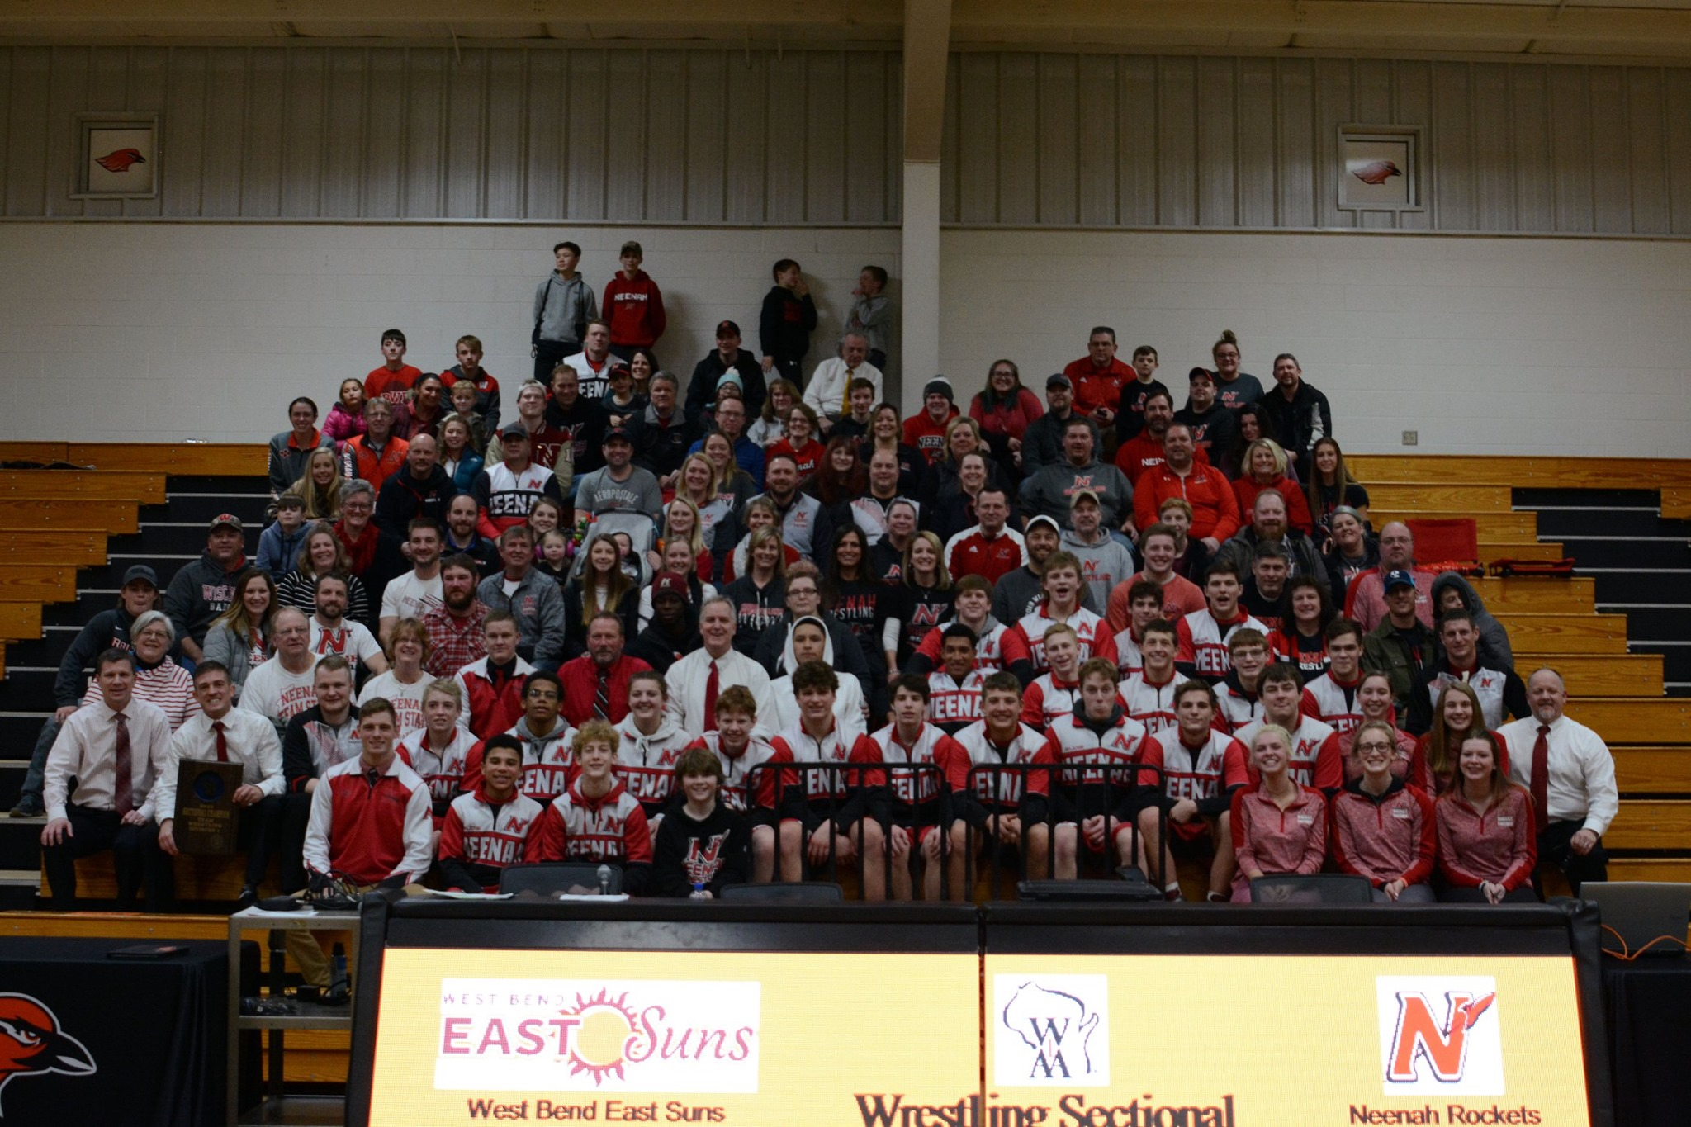
Jenssey Fermin 12
Brianna Fochs * 12
Marshall Kools * 12
Ramon Manka-Wigfall 12
Lexi Novak * 12

Team Members with 2.5 or Higher = 31/34 = 91%
Team Members with 3.0 or Higher = 26/34 = 76%
Team Members with 3.5 or Higher = 17/34 = 50%
Team Members with 3.75 or Higher = 9/34 = 26%

* Above 3.5 GPA ** 4.0 Student

Neenah HS Wrestling Career All-Time Wins

