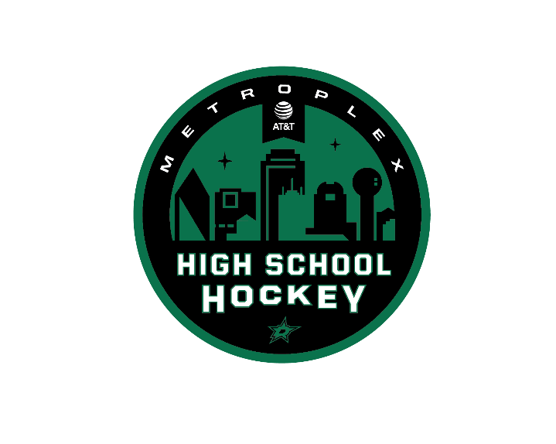

2018-2019 Season at a Glance
Important Dates to Remember!

League Informational OPEN HOUSE for Teams & NEW Parents & Players:
6:30 PM, Thursday August 9th at Farmers Branch.

Tentative Team Declarations for 2018-2019 Season: August 10th

Official Team Declarations for 2018-2019 Season: August 31st

AT&T High School Hockey League Open Tryout: Aug 16th 6:30 PM Farmers Branch. If you attend a school without a team and/or your school is not officially affiliated with a team you must attend the Open Tryout. For more information contact Keith Andresen at kandresen@dallasstars.com

Annual Fall Meeting: August 16th at DPSC-Farmers Branch 6:30 pm
** Membership Application, Coaches Information and 50% Team Fee deposits are due at this time

Mandatory Leveling Showcase: September 8th & 9th

Regular Season Begins: September 20th (Varsity Gold, Silver & Bronze) and September 23rd (JV)

Senior Night: (Choose One) Any January or February Date (must notify League in advance)

TAHA Texas Cup State Tournament: Tentative January 25-27, 2018 (Sites TBD)

Varsity Silver and Gold Regular Season Ends: February 14th

Varsity Bronze and JV Regular Season Ends: February 10th

Varsity Gold & Silver City Playoffs: February 21st – March 7th

Varsity Bronze & JV City Playoffs: February 24th – March 7th

USA Hockey HS National Tournament: March 28-April 1 (Cleveland, Ohio)

Awards Night at a Dallas Stars Game: TBD

Americas High School Showcase (St. Louis, MO): TBD

For question regarding the League please contact Keith Andresen
kandresen@dallasstars.com

