Brampton Minor Lacrosse Association – Rep Team

Dear Perspective Sponsor,
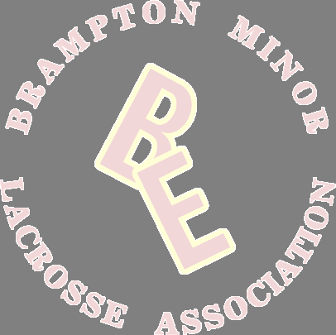
Lacrosse is a major thread in the fabric of Brampton, and indeed Canada’s heritage, with records indicating that the game has been played in our community for 130 years. Brampton Minor Lacrosse offers recreational and representative Lacrosse programs in Box Lacrosse, Field Lacrosse and Girl’s Field Lacrosse to over 800 children aged 4 to 21.

The Brampton Minor Lacrosse Association is proud to be represented by the BMLA Excelsiors Lacrosse team as they travel to communities throughout Southern Ontario during the upcoming season. Our U?? Rep team with players born in 20?? and 20?? for the 202? season will be participating in our zone with teams from Mississauga, Oakville, Halton Hills, Mimico, Orangeville and Newmarket. We will also be participating in tournaments in Hamilton and Brampton while our team’s ultimate goal is to proudly represent our City at the Ontario provincial qualifier in, Kitchener and Whitby this July The boys play an average of 25 games in 12 weeks along with 20+ practices. The exposure and the experience of the game at this competitive level will be a true benefit for the kids for years to come.

The BMLA U15 Rep Excelsiors team depends on the support of our community and sponsors to help make our team’s goal a reality. We reach out to you for your support.

Areas of support range We are in need of jersey sponsorship at $300 per player (includes the home and away jersey) or $600 team wear sponsors that will support our branded game wear such as team dry fits or $1000 team wear sponsors that will support our branded Team Polo shirt that players will wear to games.(artwork to be supplied in .eps or vector format)

*cheques made payable to Brampton Minor Lacrosse or e-transfer to bmla1943@gmail.com for all sponsorship*

Thank You for your support!

BMLA Representative Team Sponsor Form
Team Sponsored:
Company Name:
Company Address:
Company Telephone:
Company Website:
Company Contact:
 | $
Team Wear Sponsorship Donation Amount Jersey Sponsorship | $
Team Wear Sponsorship Donation Amount Jersey Sponsorship | $
Company Name as to appear on Jersey (for Jersey Sponsorship):
Which player if there is a preference:
Title Sponsor - Please attach jpeg of Company logo to post on BMLA website

