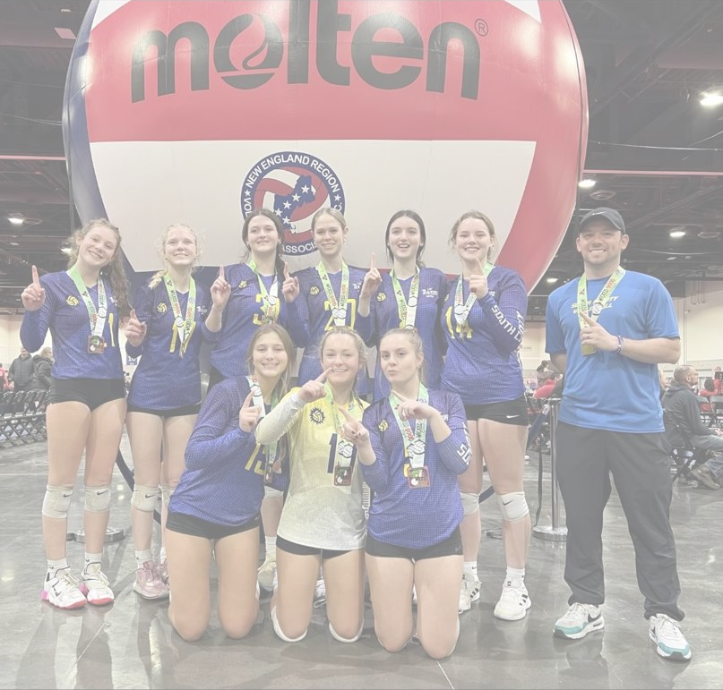
College Recruiting Guide

Recruiting Coordinator – Sebastian Noordzy
(401) 864-1480 | SCVBSeb@gmail.com | @SouthCountyVolleyball

Table of Contents

Introduction
Getting Started
Year by Year Overview
Calendars and Timelines
Recruiting Templates
FAQs
NCAA Athlete Contact Rules
Terms to Know

Introduction

The recruiting process can be daunting for people just started. Our goal at South County, is to help relieve stress during the recruiting process by breaking the process down into manageable parts to help our athletes find their homes after their club experience. We are not here to do all the work for you, but to provide the tools to you to take ownership in YOUR recruiting process. Put in the work during Grades 9-11 to have options during your Junior and Senior year.

South County has sent boys and girls to colleges across all divisions and levels, but the most important factor is that these student-athletes loved the college first and volleyball was the awesome cherry on top. You’ll spend more time away from volleyball in college than you will spend with volleyball so make sure you love your choice!

Any Questions?

Recruiting Coordinator
Sebastian Noordzy
(401) 864-1480
SCVBSeb@gmail.com

Getting Started
Set yourself up with these few key steps to get the recruiting ball rolling
- Create an email specific for recruiting to keep yourself organized and coaches can easily identify you. NamePositionHSGradYear@gmail.com is a great format. (Ex. SebNoordzyOH2024@gmail.com ) Make sure parents have access to ensure follow-up.

- Create Social Media Pages. More and more coaches and programs are using Social Media, especially Instagram and Twitter, and social media is an easy way to post highlights and updates for coaches to see. You can use the same format as your email. (Ex. @SebNoordzyVB2024)

- Create and update your Free University Athlete Profile before tournaments. Every athlete on a USAV Roster is in UA which makes it the universal database for colleges at club tournaments. Update contact information, jersey #, position, etc. so coaches can see if you fit their college profile and their program needs

- Film, Film, Film. If your team uses Hudl you can access your team’s film and create highlights. If you don’t have Hudl, you can easily film on your phone and use iMovie to create your own highlights. Highlights are used to quickly gain interest from coaches and full game matches are to see your complete level of play. Most coaches only have 1-3 minutes to spend watching film so full matches are usually for later down the road in recruiting.

- Research a few schools a week. Look at the school to see if it’s a good fit for you, then look at the volleyball program. If you are unsure of the level of the program, a lot of universities have archived matches on their website or on Youtube.

Year by Year Overview

Every year you should be prioritizing Academics and getting better at volleyball. This will help you to be the best candidate possible for the schools interested in you.
Freshman – Be the best STUDENT and LEARNER you can be. Volleyball at this age should be all about growth and very rarely are colleges looking at freshmen as prospective student-athletes. Have fun, work hard, and get as good as you can to help set yourself up for success in the future. You and your family can start thinking about what you want out of a college experience. This will help guide the rough draft of colleges you’ll investigate during your Sophomore Year.
Sophomore - Start creating and updating a broad list of schools you may be interested in. Reach out to coaches with a personalized email, highlight video, and start getting on coaches’ radars. On June 15th AFTER your sophomore year, Division 1 and 2 coaches can have back and forth contact with you (Division 3 can contact you whenever) so use this time to attend summer camps of colleges you may be interested in. If you are interested in Div 1 or Div 2, make sure to register with the NCAA Eligibility Center at eligibilitycenter.org
Junior – Narrow down your list of schools and communicate often with the coaches and schools you are interested in. There’s no right or wrong answer as to how many schools should be on this list. It could be 15-30 or it could be 8-12. It’ll depend on how interested you are in the schools and how far along you are in the recruiting process. Different schools have different timelines (Division 1 and 2 are earlier than Division 3) so make sure you communicate timelines with coaches. Talk to your guidance counselor and make sure you’ll graduate on time with the required courses and take your SAT/ACT’s (some colleges are test optional, but it’s still good to take them)
Senior – Decision time! Communicate with coaches your realistic chances of making the team and next steps in the recruiting process. Div 3 makes their decisions around Fall/Winter depending on the program and Div 1 or 2 may have already confirmed a roster spot with you. Apply to the schools you are interested in (even if you know you only want to go to your first choice) and that will help inform decisions.

Calendars and Timelines

NCAA Recruiting Calendars
Freshman Year
- Research 2-3 schools per week
- Make a broad list of approx. 50 potential schools
- Gather film and make a highlight video
- Visit some local colleges and/or attend local summer camps
  - Athletes can talk to colleges about camps before June 15th after Soph year.
- Get on coaches’ radar by sending an intro email with video
Sophomore Year
- Gather film and make highlight videos for each tournament
- Continue to research schools, and start to refine/narrow your list.
- Continue to reach out to coaches more often with interest
- Fill out recruiting questionnaires (can be found on every programs website)
- Attend summer camps before junior year
Key Date: June 15th after Soph Year – Back and forth contact allowed (Div 1/Div 2)
Key Date: August 1st after Soph Year – Official and unofficial visits now allowed (Div 1/Div 2)
Junior Year
- Make highlight videos for each tournament
- Build relationships with coaches via calls and emails
- Narrow down your list and ask coaches where you stand (shouldn’t be on the first call)
- Respond to every coach. It’s ok to politely tell a coach “No, thank you” if you’re 100% certain you are not going to their school, but it’s ok to keep options open at this point.
- Visit schools you are interested in
  - Unofficial Visits – Unlimited Allowed
  - Official visits – Only 5 allowed
Senior Year
- Continue to make visits
- Apply to schools
- Sign and commit to a school and program
  - National Letter of Intent for Division 1 and 2 – Binding contract
  - Ceremonial Letter for Division 3 – Non-Binding
- Find out summer workout schedule and get ready for preseason!

Recruiting Templates

Email to Coach – The introductory email should be personalized to show you did your research and are interested in the college. Coaches can tell if you sent 1 email to multiple coaches. Add things like Coaches name, School name, major you’re interested in at the school, how their season went or something they did on their social media. Use your own voice and let your personality shine!
- Recruiting Email Template

Highlight Video – This is the first chance for a coach to evaluate you as a player! The goal is to capture a coaches attention in the 2-3 minutes of spare time they have. Put your best highlights first and any information in a quick 2-3 minute video for coaches to put you on their “Watch List”
Example Hitter Video | Example Libero/OH Video | Example Setter Video

FAQs

Is it too late to get recruited?
No! It’s not too late. Regardless of age, you can start your recruiting process. Although you’ll need to move fast and the longer you wait, the less spots available at schools you like!
When should I start?
The sooner the better. Generally, you should start towards the end of your freshman year and ramping up Sophomore and Junior Year.
How do coaches find me?
Coaches find you when you make yourself known! There are hundred of volleyball players at tournaments and it’s impossible to see everyone, so coaches will prioritize watching the players that have contacted them.
What should I do on my first call with a college coach?
Make a list of questions you have about the school and the program. Take notes of anything important you learn during the call. The point of the first call is to answer any questions and identify if there is a potential fit.
Sample Questions.
    - What tournaments/recruiting events are you going to?
    - What are your positional needs for my class? Are you recruiting my position?
    - What is your team’s culture like?
    - What is your coaching style/philosophy?

NCAA Athlete Contact Rules

When can Division I coaches contact athletes?
- Any time: Athletes can receive non-recruiting materials from college coaches, such as questionnaires, camp brochures, nonathletic institutional publications and NCAA educational materials published by the NCAA.
- June 15 after sophomore year: Coaches can extend verbal scholarship offers, call athletes and send athletes all forms of private electronic correspondence, including text messages, instant messages, direct messages and emails, as well as all recruiting materials.
- August 1 before junior year: Athletes can begin taking official visits, and they can also arrange unofficial visits with a school’s athletic department and meet with the coach while on campus. Coaches can begin conducting off-campus contact with athletes at their residence or school.

When can Division II coaches contact athletes?
The NCAA Recruiting Rules for Division II schools are slightly more relaxed than those for Division I, and the rules are the same across all sports:
- Non-recruiting materials: Athletes can receive brochures for camps, questionnaires, NCAA materials and non-athletic recruiting publications at any time.
- Printed recruiting materials: Starting July 15 after an athlete’s sophomore year, coaches can begin sending recruits printed recruiting materials.
- Telephone calls: Starting June 15 after an athlete’s sophomore year, coaches can start calling athletes.
- Off-campus contact: Coaches can conduct off-campus communications with athletes and/or their parents starting June 15 after an athlete’s sophomore year.
- Unofficial visits: Athletes can take unofficial visits at any time.
- Official visits: Athletes may start taking official visits starting June 15 after an athlete’s sophomore year.

When can Division III coaches contact athletes?
DIII schools have the most relaxed NCAA recruiting rules of all the division levels. Similar to NCAA DII, they are the same for all sports:
- Recruiting materials: Athletes can receive recruiting materials at any time.
- Telephone calls: There is no limit on when college coaches can call athletes.
- Digital communications: There is no limit on when college coaches can contact athletes digitally.
- Off-campus contact: After the athlete’s sophomore year, college coaches may begin to conduct off-campus communications.
- Official visits: Athletes can begin taking official visits after January 1 of their junior year.
- Unofficial visits: Athletes can make an unlimited number of unofficial visits at any time.

Terms to Know

Contact: A contact happens any time a college coach says more than hello during a face-to-face meeting with you or your parents off the college’s campus.
Contact period: During a contact period, a college coach may have face-to-face contact with you or your parents, watch you compete or visit your high school and write or telephone you or your parents.
Dead period: A college coach may not have any face-to-face contact with you or your parents on or off the college campus at any time during a dead period. The coach may write and call you or your parents during this time.
Evaluation: An evaluation happens when a college coach observes you practicing or competing.
Evaluation period: During an evaluation period, a college coach may watch you compete, visit your high school and write or telephone you or your parents. However, a college coach may not have face-to-face contact with you or your parents off the college’s campus during an evaluation period.
Financial aid: (scholarship) Any money you receive from a college or another source, such as outside loans or grants. Financial aid may be based on athletics ability, financial need or academic achievement.
Five-year clock: If you play at a Division I school, you have five-calendar years in which to play four seasons of competition. Your five-year clock starts when you enroll as a full-time student at any college. Thereafter, your clock continues, even if you spend an academic year in residence as a result of transferring, decide to redshirt, if you do not attend school or even if you go part time during your college career.
Official visit: During an official visit, the college can pay for transportation to and from the college for you, lodging and meals (Division I allows for up to three meals per day) for you and your parents or guardians, as well as reasonable entertainment expenses including three tickets to a Division I home sports event or five tickets to a Division II home sports event. Before a college may invite you on an official visit, you will have to provide the college with a copy of your high school transcript and ACT, SAT or PLAN score (test scores are required for Division I only) and register with the NCAA Eligibility Center.
Quiet period: During this time, a college coach may not have any in-person contact with you or your parents off the college’s campus. The coach may not watch you play or visit your high school during this period. You and your parents may visit a college campus during this time. A coach may write or call you or your parents during this time.
Recruited: If a college coach calls you more than once, contacts you off campus, pays your expenses to visit the campus, or in Divisions I and II, issues you a National Letter of Intent or a written offer of financial aid, you are considered to be recruited.
Recruiting calendar: NCAA member schools limit recruiting to certain periods during the year. Recruiting calendars promote the well-being of college-bound student-athletes and ensure fairness among schools by defining certain periods during the year in which recruiting may or may not occur in a particular sport.
Season of competition: Generally, NCAA rules say that any competition in a season — regardless of the amount of time — counts as having played a season in that sport. If you play any time during a season, regardless of how long you played, it counts as having played for an entire season in that sport. Your season of competition starts when you spend one second in competition on the field, court, gym or track.
Ten-semester/15-quarter clock: If you play at a Division II or III school, you have the first 10 semesters or 15 quarters in which you are enrolled as a full-time student to complete your four seasons of participation. You use a semester or quarter any time you attend class as a full-time student or are enrolled part time and compete for the school. You do not use a term if you only attend part time with no competition or are not enrolled for a term.
Two-year college: An school where students can earn an Associate of Arts (AA) degree, an Associate of Science (AS) degree or an Associate of Applied Science degree within two years. Some people call these schools community colleges or junior colleges.
Unofficial visit: Any visit by you and your parents to a college campus paid for by you or your parents. The only expense you may receive from the college is three complimentary admissions to a Division I home athletics contest or five complimentary admissions to a Division II home athletics contest. You may make as many unofficial visits as you like and may take those visits at any time. The only time you cannot talk with a coach during an unofficial visit is during a dead period.
Verbal commitment: A verbal commitment happens when you verbally agree to play sports for a college before you sign or are eligible to sign a National Letter of Intent. The commitment is not binding on you or the school and can be made at any time.
Walk-on: Someone who is not typically recruited by a school to participate in sports and does not receive a scholarship from the school, but who becomes a member of one of the school’s athletics teams.

