TIME CLOCK
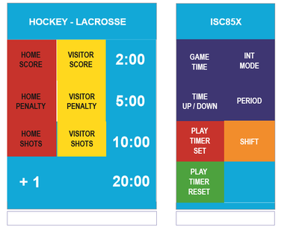
Make sure the screen states down. If not hit the purple Time Up/Down button.
SET TIME:
Press GAME TIME, Enter MINUTES, press enter, enter, enter. (For Mite games press SHIFT & MINS then enter)

PERIODS:
Periods should automatically move up by 1 when you reset the clock at the end of the period.
Manually Change- Press Period then number from key pad.
RUN THE CLOCK:
Switch on the bottom right to stop and run.
GOALS:
Hit HOME SCORE or VISITOR SCORE and the blue +1 button.
PENALTY:
Stop clock and Hit HOME PENALTY or VISITOR PENALTY- Next is the jersey NUMBER, ENTER, then MINUTES, ENTER, SECONDS, enter. (if an even number like 2 minutes just hit enter)
To Enter additional penalties: Hit PENALTY then ENTER three or more times to skip down to the second and third line. To Edit follow up above and press enter to correct line and modify.
To remove a penalty, press HOME PENALTY or VISITOR PENALTY. If the cursor is on the correct penalty, press CLEAR, ENTER, CLEAR, ENTER, CLEAR, ENTER to clear out each field.
Between Periods- Press INT MODE, if need to change time enter the minutes and press enter. Hit INT MODE to end
3 minute warm up and 1 minute between periods.

