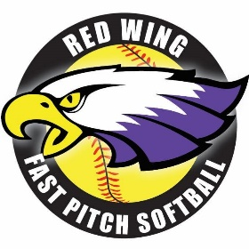

Red Wing Girls Softball Association
Registration 2026

Competitive fastpitch traveling teams are being organized for the upcoming summer season at five possible age levels: High School Division (Ages 15-18), 14 & under, 12 & under, 10 & under and 8 & under. The season lasts from April/May to late July. Each team will compete at one or more invitational tournaments. Parents are expected to assist in transporting the players to/from games.
Teams will consist of approximately 12-16 girls and practices may start as early as April or early May as per individual coach. USA rules are used and players will be expected to give their team priority over conflicting activities.
Teams will be scheduled to play games once per week. All teams typically play double headers with a 65-minute time limit for each game. There will be 1-3 practices held a week in addition to the games. Practice days are decided by each coach.
Once a week games are a change from previous years. RWGSA has elected to make this change to focus on promoting skills and development.

In past years, games were played on these days:
- High School Division - Thursdays (ages 15-18)
- 14U - Mondays or Wednesdays (ages 13-14)
- 12U - Tuesdays or Thursdays (ages 11-12)
- 10U - Wednesdays (ages 8-10)
- 8U - Thursdays (ages 6-8)
If you are interested in coaching for a specific team, please reach out via email to rwgsassociation@outlook.com or by phone to: Levi Dahling @ 651-380-8314 by March 1st.

Uniforms

Uniforms/Required equipment
A jersey will be included in the price of registration. Please be sure to provide jersey size and 2 jersey number choices. (Sample jerseys will be available to try on at the RWGSA Winter Clinic.)

Each player is required to have the following equipment:
- Glove
- Bat (stamped with the USA or ASA logo)
- Batting helmet
- Fielding mask
- Cleats (plastic cleats required for 8U-12U, metal cleats may be used for 14U and above)
- Black softball pants
- Socks (color will be determined and communicated prior to season starting)
- Water bottle
- Batting gloves (optional)
- Sliding shorts (optional)

RWGSA has a limited number of helmets and gloves sized for 8U or 10U to donate to players on a first come first serve basis. Please reach out to rwgsassociation@outlook.com if you are interested. Registration payment must be received in full prior to distribution of these items.

Tournaments

RWGSA will be hosting a home tournament June 20th for 8U teams and June 26-28th for 10U, 12U, 14U and 18U/HS at the Prairie Island sports complex. All Red Wing teams will be participating. The Association has added a $100 volunteer deposit to your registration. Each player family will be responsible for volunteering 4 hours at their home tournament. (4 hours total per player, with a cap at 3 players/12 hours total.) Once this commitment is completed, the $100 deposit will be returned to families via the method of payment. Please communicate if this method does not work for your family and an alternate method is preferred.
Alternative volunteer options throughout the season are available to fulfill this volunteer obligation, if families are not available during the tournament weekend. Examples include but are not limited to team manager, game time book keeping, pre-tournament committee, etc.

In addition to the home tournament, all Red Wing teams will be eligible to participate in 2 extra tournaments, based upon availability.
Tournaments will be scheduled by the individual team coaches and communicated to individual teams.
Volunteering

The RWGSA will be collecting a $100 deposit as incentive to complete requested volunteer hours. In order to streamline this process, this cost has been automatically added to your registration fee.
The deposit is for your volunteer time at our home tournament in June (dates TBD). We rely on parents/families to fulfill these volunteer commitments so we can have a successful tournament. We are requiring 4 hours per player (with a cap at 12 hours/3 players). Once this commitment has been fulfilled, your deposit will be automatically returned to the payment method at registration. If an alternative method of payment for this deposit is preferred, please reach out to rwgsatreasurer@gmail.com.

If you have plans during the tournament weekend or are otherwise unable to attend the tournament, alternative volunteer options throughout the season are available to fulfill this volunteer obligation. Examples include but are not limited to team manager, game book keeping, pre-tournament committee, etc. Team coaches count as fulfilling this volunteer obligation. Please communicate with the association ASAP to make other arrangements for your volunteer commitment. (RWGSAssociation@outlook.com)

Evaluations
RWGSA will be holding evaluations to determine teams on March 8th from 10:00am-3:00pm at Red Wing High School. All players 10U, 12U, 14U, 18U/HS will be required to attend evaluations.
8U players will not be obligated to complete evaluations, unless they would like to be considered for a 10U position. Please note that RWGSA prefers a minimum of 11 players and a maximum of 14 players on a team. With this criteria in mind, teams will be established first based on having an appropriate number of players and second on where a player requests and is qualified to play.
All players will be placed on a team and there will be no "cuts". Players will be evaluated in the areas of throwing, hitting, infield, outfield and speed. Pitching/catching evaluation times will be optional and for those that are interested in playing either position.
Additional details including report times will be communicated closer to the event date.

Payment and Refund Policy
Refund requests will be accepted for players that request this after registering and before evaluations have been completed.
No refunds will be considered after evaluations, unless presented to the board with a written explanation for the refund request and pending board approval.

Scholarship Policy
Red Wing Girls Softball Association has limited funding to assist families with partial payment for the registration fees. A written request for assistance must be complete at the time of registration. The RWGSA Board will review all requests for scholarships.
The scholarship will pay for 50% of the registration fee and the family is responsible for the other 50% of the registration fee prior to the start of the season. Payments may be made for the family’s portion of the registration fee but must be paid in full prior to the player being able to participate in practice or game settings. RWGSA may request additional volunteer time (in coordination w/ the scholarship family) to offset this cost. Failure to complete requested additional volunteer hours may result in denial of future scholarship opportunities.
If you are requesting a scholarship for the season, please contact RWGSA board for an application at: rwgsassociation@outlook.com or Levi Dahling at: 651-380-8314.

An additional resource available to all Red Wing athletes is the “Team Rodge Fund”. Created in memory of coach and school social worker Chris Rodgers, the Team Rodge fund aims to support all youth fully engage in sporting activities. Funds can supplement participation needs aside from registration. Please refer to their website for further details and applications:
https://www.riseuppartnership.org/team-rodge

Red Wing Girls Softball Association
2026 Registration Form

AGE CHART 2026

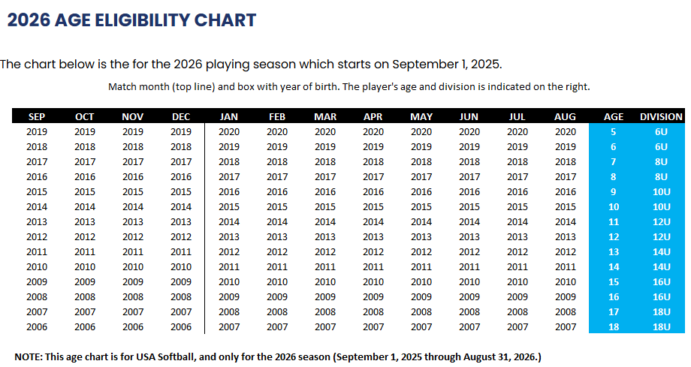

Sign your athlete up according to her date of birth. Please refer to the chart above.

Registration Fee*: Please circle age division according to the age chart on the website

8U - $180 10U - $300 12U - $300 14U - $300 High School Division - $180

Jersey size: YS YM YL YXL AS AM AL AXL

Jersey Number: Choice 1 ____________ Choice 2 _____________

Make checks payable to Red Wing Girls Softball Association, please. They can be mailed to:
RWGSA
PO BOX 210
Red Wing, MN 55066

Player Information:

Name ____________________________________________________________________
Address __________________________________________________________________
Parent Cell _________________________ Player Cell ___________________________
PARENT EMAIL ___________________________________________
Parents/Guardians __________________________________________________________
Age ______ Current Grade ______ Birth date __________

Second Parent (if applicable)
Name ____________________________________________________________________
Address __________________________________________________________________
Phone __________________________________ Cell ___________________________
PARENT EMAIL ___________________________________________

List any planned vacations for June-July: _______________________________________
___________________________________________________________________________

Red Wing Girls Softball Association
Statement of Release

I hereby authorize the Red Wing Girls Softball Association to accept
_________________________________________ as a participant in the Red
Wing Girls Fastpitch Softball Program. I recognize that there are physical hazards in the game of softball and herewith release and hold blameless the Red Wing Girls Softball Association, the Red Wing School District, and City of Red Wing and the coaches from all liability from injury/illness because of our child’s participation in the 2025 softball season.

___________________________________ _______________
Parent/guardian signature Date

___________________________________ _______________
Parent/guardian signature Date

The Mission of the Red Wing Girls Softball Association is to provide Red Wing area girls the opportunity to: participate in youth softball activities, further develop their athletic skills, promote sportsmanship, and develop fundamental skills in the sport.

GUIDELINES FOR PARENTS

- I will encourage good sportsmanship by demonstrating support for all players, coaches and umpires at every game, practice, or other events.
- I will place the emotional and physical well-being of my child ahead of any personal desire to win.
- I will provide support for coaches working with my child to provide a positive, enjoyable experience for all.
- I will remember that the game is for the players and not the adults.
- I will not react negatively or engage in any unsportsmanlike conduct with umpires, opponents, players, coaches or fans.
- I (and my guests) will be a positive role model for my child and encourage sportsmanship by showing respect and courtesy, and by demonstrating positive support for all players, coaches, officials and spectators at every game, practice or other sporting event
- Parents concerns shall be addressed to the board and not the coach after at 24 hour waiting period. The Association will not tolerate any harassment of coaches, parents, umpires players and/or board members.
- Any phone calls should be directed to the association President, Levi Dahling.
(Phone: 651-380-8314) rwgsassociation@outlook.com If deemed necessary, a meeting will be set up between the board, parents and coach.
- Inappropriate actions may result in a warning or suspension by the association board.
- I will provide transportation to out of town games or ensure she has a ride.

_______________________________ ____________________________ ____________
PARENT’S SIGNATURE PARENT’S SIGNATURE DATE

GUIDELINES FOR PLAYERS

1. I will listen to my coaches and respond to them in a positive manner.
2. I will support my teammates’ efforts by using positive statements, actions, and gestures.
3. While in the dugout, I will remain positive by using proper posture and vocal enthusiasm.
4. I will attend practices and games to improve my skills and to help my team succeed.
5. While I’m on the field, I will not react negatively to the officials, opponents, opposing coaches or fans.
6. I understand that I will be removed from the game immediately and not returned for any inappropriate behavior.
7. I understand that I may be suspended from practices, games, or tournaments if I display unsportsmanlike-like behavior and this decision will be made by my coaches and the board officers.

____________________________ ____________________________ ___________
NAME (print) PLAYER’S SIGNATURE DATE

Red Wing Girls Softball Association
Photograph Waiver Form

Red Wing Girls Softball Association (RWGSA) requests permission to photograph your child and use the photographs. The photographs taken, and all rights associated with them, will belong solely and exclusively to RWGSA. The photographs will be used for the RWGSA website, as well as other media tools such as newspapers. The photographs may also be used on t-shirts, posters,
videos, and other materials relating to our program. The photography will be used in a tasteful and professional manner.

I hereby grant permission to RWGSA to use photographs taken at any event to be used on websites, or other media without notifying me. I hereby waive all rights with respect to the photographs, including copyright and privacy rights and the right to inspect or approve the photographs, publications, or electronic matter that may be used in conjunction now or in the future, whether that use is known to me or unknown, and I waive any rights to royalties or other compensation arising from or related to the use of the photographs.

I hereby agree to release and hold harmless RWGSA, its officers, employees, and agents, from and against any claims, damages, or liability arising from or related to the use of the photographs, including, but not limited to any re-use, distortion, blurring, alteration, optical illusion or use in composite form, either intentionally or otherwise, that may occur or be produced in production of the finished product. It is the discretion of RWGSA to decide whether to use the image.

I, as the parent or legal guardian of the below named child, have read this release. I fully understand the contents, meaning, and impact of this release. I agree to the terms of this release and voluntarily grant my permission to RWGSA. I understand that I am free to address any specific questions regarding this release by submitting those questions in writing prior to signing, and I agree that my failure to do so will be interpreted as a free and knowledgeable acceptance of the terms of this release.

_____ No, I do not want RWGSA to photograph my child.
_____ Yes, I give permission for RWGSA to photograph my child

Minor’s Name: ___________________ Minor’s signature: _________________________

Parent/Guardian Name: _________________________________________________________
Parent/Guardian Signature: _________________________________________________________

Phone Number: (____) ____-_________

