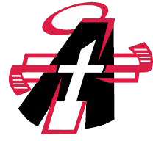FARGO ANGELS YOUTH HOCKEY RAFFLE DRAWING RESULTS

12/7/19

1ST PRIZE $750

2ND PRIZE $700

3RD PRIZE $500

4TH PRIZE $500

5TH PRIZE $500

6TH PRIZE $400

7TH PRIZE $400

8TH PRIZE $250

9TH PRIZE $250

10TH PRIZE $250

$

MATT NOAH KAREN HANKEL MIKE QUINER DUANE ZWINGER

ANDREW KANKELFRITZ

KYLE FROSLIE

ZACH JORDE PATTIE MONTOUR CHRIS LEE

JANE NOBLE