Instructions on how to print your approved tournament rosters
1. Log in to your coach/manager account and click on the "Team Management" button
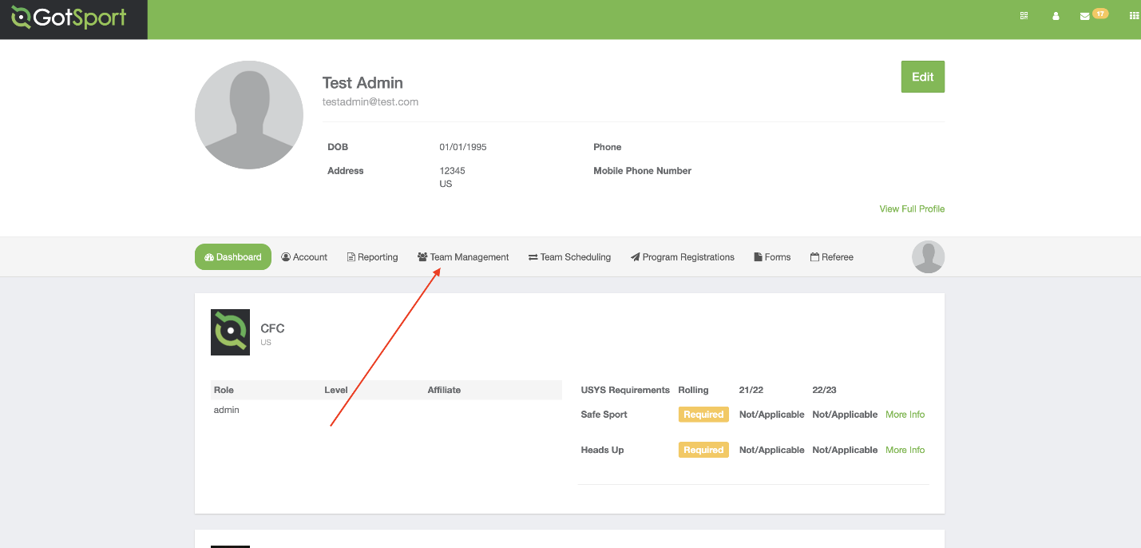
2. Click on the name of the team you are working on
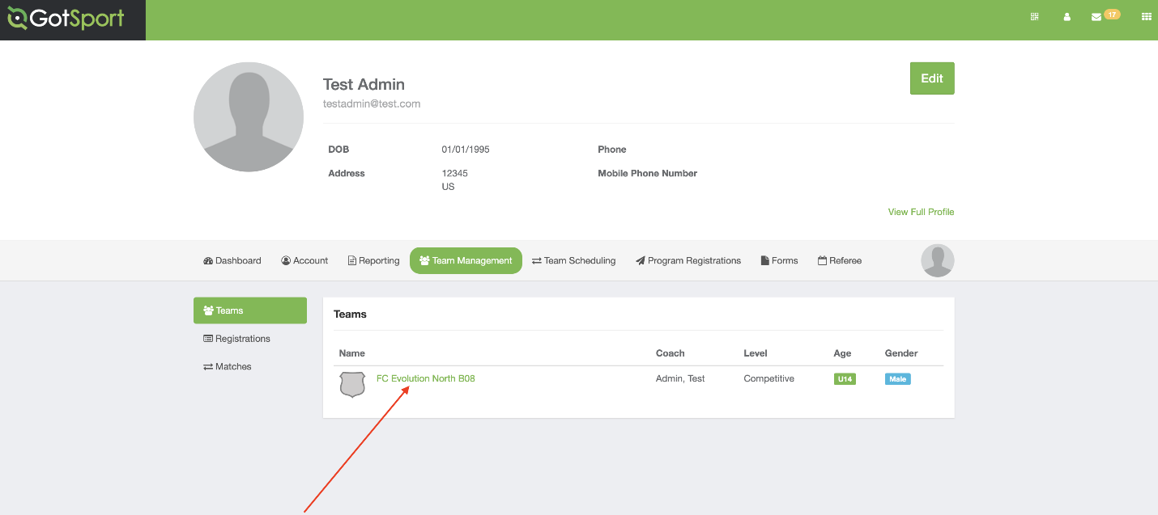
3. Open the "Team Registrations" tab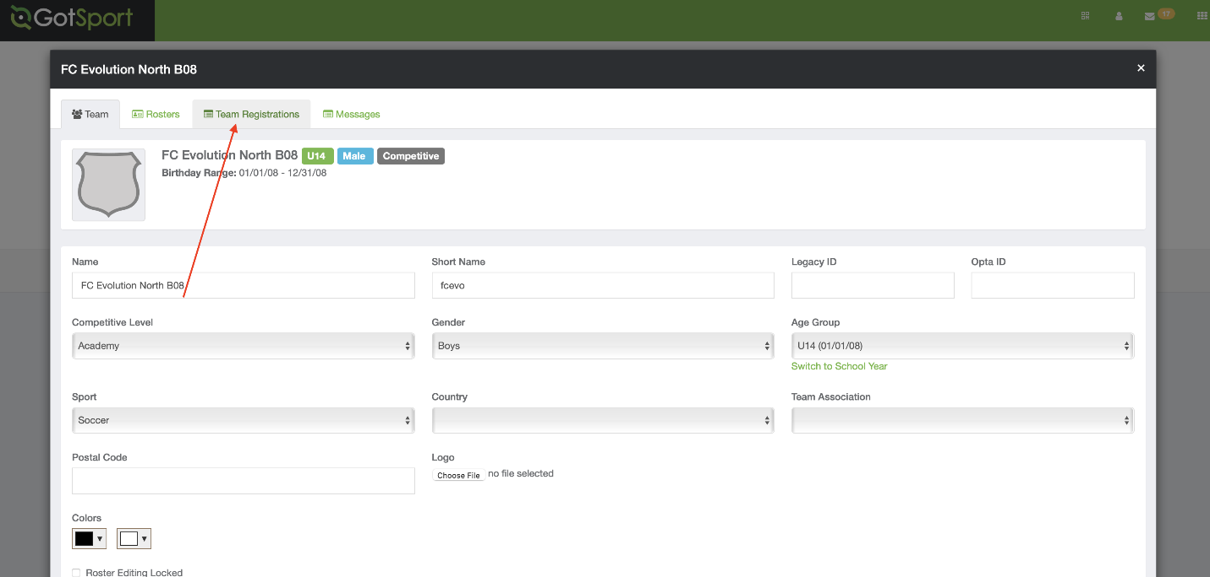
4. Click on the Event “Wasatch Soccer Classic”
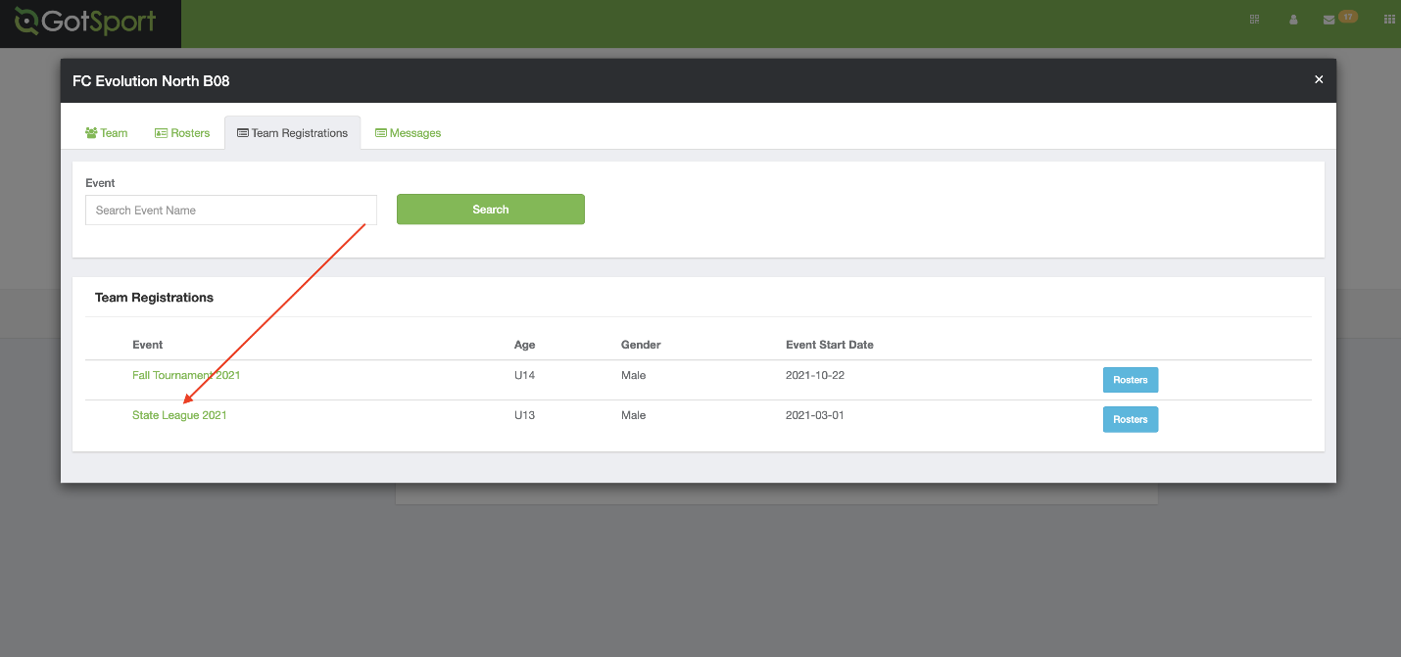
5. Open the "Registration" tab
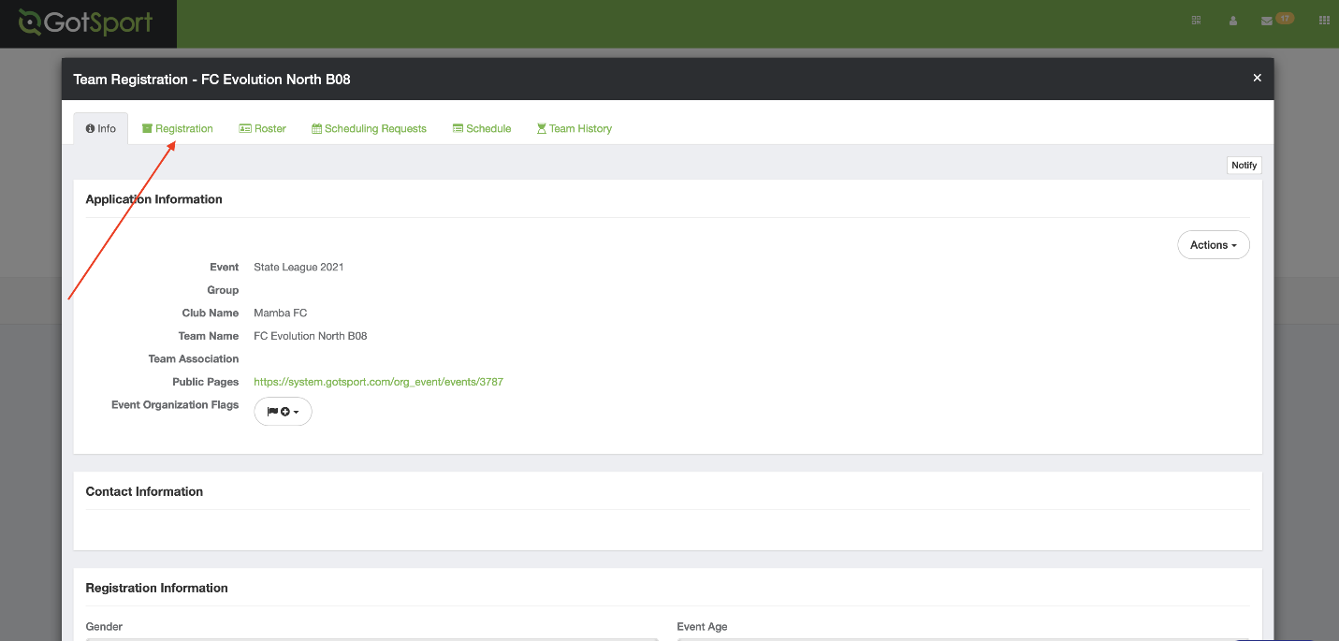

7. Print your approved tournament roster that has been uploaded by the Tournament Director into the “Tournament Photo Roster” field. You originally uploaded your tournament photo roster to this field. The Tournament Director reviewed your roster, approved it, and then REPLACED the file in this field with your approved roster.
