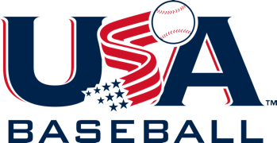

- PURE Baseball
  - Zero tolerance campaign for abuse awareness
  - Senate Bill 534
  - Free of cost
  - www.purebaseball.org
- Coaches Certification
  - 3 Levels
  - Emphasis on player safety & baseball fundamentals
  - Online course modules Level A & B
  - Level C includes both online modules + event attendance – this one counts!
  - Free of cost
  - www.usabaseball.com Development
- Coaches Clinics
  - 3 hours minimum
  - 250 available in 2020
  - Partners: MLBPAA, GameChanger
  - Satisfies Level C in-person requirement
  - Hosted by leagues, college & high school programs, MLB clubs
  - Emphasis on growing the game at a grassroots level
  - Free to attend
  - www.coachclinics.org
- Regional Clinics
  - Two-day immersion event at MLB facilities
  - Day 1 indoors, Day 2 on-field
  - 12 clinic sessions + PURE Baseball course completion
  - Social & dinner day 1, lunch day 2 included
  - USA Baseball branded gear + Dicks Sporting Goods & Gamechanger items
  - 2020 schedule getting finalized soon
  - Cost to attend varies dependent upon host
  - www.coachclinics.org
- USA Baseball Mobile Coach App
  - Sample practice plans
  - Drill library
  - Available on Apple & Android stores
  - Free of cost
- Fun At Bat
  - Elementary school bat & ball program
  - Free equipment kit & curriculum approved by SHAPE America
  - Have your district apply at : www.funatbat.org

Andrew Bartman, Director of Coaching Development
andrewbartman@usabaseball.com / 217-737-3593 (Cell)
@CoachBartman – Twitter / coach_bartman – IG / Facebook

