How to add a guest player from a different club.

Follow the steps below to add a guest player to your event roster. Player's must go through their [individual player account and register](https://gotsoccer.zendesk.com/hc/en-us/articles/115000773927-How-do-I-register-my-child-as-a-guest-for-an-event-)for the event as a guest before you will be able to add them.

**Step One:**

Once logged into your team account click on the name of the event you are looking to add the guest player for.

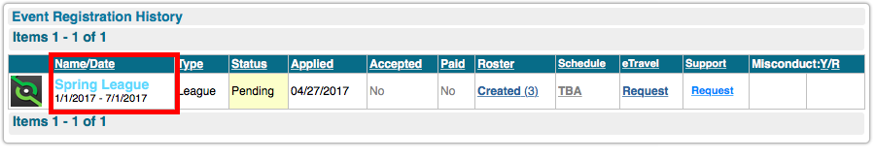

**Step Two:**

Click on the "guests" tab, and then click on the player's name you are looking to add.

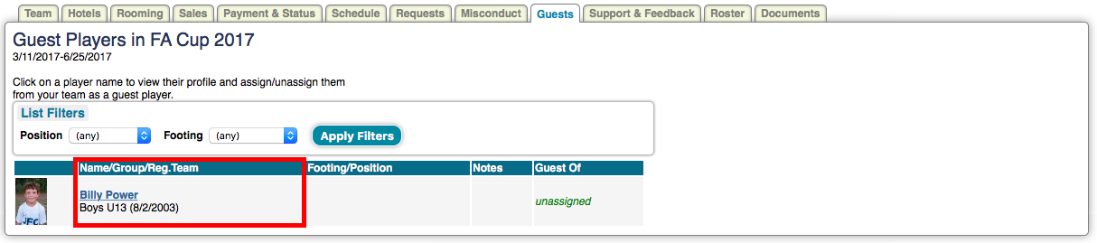

**Step Three:**

Click the dropdown next to "Guests Of" and select your team. Then click update.

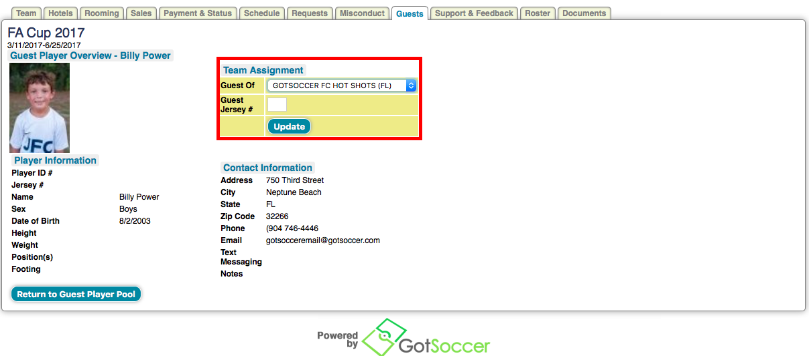

**Step Four:**

Go to your event roster and hit the add guest button at the bottom of the page.

