
2025 Championships General Tournament Rules and Information
Wave Assignments
*Subject to change if division numbers change significantly
AM wave Friday will start at 11am. AM wave Saturday will start at 8am
Week 1 - March 26-28 | Week 2 - April 4-6
Rock Hill | Rock Hill
12 Girls - AM | 13 Power - AM
13 Girls - AM | 14 Power - AM
14 Girls - PM | 15 Power - AM
16 Girls - PM | 16 Power - PM
 | 17 Power - PM
Spartanburg | Spartanburg
15 Girls - AM/PM split | 17 Club - PM
16 Boys - PM | 18 Girls - AM
18 Boys - PM
Week 1: March 28-30 and Week 2. April 4-6
AES Format-Times: ALL Teams will play Friday, Saturday and Sunday
https://results.advancedeventsystems.com/event/PTAwMDAwMzg0MTg90/home
WEEK 1 March 28-30
ROCK HILL
Age Group: 12U Girls, 13U Club, 14U Club, 16U Club
Rock Hill Sports Center 326 Technology Center Way, Rock Hill. 18 Courts
EARLY Tickets Sales and Coaches check in will be available Thursday March 27th from 4-6pm.
SPARTANBURG
15U Club , 16U Boys, 18U Boys
Upward Star Ctr 9768 Warren H Abernathy Highway Spartanburg, SC.
Luke VB Ctr -6655 Pottery Rd, Spartanburg, SC (Friday only)
On Friday only 15s girls will be assigned to Luke starting at 11am, Guys will begin at Star Ctr at 6pm. On Saturday and Sunday all teams will be at the Star Center. Doors open at 7am both days.
Luke for Friday 18u: Doors will open at 10:00am. Tickets sales and coach check in opens at 10am.
Star Ctr on Friday: Doors will not open until 5pm (Can’t get in before 5 due to school)
Week 2: April 4-6 Friday -Sunday
Rock Hill Sports Center 13-17 Power
EARLY Tickets Sales and Coaches check in will be available Thursday April 3rd from 4-6pm at Rock Hill only.
Winthrop WEST Ctr will be used for 4 courts. Teams assigned there will rotate from there to RH Sports Ctr on another day. See details below
SPARTANBURG. 17 Club and 18u
Upward Star Ctr 9768 Warren H Abernathy Highway Spartanburg, SC.
Luke VB Ctr -6655 Pottery Rd, Spartanburg, SC (Friday only)
Luke for Friday: Doors will open at 10:00am.
ALL MATCHES WILL BE PLAYED AT LUKE ON FRIDAY, All Matches for Sat and Sun will be Star Ctr

COACHES: Read important information.
- Check in: If possible, check in Thursday 4-6pm for teams playing in Rock Hill. For Spartanburg, check in Friday at Luke (Boys at Star ctr)

- GIFTS: Rock Hill- Check in will be in the Big Room where food tables are located (spectator tickets). You are encouraged to check in Thursday from 4-6pm, or anytime Friday upon arrival. If you are assigned West Ctr on Friday- go to check in Saturday at RH Sports Ctr. Gifts will only be available for pick up on Friday or Saturday only.
- Wrist Bands: You will pick up your wrist bands at check in. You can only receive bands for coaches or adult members who are NOT on another team roster. You are responsible to get bands to other adults on your roster. YOU MUST WEAR YOUR WRISTBANDS.
- ROSTERS: Bring minimum 2 copies. 1 to turn in at check in, the 2nd to provide official at your first match.

PARENTS: Read important information
- Tickets: All Locations- Cash or Check only- plan accordingly. Ticket cost is $15 per day, 3 day pass if $35. Rock Hill- if possible, come in Thursday from 4-6 to purchase tickets and avoid the lines. YOU MUST WEAR YOUR WRISTBANDS.
- SEATS: Be courteous concerning seats: When you team is not playing- move to allow spectators whose teams are playing to sit by the court- NO SAVING SEATS.

4 Courts at West Ctr- Winthrop for week 1 only.
701 Oakland Ave Rock Hill
No food inside the facility. Can bring sport chairs. There will be limited bleachers available. Can NOT get on walking track above the courts.
Parking: There is parking around the West Ctr, see picture below.
Arrangements have already been made with WUPD as the event is being run through University Events and WUPD. For this event, the Margaret Nance parking lot, the Visitor Parking Area Between the West Center and McBryde Hall, and the Johnson Hall parking lot have been reserved for Saturday and Sunday. Because of this, your spectators and others, do not have to get Visitor parking passes. The WUPD officer that is working this event will be floating inside and outside in order to keep tabs on security/parking issues.
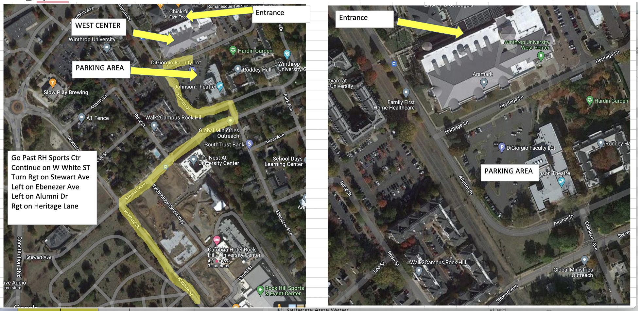

Luke Center- you can bring sport chairs- none to Star Center.

FACILITY INFORMATION NEXT- Rules and Regulations after this section
ROCK HILL SPORTS CENTER LAYOUT

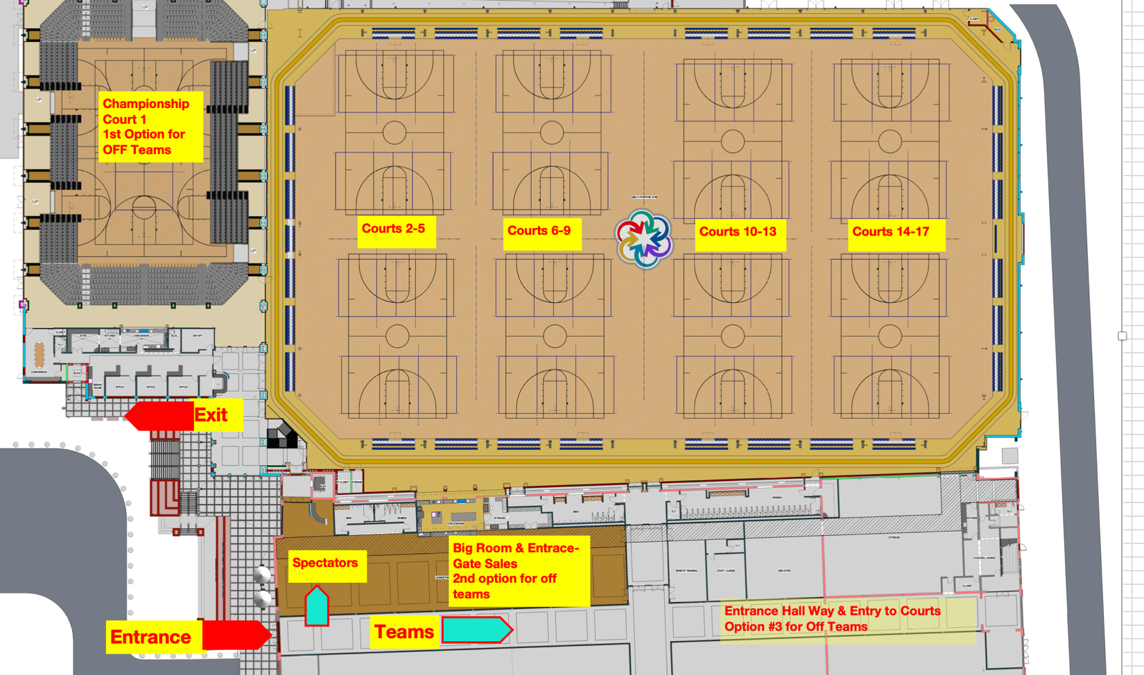
Courts 15-18
Courts 11-14
Courts 7-10
Courts 3-6
Court 1 & 2

ALL enter right of main entrance.
Spectators/parents to the left. Players down the hall way.
Players do not need wristbands. Coaches check in- Big room

VERY IMPORTANT: PARKING
Cars can NOT stop and drop off in front of the facility. This causes back up and delays.
PARKING IS FREE IN THE ADJACENT PARKING DECKS A & B.
NO EVENT PARKING ALLOWED UNDER THE SPORTS CENTER
NO PARKING BEHIND THE BUILDING ON STREET! Will be towed.
- THERE IS NO FREE PERIOD FOR ON STREET PARKING.
- Oversize vehicle parking is very limited. Oversize vehicles may be required to park off-site.
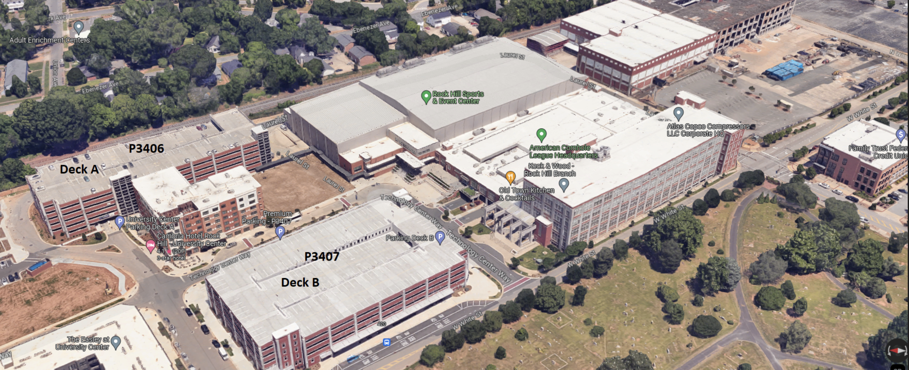

Most Common FAQ:
Detailed information is below FAQ
What is the format, days-times played:
Teams play in waves (Early and Late). The exact times and assignments are not released until about two weeks prior to the tournament. ALL TEAMS WILL PLAY Friday, Saturday and Sunday.
Friday starts at 11AM but teams could start early or as late as 6pm. Saturday has an 8 AM wave and a 3 PM wave. All teams advance to Sunday playoffs and start times vary from 8am to 1pm. Always check AES before you leave the facility about your next day assignments AND again the next day in event something changes. Sunday, typically if you lose you ref the next match.
Gate Tickets:
We will NOT offer pre-ordered gate tickets.
For Friday doors to courts will not open until 10 AM for Week 1 at Rock Hill and Luke Ctr, the Star Center will not open until 5pm.
3 Day Weekend Passes: Adults $35, Children 17 or younger is free.
Day Passes
Adult $15 per day
Tickets cannot be used for multiple weekends.
Hotel Room Blocks: This is Stay to Save Tournaments
All Teams/ Parents are required to use the Region Hotel Blocks for hotel reservations. Failure to meet could result in fines to the club/team. Complete details are here:
https://www.palmettoregionvb.org/page/show/3651936-hotel-stay-to-save-faq
FOOD/ TABLES:
No outside food can come into the facilities. Tables are available for meals in Rock Hill, but can not be used as Team Tables. Welcome to stay and eat or take a break but allow others to do the same.
No food tables allowed inside Spartanburg locations.
RULE DETAILS
Read all rules, instructions, and information carefully- it could result in fines or point penalties.
COACHES
Rostered Adults: Each rostered adult receives a free wrist band. Stop by the Coaches table on to pick up. You will need your photo ID and show name on Sports Engine Roster or your USAV membership card. Wristbands are limited to 5 adults per roster and same adult can not obtain tickets if they are listed on multiple rosters.
For questions related to withdrawal, changes, or entries, email the region at tournaments@palmettovb.com . Parents- before you email region, contact your club director.
There will be no coaches meeting: review the formats and information on this site. We require coaches to be familiar with all information here and from AES. No printed material will be available on-site. Take the time to review all information below. FAILURE in some areas can result in penalty points or fines! Formats and schedules will be posted on Advanced Event Systems – www.advancedeventsystems.com.
HOW THE TOURNAMENT FORMAT WORKS:
Regional championship seeds are based on the USAV National Rankings and the SportsEngine AES Power Rankings as of 3/18/25. The region has a committee that reviews the seeds prior to publishing. Please understand that differences in rankings exist between multiple systems, and we do our best to take into account all available information and results when determining seeds. The Championship formats are set up such that teams have multiple chances to advance to the Gold bracket – the Day 1 seed being off by a few spots likely will not prevent a good team from advancing.

Questions about seeds and formats should be directed to your Club Director first. The Club Director may contact the region with questions, but no changes are guaranteed once schedules are posted.

AES and USAV rankings can be viewed here: https://advancedeventsystems.com/rankings

On Friday and Saturday, teams move up or down based on Win-Loss record.
We encourage all to review the format and flow, provided on AES. Always check back, even up to the day of the event for changes that may have taken place. Any format concerns must be addressed 10 days in advance. No requests for changes will be addressed inside of 10 days.
Start Times & Schedule
For Week 1
Friday Times: Ticket Sales & Coaches check in open at 10:00. First games start at 11 AM
Saturday and Sunday gate and ticket sales open at 7am. Games begin at 8am and may start up to 15 mins early if teams are ready.
Friday play times will be divided into 2-3 waves, depending on location. First wave will begin at 11am. Check schedule in AES online. Matches and pools may run early – be sure to arrive at your court a minimum of 30 minutes prior to any scheduled match. Keep up with AES schedule online.
Saturday play times will also be in two waves: AM wave will start at 8am and PM wave will start at 3 PM. Saturday can run early, keep check with AES schedule.
Any team who reports late to scheduled time as work team or playing team will be penalized 1 point per minute after the scheduled match time.
All teams advance to playoffs on Sunday, play begins at 8am. If you lose on Sunday, most of the time you will have to ref another match, often on same court, but check schedule. Teams who play at 9am may have reffing duty at 8am – make sure you check your schedule. Missing a ref duty carries a fine and/or penalty. Sunday is SINGLE ELIMINATION, with consolation matches for some teams/brackets.
During the event, Pool formats, start times, and schedules can be found in Advanced Event Systems. You can track your pools by accessing AES from any smart phone or computer.
Check AES before you leave the facility and check again later that day and the next day in case something changes.
Coaches Gift Pickup
All Head Coaches and Directors need to check in personally in order to receive your gift between 10:30am -5:30pm Friday. Bring a copy of your roster to show your position on the team. Coaches who hold head coach position only receive one gift. Coaches can NOT pick up gifts for others. Gifts are provided only for coaches who remitted their information before the deadline.
Teams at Luke on Friday: Coaches/Directors, pick up your gifts Friday at your location.
Players can enter playing area by wearing their uniforms.
Non Playing adults must wear wrist bands the entire weekend and show in order to enter playing area. Lost bands will NOT be replaced free.
Head Coach: Rosters
- Need three copies of your team Sports Engine roster, 1 for check in, 1 for officials the first day and 1 extra if needed. All members playing, coaching, officiating or on the bench must be listed on roster. Officials will check daily. For check in, mark out in RED, any players or adults who will not be attending the weekend (before you get to check in desk). Max of 5 adults listed on a roster.
- You are allowed to write in change of jersey numbers, but not player names.
Food & Seating
Food, drinks, tables, and coolers are NOT allowed in the facilities. Coolers and food tables are NOT allowed outside Star or Rock Hill facilities.
Portable sport chairs are NOT allowed due to space limitations. Seating will be available around each court. They are allowed at Luke for Friday.
Rock Hill sports center has break/food tables, but these are NOT TEAM TABLES. You are welcome to take a break or eat at the tables but can’t save the table or stay there all day. Other spectators/teams need a place.
IF YOUR TEAM IS NOT PLAYING, PLEASE MOVE FROM SEATS TO ALLOW SPECTATORS FROM TEAMS PLAYING TO SIT.
Entry Fees, Wristbands
Bands must be worn on wrist for entry.
NO REFUNDS. Lost or forgotten passes will not be replaced. You will be required to purchase a new pass. If your band is damaged, return it to the ticket desk for replacement. YOU MUST wear the band on your wrist, do not attach to bag.

All Region Awards
Coaches from each team will have the option to remit to the region two players per team that will be listed as 1st and 2nd team All-Region. This will be posted online after Week 2 of Regionals, around April 12th.
Division Awards:
If your team wins a division, you must have a form from the R1 official, bring to area near championship desk to receive awards. Only players-coaches in attendance can receive awards. All awards at Regionals will be Tshirts.
All Division winners is provided awards for ONLY First Place. Prizes in the Open Gold Division is awarded in 1st and 2nd.
Officiating Duties and Score Reporting
Officiating Duties
Region provides paid R1 officials. There may be times that an R1 official is scheduled for a match and is running late on another court. The working team is responsible for starting the match on time. The coach (not player) must work as the R1 until the paid official arrives at the court. If the scheduled R1 is not at the court by start of the first set, send someone to the championship desk to notify region staff. Do not wait to start warmups.
14u and below are required to have adult/coach as R2. We request you have adult/coach for all age divisions.
Scoresheets for the match will be remitted to the championship desk. Scoresheets must be correct and completed in full or a 5-point penalty can be charged to the working team. Last year we had too many scoresheets with incomplete info. Coaches should check scoresheets before sending them to the desk.
Coaches or another rostered adult are required to stay at the table when their team has work duty. Remind your scorekeepers there are only to be 3 at the table – libero tracker, score flipper, and scorekeeper. NO PHONES
Palmetto Region requires that while on officiating duty, no one is to have in possession a cell phone, iPod, or other electronic device, or food. This includes R1, R2, Line judges, and scorekeepers. Violation of this rule will result in a 5-point penalty to the working team for the next match. We would prefer an adult to line judge and flip score.
Teams who do not report on time for officiating duties: point penalty for next match. 1 point per minute late up to 25 points. If no show or not sufficient workers, club has the choice of 1 game forfeit or $150 fine and 10 point penalty on first game of next match. If last match and team leaves, it is a $200 fine.
First Aid/Athletic Trainer
The Palmetto Region will provide an athletic trainer and first aid is available for injuries. If you want wrapped as a prevention, you must bring your own tape.
Any facility with 6 or more courts will have an athletic trainer. For the West Ctr, injuries will need to be driven to the Sports Center to be seen. Contact the gym supervisor; they will call ahead and meet the person in the back of the center. In case of a serious injury, call an ambulance.
PARENTS and SPECTATORS:
All pool information, court assignments may be found on AES ( advancedeventsystems.com).
The Palmetto Region has a NO-TOLERANCE policy on screaming, yelling, or making any derogatory remarks to ANY official, spectator or team member. Keep in mind…Talk and treat others with respect. Penalty is immediate dismissal from gym, no warning. Region teams may face sanction to participate in future tournaments. Anyone, regardless of who started, will be immediately removed from venue.
Any questions concerning the format or tournament rules must be addressed to your coach, they in turn can ask the championship desk. We do not accept questions or protest from anyone other than the head coach.
If you team is not playing on your court, PLEASE show courtesy and allow teams who are playing to have seats around the court. DO NOT SAVE seats while not playing.
Formats / Rules
Warmups
Warmups will consist of 2-4-4: 2 minutes of shared court time, 4 minutes for the serving team to hit and serve on full court, and 4 minutes for the receiving team to hit and serve on full court.
Match Format
PLAYING FORMATS: Unless otherwise designated, all matches are two out of three sets with the third set played only if necessary. ALL matches on FRIDAY will start with a score of 0-0 for sets 1 and 2. If a third set is necessary, play will be to 15 points starting at 0, switch sides at 8, and coin toss required. There will be a 2-point cap on all sets Friday. A 2 POINT CAP MEANS IF THE GAME PASSES 25 POINTS THE FIRST TO 27 WINS. (There could be a winning score of 27-26).
ALL matches on SATURDAY will start with a score of 0-0 for sets 1 and 2. If a third set is necessary, play will be to 15 points starting at 0, switch sides at 8, and coin toss required. There will be a 2-point cap on all sets Saturday. (There could be a winning score of 27-26). Note that some 3-team pools on Saturday will play all 3 sets to 25, regardless of the winner of the first 2 sets. These will be designated in AES and on the scoresheet. Saturday’s play will determine what playoff bracket teams will participate in; all teams will advance to Sunday.
ALL playoff matches on SUNDAY will start with a score of 0-0 for sets 1 and 2. If a third set is necessary, play will be to 15 points starting at 0-0, switch sides at 8, and coin toss required. There will be NO caps in Playoff Play Sunday.
IF you lose on Sunday, you will work a match following your loss. Make sure you don’t leave before checking your duty or the team will be fined.
Some teams ref before they play – make sure you check schedule on Saturday for your times on Sunday. Teams who are not available for working duties on time are subject to $50 fine.
Teams seeking National Bid Must notify region you plan to seek bid by March 10.
- Please review the bid information that has been sent out to all teams that submitted by the deadline.
- You are required to get commitments from your team they are agreeing to commit and attend nationals if they win the bid. Don't wait until day of winning to ask. Decision must be made prior to Championships.
- Note: if you accept the bid and later determine NOT to attend, USAV has a severe penalty and sanction for teams who drop.
If your team is in a possible tie, DO NOT leave the venue until it is resolved. Come to Championship Desk with questions.
Ghost Players
Teams will be allowed to play with 5 players and use a “ghost player,” with the exception of teams seeking a bid.
Protests
Notify the R1 immediately if you have a protest. Protest committee will consist of 3 certified officials chosen by official’s chair.
Tiebreakers / Playoff Games
Tiebreaker order:
- Matches won vs. lost (if 3-way tie, then proceed to #3)
- Head to Head
- Set %
- Point %
- Flip a Coin
Playoff games will ONLY be played for pools leading to the Gold bracket, and only if the involved teams are tied in BOTH match record and set record.
Procedures for Breaking Ties if leading to Gold Bracket:
In the event of a tie or potential tie, all teams should remain in the facility until it is determined if playoff matches are necessary.
- At the conclusion of pool play, the pool finish positions of the teams are determined by their pool match records.
- If there is a tie in match record AND set record among 2 or more teams in the pool, ties will be resolved using the GJNC National Tie Break Rules
Three-way ties
- If three teams are tied in match record AND set record, ALL THREE TEAMS WILL PARTICIPATE IN TIE BREAKER SETS.
    - If two teams can advance to gold, the #1 seeded team will automatically advance, and the #2 and #3 seeded teams will play each other, with team #1 reffing.
    - If only one team can advance to gold, the #2 and #3 seeded teams will play each other first, with team #1 reffing. The winner of that match will play the #1 seeded team, the loser of match 1 will ref match 2.
Two-way Ties:
- There will be no tie-breaker games played.
- The first place team will be the team that won the pool play match between the 2 tied teams (head to head)
- This is the procedure for all two-way ties, even when one team might still advance to Open Gold Division; the tied teams have already determined the better team through head-to-head competition.
If all teams in the pool leading to Open Gold have already qualified for the GJNC, there will be no tie breaker sets for that pool. Ties are resolved by ranking according to set percentage, or, if necessary, point percentage.
Format for Tie Breaker Sets
- Tie break sets are played to 25 points with one team winning by two points, no cap.
- Teams will switch sides at 13 points.
- The team with the highest point percentage is seeded first.

