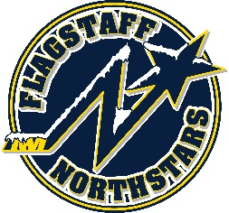
Flagstaff Youth Hockey Association
BOARD OF DIRECTOR’S MONTHLY MEETING AGENDA
July 28, 2021

Topic: FYHA General Board Meeting
Time: July 28, 2021 @ 6:00PM
Location: In person @ 215 E Birch Ave or Zoom Meeting ID: 918-5841-9239

GENERAL BOARD MEETING
Topic: FYHA General Board Meeting
Time: 6:00pm

Approval of Minutes:
Reports
- President’s Report- Travis Joralmon:
- AAHA Hockey Director- Travis Joralmon:
- ADM Coordinator: Kris Walsh:
- Coaching Coordinator- Travis Johanson:
- Equipment Manager- Greg McLaughlin
- Fundraising Coordinator-Kyle Palmer:
- Ice Scheduler-Brad Mihalik:
- COVID Updates and Protocols- Brad Mihalik:
- Registrar-Judy Smith:
- Treasurer-Lauryn Sandoval:
- Webmaster-Courtney Matthews :

UPCOMING EVENTS:
- Summer Pond Hockey Dates: June 8,2021-August 3, 2021 Tuesday
  - 8u&10U: 4:30-5:30
  - 12U&14U: 6-7p
- Stick Time 6u &8u club and goalie June 6, 2021- August 8, 2021 3pm-4pm
- Little Howlers 7/31-9/25
- Travel starts 8/9/2021
- Club to start 9/27/2021

RECENT EVENTS:
- Northwestern: 7/12-7/16
- Dark Sky 3x3 Tournament- July 23, 24, 25

NEW BUSINESS:
- Dryland Presentation—FIIT Nation’s Arturo Ross
- Red, White, and Blue Tournament
- Coyotes Grant

- Managers Meeting
- Fundraising Committee: Kyle Palmer: goal $25,000: • Fundraising Letter to businesses: all have been sent and distributed • Skate-a-ton: Adam to provide date to Kyle • Fundraising Campaign: • Coyote Box Raffle tickets • $6,400 from Dark Sky tournament (if not covered above during report)

