

OCONTO FALLS BASKETBALL
Swish Club – Off-Season 2026
Information sheet
GOAL:
The goal of the Swish Club is to provide an off-season shooting incentive to improve our basketball skills, specifically shooting techniques during the offseason.
REWARDS:
- 4,000 made shots earns you a Swish Club t-shirt
- 6,000 made shot, earns you a Swish Club Plaque
- 10,000 made shots earns you a Rock Basketball or $40 gift card to Dicks Sporting Goods
- 15,000 made shots earns you a Rock Basketball, t-shirt and bench buddy (join the Varsity team for pregame activities such as warm up and sit on the bench during a game.)
- 20,000 made shots earns you a Rock Basketball, $40 gift card to Dicks Sporting Goods and bench buddy.
RULES:
- Count only made baskets because it is easier for kids to keep track of and it emphasizes practicing with a purpose.
- Use proper shooting form. View the FOREST Method below (t.ly/QB4IW).
  - 11 DRILLS TO BECOME A BETTER SHOOTER!!! | HoopStudy Basketball (t.ly/LGDab)
- Do not count “garbage shots”. Practicing with bad form will make bad habits and will not lead to becoming a good shooter.
ACCOUNTABILITY:
- You must have an adult to supervise/witness the shots. This person(s) must sign or vouch for your shot totals. For high school players, your coach must sign off on your shot total.
- They do not have to see and count every single shot but we do want to hold the kids accountable.
- Parents - this is a good opportunity to teach work ethic, honesty, and accountability.
- Please don’t just write down high numbers so your kid gets something for nothing!
IDEAS:
- I highly recommend checking out Ryan Borowicz’s YouTube Channel - t.ly/fGH0
  - Shooting workout 1 - t.ly/c1ER
  - Shooting workout 2 - t.ly/9LWf
  - There’s also really good dribbling routines. Subscribe to the channel!
- The attached workout is a basic recommendation that is pretty easy for kids to follow, but any good shooting drill can be counted. Don’t be afraid to be creative.
  - Mikan drill
  - Partner shooting
  - Practicing attack moves
  - Any drill that you learned from your coach during last season
  - Look up moves and drills on youtube and copy those (if they’re good)
- DON’T GET FRUSTRATED! Keep it fun. When the makes are slow, move closer to the hoop, do more layups, etc.

- For layups, incorporate basic moves you may have practiced with your coaches:
  - Sweep and go
  - Shot fake and go
  - Foot fake and go
  - Crossovers
  - Pro hops
  - Attack move/footwork you want to try
- Tracking Makes:
  - Use the printed sheet on the following page. I suggest hanging it somewhere where your child will see it daily.
  - Use the digital version of the sheet on the following page by typing this: t.y/5h3t and then click on File > Make a Copy.
  - There are apps and many other ways to track shots. If you have something better for you, let us know and we will accept whatever as long as the kids are shooting, improving, and being honest.
  - Driveway chalk is great for keeping track of shots while shooting at home.

ADDITIONAL WAYS TO GET SHOTS IN:
- Hopefully we will have open gym times set up for kids to come in and use the shooting machines.
- Attend basketball camps to continue to push you and learn new skills.
CONTACT & COMPLETION:

- Turn in your shot chart and contact information to:
Oconto Falls High School
Attn: Tim Solarek, Oconto Falls Hoops Club President
210 North Farm Road
Oconto Falls, WI 54154

- Or complete the following Google Form Survey and attach pictures of your shot chart:

t.ly/u7gF

Shots made chart (DIGITAL Sheet) OR t.ly/5XtGl
SHOTS MADE & WHAT YOU CAN EARN:
- 4,000 made shots earns you a Swish Club t-shirt
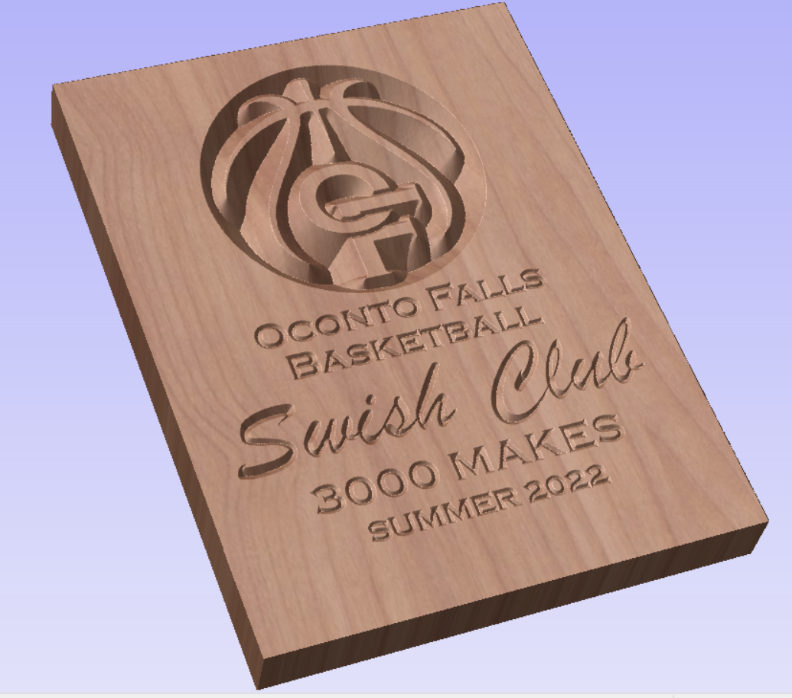
- 6,000 made shots earns you a Swish Club Plaque
- 10,000 made shots earns you a Rock Basketball or a $40 Dicks Sporting Goods gift card
- 15,000 made shots earns you a Rock basketball, a different style shirt with 15k on it, and you can be a bench buddy for a select game.
- 20,0000 made shots earns you a Rock Basketball, $40 Dicks Gift card and you can be a bench buddy for a select game.
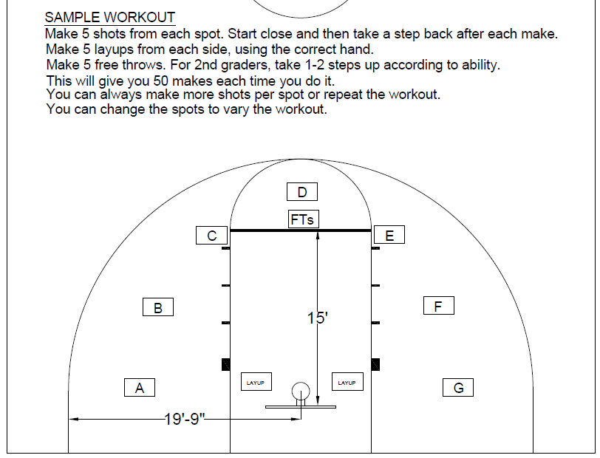
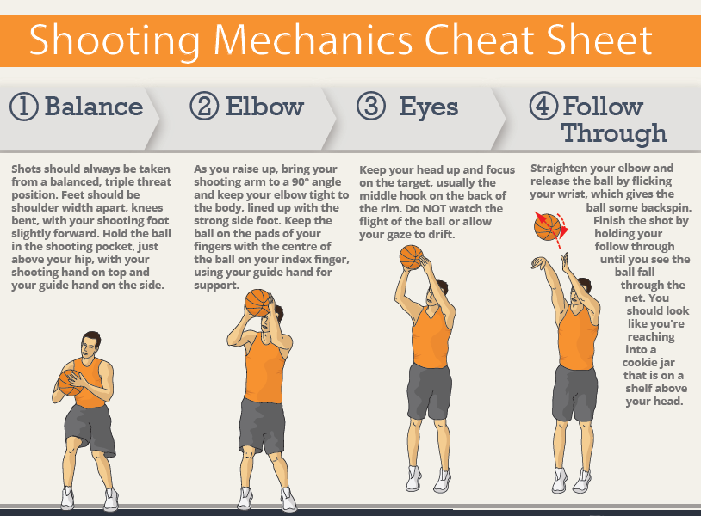
Search this method on YouTube. There are videos that explain all of these steps. t.ly/QB4IW
FOREST
- “F” is for Finger
- “O”is for Off Hand
- “R”is for Rhythm (Dip)
- “E” is for Eyes
- “S” is for Sweep & Sway
- “T” is for Turn
Pro Shot Shooting System has a collection of video tutorials that are vital to a learning shooter. He publishes a lot of material on basketball fundamentals and I would highly recommend him to any shooter interested in improving their shot.
There are subtle differences between the two shooting acronyms. The first is that BEEF tends to lead shooters to learn a form that resembles a two-motion shot. FOREST, on the other hand, is more form-neutral and aids both one and two-motion shooters.
The following are the recommended drills from Coach Bebeau:

Stationary Ball Handling | - Pound Right hand, Pound with Left Hand (30 Seconds per hand)  - High-Low each hand (30 Secs per hand)  - Narrow Crossover (30 secs) - Wide Crossover (30 Secs)  - Figure 8 (1 minute)
Form Shooting | - One hand form shooting - 10 makes straight on and 10 makes from each baseline.  - Repeat using one, two up and through form shooting.  - Flip Square Catch Shoot within 10 feet - use left right and right left footwork  - Spin the ball out to yourself, get your feet set and squared to the rim, and shoot your jump shot. Make sure to get rotation on your shot and hold your follow through.
Drill #1 | - Rebound & finish - Toss the ball of the backboard to yourself.  - Rebound, power dribble & finish  - Rebound, power dribble & reverse layup
Drill #2 | - Drop step baseline right block and left block  - Drop step middle right block and left block  - Turn around short jumper right block and left block  - Up & under 1 dribble to the rim right block and left block
Drill #3 | Use these moves from each baseline, right wing, left wing and the top of the key.  - Spin to self, catch & shoot  - Spin to self, catch and sweep right hand and left hand layups  - Spin to self, catch, shot fake, attack the rim  - Spin to self, catch, shot fake, shot  - Spin to self, catch, shot fake, 1 dribble, pull up jumper
Drill #4 | Catch and shoot footwork shooting.  - Spin to Right Baseline - left - right catch and shoot  - Spin to Left Baseline - right - left catch and shoot  - Right & Left Wing - spin right first step left / spin left first step right  - Right & Left Elbow - same as wings footwork
Drill #5 | Shooting/Scoring off the Dribble  - Start on the block, spin to the elbow, catch on a jump stop, and reverse pivot both ways, sweep and score off of one dribble.  - Right block, reverse pivot on left foot, sweep to the outside right hand layup.  - Right block, reverse pivot on right foot, sweep middle left hand middle finish.  - Left block, reverse pivot on right foot, sweep to the outside left hand layup.  - Left block, reverse pivot on left foot, sweep middle right hand middle finish.  - Retreat dribble pull up jumper or layup  - Right & Left wing pull up jumpers  - Right & left wing step back jumpers

Oconto Falls Panther Swish Club started by Derek Tate

