Keep track of where shots were taken and scored.
Fill out this information before the game starts. After the game…White sheet goes to the Home team and Yellow sheet goes to Visiting Team
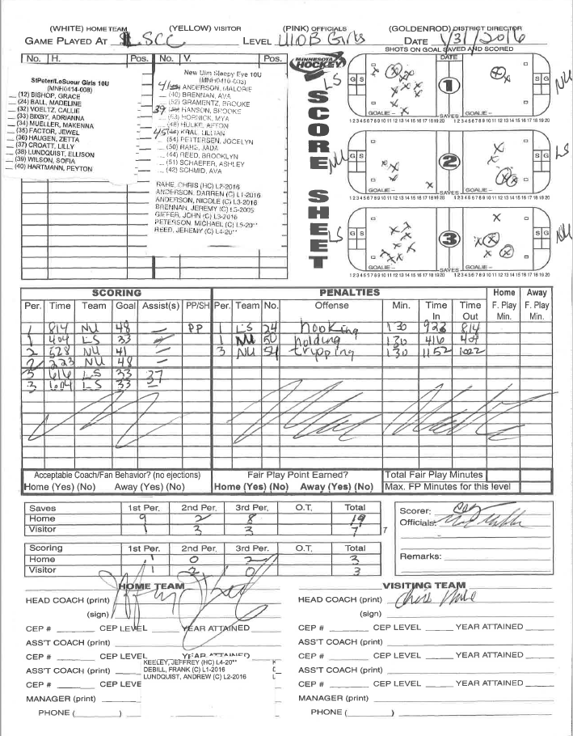
Period

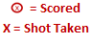
Fill in goals scored per period.
Home and Visiting Coach MUST sign the sheet before the start of the game. The on ice official will bring this over to the coaches.

Saves: count the shots taken. Do for each period
Fill in ALL the columns for scoring. PP =on power play. SH=short handed
Fill in ALL the columns for penalties. No need to fill in Home and Away F. Play columns
Sign your name as the scorer
Abbrv. what team is in goal as you are seeing it on the ice.
Home Team Sticker Roster
Visiting Team Sticker Roster

