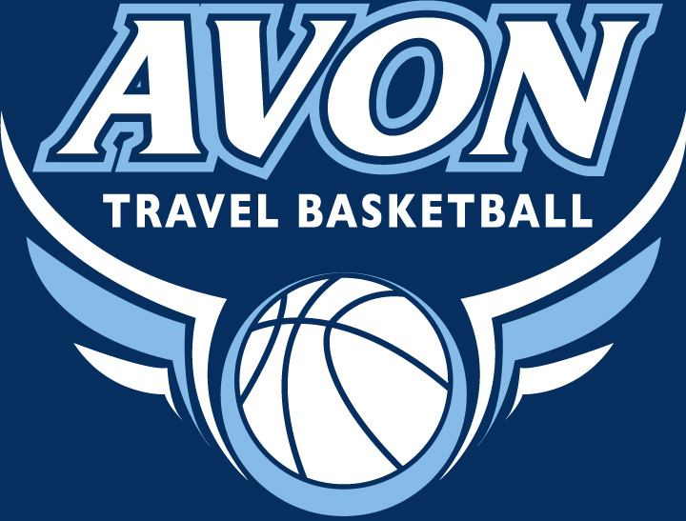

Avon Boys Travel Basketball Association “ABTBA” October 10, 2018

Dear Prospective Sponsor,

Avon Travel Basketball Association “ABTBA” provides Avon boys in the 5th through 8th grade the opportunity to play competitive basketball across the state for over 15 years. ABTBA has over 60 participants on six teams, playing in two travel leagues (representing over 20 towns) in the greater Hartford area. We are a vibrant organization with many local alumnae, including the Avon High School Varsity Boys Basketball Coach, Kris Pedra. This year we will be adding our sponsors to the players’ shooting shirts that they wear before every game.

We hope you will consider one of the following sponsorships for the 2018/2019 ABTBA year:

Silver Sponsorship for $100 includes:
- Your company name on our website at www.avontravelbasketball.org with a link to your website if available (8 month posting)
- Recognition at the ABTBA year-end banquet March 2019

Gold Sponsorship for $350 includes:
- Silver Sponsorship benefits PLUS your company name on the back of the ABTBA shooting shirts worn by the 60+ players

Platinum Sponsorship for $750 includes:
- Silver sponsorship benefits PLUS company name prominently displayed on the ABTBA shooting shirts worn by the 60+ players

If you are interested in sponsoring the ABTBA, we kindly request payment no later than November 26, 2018 to ensure sponsorship. Please make checks payable to Avon Boys Travel Basketball Association and remit to:
Jeremy Vitkauskas, c/o ABTBA, 33 Frandel Drive, Avon, CT 06001

Thank you again for your consideration of supporting Avon Boys Travel Basketball Association.

Sincerely,

Jeremy Vitkauskas
jv@farmingtoncountryclub.com

