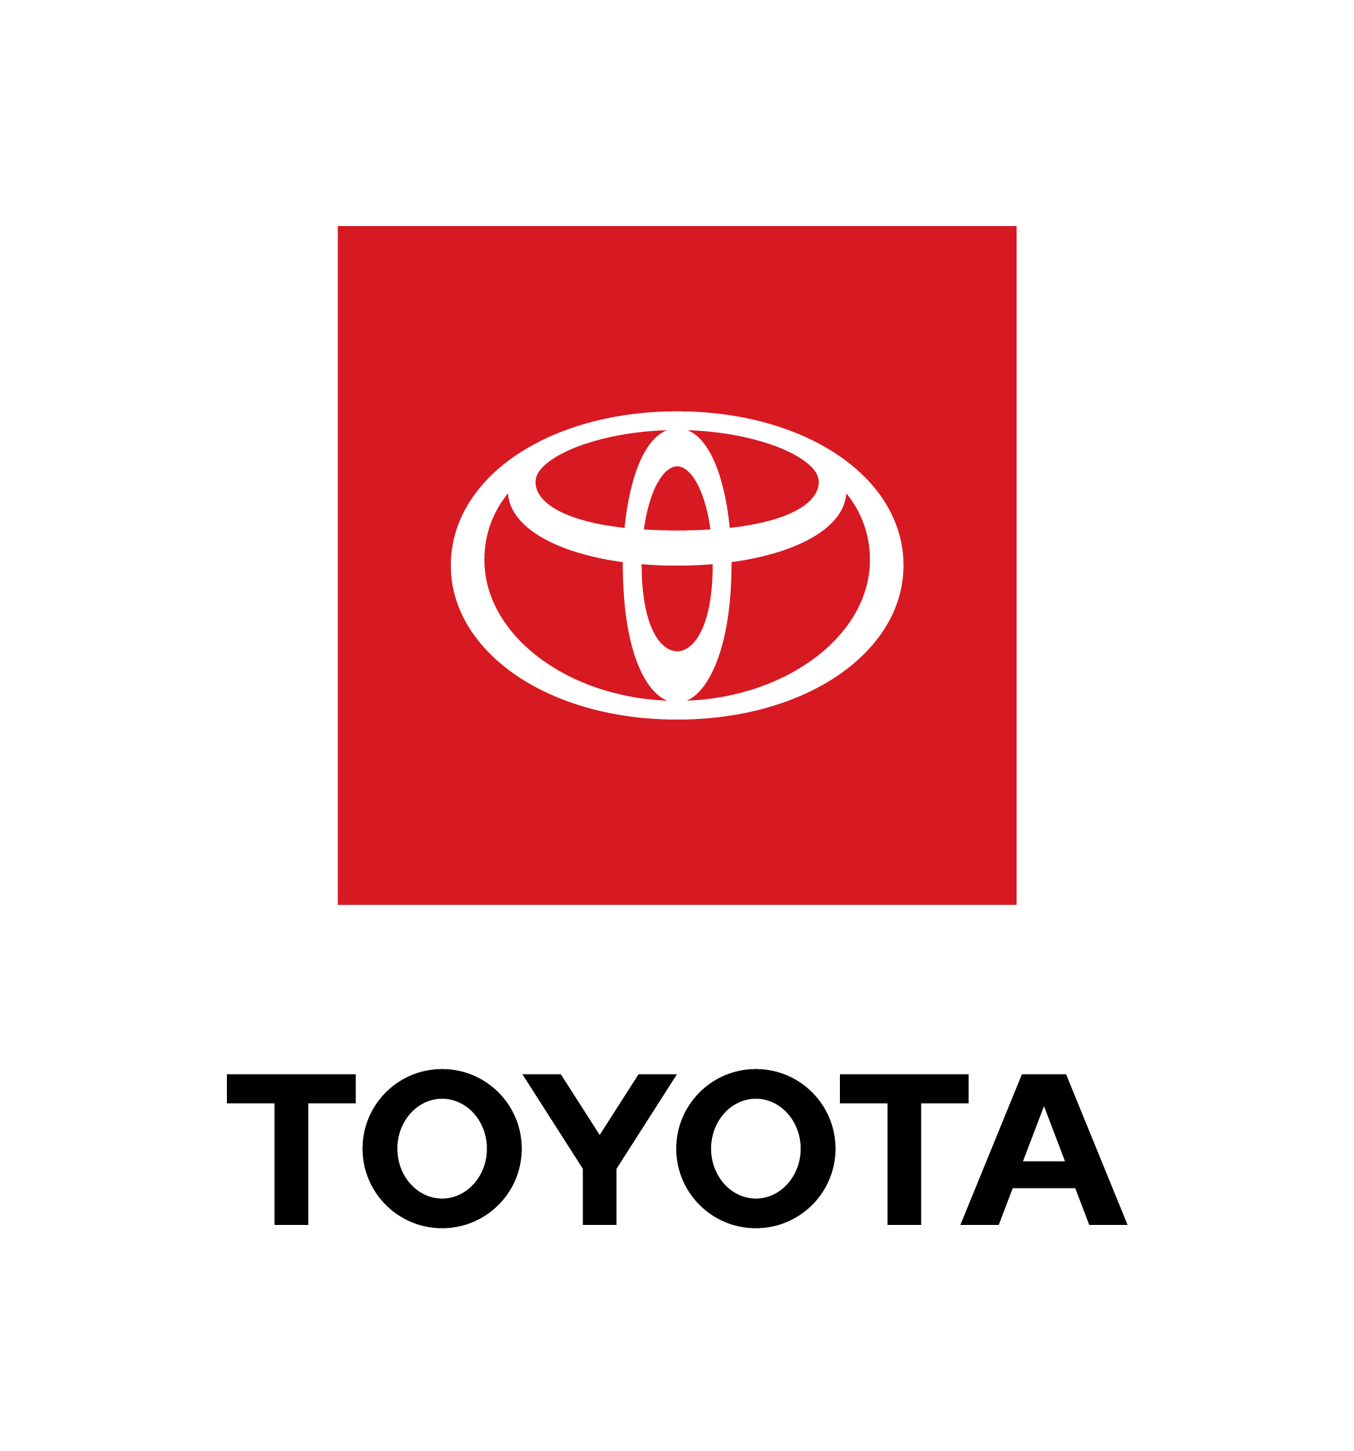
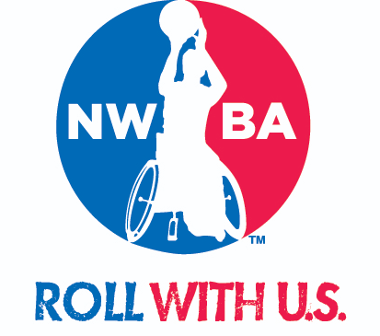

2020 Timothy J. Nugent High School Academic All-American
Presented by Toyota

Academic Recognition for Grades 10-12

The NWBA and Junior Division Executive Committee annually recognize athletes of the Junior Division for their success with their academics. The 2020 awards marks the 23rd time the Junior Division has recognized its best student-athletes for their work off the court.

The Timothy J. Nugent High School Academic All-American recognizes athletes 10th through 12th grades. The Academic All-American has been a great opportunity for accomplished athletes of Junior Division to showcase their talents off the court.

The NWBA Junior Division academic recognitions are in memory of our dedicated and visionary founder, Dr. Timothy J. Nugent. Dr. Nugent had the courage to start the NWBA to provide more opportunities for people with disabilities. Dr. Nugent cared way more about wins in society than wins on the court. Dr. Nugent realized the number one tool to improve a person's place in society was education. The Junior Division remembers Dr. Nugent by pushing the next generation of leaders towards the power of education.

There will be five individuals selected to the First Team Academic All-American and will receive a scholarship for direct tuition assistance to their college education. An additional five applicants will be selected to the Second Team Academic All-American, and additional qualifying applicants may be selected to the Honorable Mention Academic All-American.

All award recipients will be announced at the 2020 NWBA Junior Division Annual Banquet at the 2020 National Junior Wheelchair Basketball Tournament on Saturday, March 14 in Wichita, Kansas.

For full consideration please submit the following application by 11:59 p.m. Central time on Saturday, February 1, 2020.

Emily Hoskins
752 Shandale Drive Madison TN 37115
Emilyhoskins6@gmail.com

Please do not wait to the last minute to work on your project. It might require more time than in the past.

Student Athlete’s Name:

NWBA Junior Division Team:

Email Address:

School Name:

School Principal:

School Principal Email Address

Principal or Counselor Signature: ___________________________________________

Grade in School 10 11 12
Younger grades 5-9 should apply for Academic Achievers

MUST have a Cumulative Grade Point Average of 3.0 on 4.0 scale.

- What is your Cumulative GPA ____ Is the number above 3.0 on a 4.0 scale?
- Must have all A’s, B’s and C’s in your last grading period to be eligible. If you have a D or F in your last grading period you are not eligible this year but keep working hard in school and try again next year.

To be eligible for the recognition the student-athlete must include:

- Copy of current cumulative high school transcript.
- One letter of recommendation from a teacher, coach, mentor or principal that best captures why this student athlete deserves to have this recognition of Academic All-American. We ask that this person has direct knowledge of the applicant’s academic performance or extracurricular activities. We also ask that the person writing the letter of recommendation not be related to the applicant.

- A project with the following theme: While wheelchair basketball is obviously a big part of life for everyone involved with the NWBA, sometimes it’s important to remember that there simply is more to life than this sport. Student athletes may have their sights on playing at a higher level – the Adult Division, the Collegiate Division, or possibly even at the Paralympic level. For even the most accomplished athletes, it is still important to have a life outside of sport. For this year’s project the NWBA wants to hear about an applicant’s goals for life. Perhaps they have an interest in a pursuing further education or a specific career. Maybe they have “bucket list” type goals. We are asking applicants to submit a project discussing these goals and how they plan to achieve those. What things have applicants learned through the game of wheelchair basketball that will help them in working towards these goals? The NWBA places an emphasis on creativity and projects that can be shared via social media.

- All video submissions must be posted to YouTube with full access provided.

- Registered member and complete 2019-2020 Junior Athlete Registration on file with the NWBA. This included an electronic signature acknowledging the NWBA’s media agreement:

“I hereby agree to be filmed, videotaped and photographed, and to have my name, image, picture, likeness, voice and biographical information otherwise recorded, in any media by the NWBA. I hereby grant NWBA with no financial or other compensation due to me, full right and license to use, and to authorize third parties to use, in all media, the footage for: (1) news and information purposes, (2) promotion of the specific competition(s) in which I compete, (3) promotion of the Sport, and (4) promotion of the NWBA. I hereby certify that the information provided is being done directly by myself for, or if representing a minor as a legal guardian, and that it is true and accurate to the best of my knowledge. I also understand that the false information is ground for denial of membership.”

If you have questions, please direct them to Emily Hoskins at emilyhoskins6@gmail.com.

