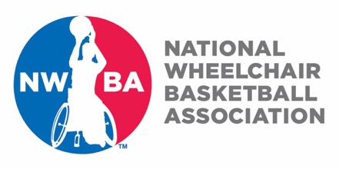
NWBA Classification Course
Registration Form

January 20-22, 2023 at University of Alabama

Participants Name: (Mr./Mrs./Ms.)

Address:

City: State: Zip Code:

Home Phone: Cell Phone:

Email Address:

Date of Birth: (Month/Day/Year)

Team Affiliation (if applicable):

NWBA Membership Number:

Registration Fee is $100.00. Cash Check Credit Card (circle one)

Registration fee covers class material/training and lunches during training.

Please fill this form out and email to Jayne Chilutti nwbaclass@yahoo.com. Upon receipt of this completed form, you will be contact for payment information (if Credit Card is circled; and processing fees will apply). You will be responsible for your transportation to and from the facility during the clinic. You are responsible for your lodging cost; however support may be able to be provided on a limited basis for those in need. For questions contact Jayne at nwbaclass@yahoo.com.

The clinic will be held at the Stran-Hardin Arena at University of Alabama
410 Peter Bryce Blvd, Tuscaloosa, AL 35401

