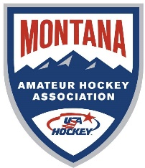
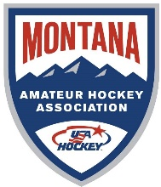
Treasure State League
State Tournament Financial Report
2025 - 2026
All Host associations must complete this report and submit to the Tournament Director within 10 days of the final day of the tournament.
Association Name: _____________________________________________________________
Tournament Hosted: _________________ Dates: ____________________________________
Contact Name: ________________________________________________________________
Phone #: _______________________________ Email: ________________________________
Income | Comments | Amount
Admission
Apparel Sales
Concession Sales
50/50 Sales
Raffle Sales
Sponsorships
Team Fees
Other
Other
Total Income
Expenses | Comments | Amount
Apparel Cost
3rd Place / Awards
Concession Costs
Ice Usage
Officials Meals/Miles
Officials Lodging
Player Bags
Other
Other
Total Expenses

Net Profit or Loss

Please see next page

Treasure State League
State Tournament Financial Report

Association Name: _____________________________________________________________
Tournament Hosted: _________________ Dates: ____________________________________

Please submit to MAHA Tournament Director @ mthockey.tourney@gmail.com

Please include completed Tournament Bracket with schedule and scores.

Notes/Comments:
_________________________________________________________________________________________________________________________________________________________________________________________________________________________________________________________________________________________________________________________________________________________________________________________________
The purpose of this reporting is to assist the MAHA Board in understanding the cost of hosting state tournaments. Annual tournament fees are set based on the information you provide.

We thank you and your Association for the efforts and time of hosting the State Tournament and completing the requested documents. Your efforts enable all Montana Youth Hockey players to participate in a memorable MAHA State Tournament.

