Steps to Claiming a DIBS Session
- Log into our website. Just like you did to register your skater(s). 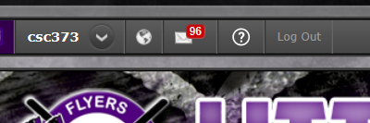

- Click on DIBS (located on the right-hand side of your screen on the activity bar)

- Your DIBS homepage should look like this, listing each of your skaters. If you have multiple skaters, please claim hours under your oldest skater for ease of tracking on the administrator’s end.
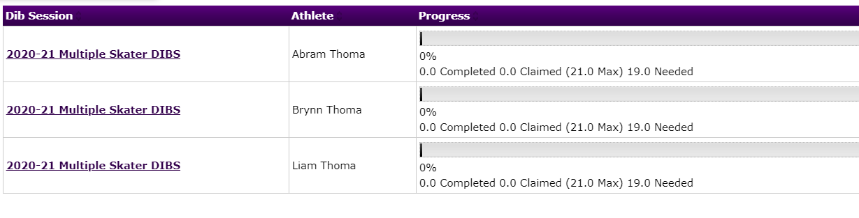

- Click on the opportunity you are wishing to claim. A screen will populate that lists all unclaimed and claimed hours. If you find one that works for you and it is not claimed, click on it (click on the purple Concessions).
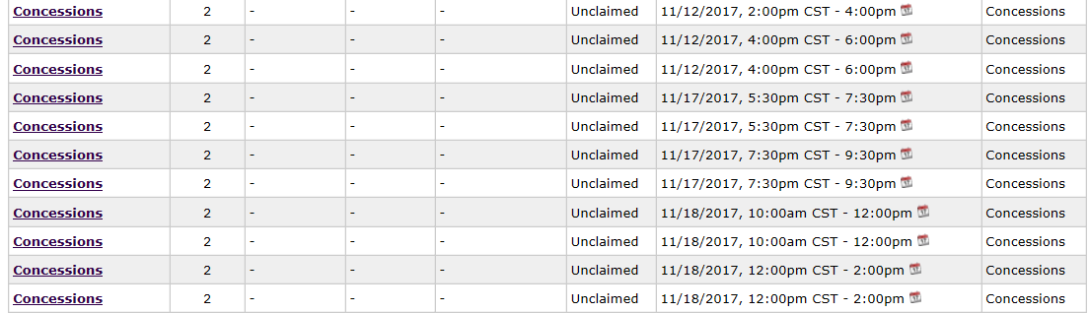

- Once you click on the purple wording. This will appear. Click claim if you are still wishing to work this shift. Please pay attention the cancellation requirements: 2 days a head of event or 4 days.

- When you click on claim this DIB item, this screen will appear. Fill in all required sections and “Claim DIB item.” Regardless of email address entry upon claiming shift, confirmation email and 24-hour reminder email will be sent to the account associated with the skater.
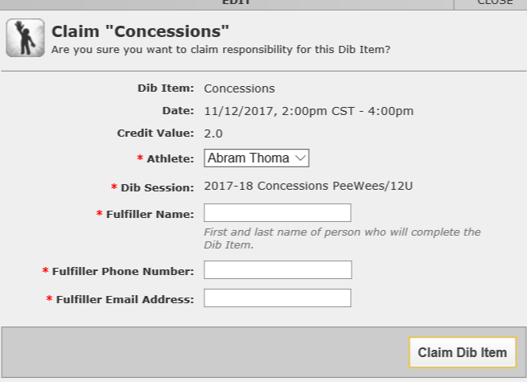

- Mark your calendar. You will receive an automated reminder 24 hours prior. Once the date has passed, your shift will be verified, and progress can be noted on the DIBS screen. Hours will be verified monthly.

- Life happens. If you cannot work a shift that you claimed, cancel claim. This must be done at least 48-72 hours prior to the start of your shift. (48 hours for non-concession shifts, 72 hours for concession shifts)
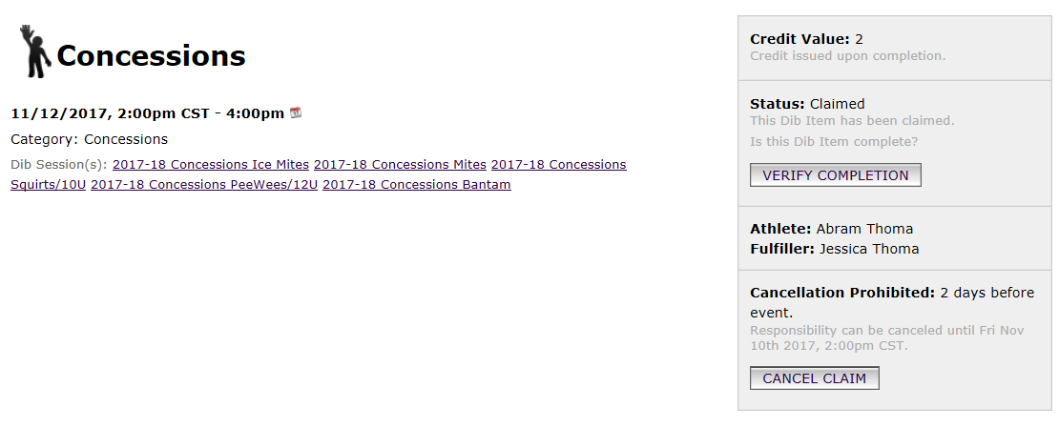
- If you are unable to work the shift you had claimed and are unable to cancel it because you are outside the 48 or 72 hour cancellation window, it is your responsibility to find your replacement and to contact the concession stand manager or DIBS coordinator with the name of your replacement. MARKING REQUEST CANCELLATION AND not doing the steps outlined under this point with result in a NO SHOW = VOLUNTEER DEPOSIT CASHED.

