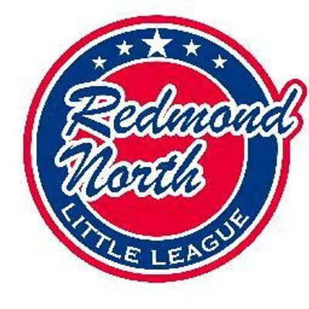

June 11, 2018 Meeting Minutes
Attendees:
Alec Weintraub
Bill Bieber
Kathy Duncan
Elaine Gunn
Josh Sattler
Meghan Dosch
John Kim
Kristal Klein
Jamey McMahan
*Note: Several members absent due to 8th Grade Graduation conflict.

Initial Business
President, Alec Weintraub, called the meeting to order. He began by offering the board the following updates:
- Big thanks to Kathy and Meghan for their help with the Jamboree event. It was a great event.
- He stated that he thought the season ended really well.
- He noted that Eastlake and Red-West enjoyed playing us. He suggested that RNLL play them again next year. Board members agreed and one board member suggested that we do it again next year without any pre-season games perhaps.
- He mentioned that the RNLL survey went out and we have some feedback to work with. Some board members heard bad feedback from AAA in-person, and Alec stated that we need to rethink rules and Jamboree tournament highlighted this. He stated that the board may need to change the constitution and cautioned that we need to make sure rules we produce are fair. This will be explored further at the beginning of the new season.
  - Alec will send another final end of the year email to RNLL families and again stress the need for surveys to be filled out and completed.
- He reiterated rules about modifications to helmets. Only Easton and Boombah baseball helmets with C-flaps are permitted by the league.
- He state that the mandatory training for managers and coaches for All-Stars needs to happen ASAP. He suggested a Happy Hour format. Kathy will send out an email to all managers reminding them of requirement, letting them choose their date and location, and noting that the meeting needs to happen in the next week.
- He stated that we owe Red-West money for fees, registration, and trophies. Board unanimously voted for check to be paid and issued.
- He discussed coordination of All-Star Send-Off on June 19th. He noted that balloons, meals, and snacks were needed. Board suggested that All-Star points of contact be reached out to lead this with board helping as needed or requested.
- He noted that All-Star documentation is almost all done. Also, this will be the last year with the “Just Baseball” jerseys and stated we may need to buy a few helmets.
- He stressed that we can no longer send softball registrations to go to Red-West. He suggested that RNLL accept the registrations in our league boundaries and then do an official combine with Red-West if needed due to numbers. Board voted and approved this item.
- He provided an update on the batting facility. He had a good conversation with King county and noted that his point of contact and county are working on formal agreement that will go in front of city council at the end of the month. Building permits are ready to go just waiting on engineering designs and decisions. We are making good progress on finances to move forward, just trying to get people we are paying to get on get on out schedule. A board member suggested that if the batting cages could be complete by Evaluation day that it would be awesome.
- He stressed the need for board recruiting noting that there are a lot of good families in AA, AAA, and it would be the perfect time to get these families involved in league. The board is in dire need of a Webmaster and Treasurer among other open positions.

Fundraising & Sponsorship Update

Meghan Dosch, Fundraising and Sponsorship Coordinator, stated that she is trying to get pictures of all the back of shirts for every IB team for Land of Frost. She has 14/15 of pictures of back of shirts. D9 program ad got sent off with 3 sponsors. She noted that she has another sponsor lined up for next year.

Chief Umpire Update

John Kim, Chief Umpire, noted that several teams qualified for party due to Umpire coverage: Majors (Dodgers, Twins); Coast (Mets, Cubs & Phillies), and AAA (Giants). He also mentioned that the Junior Umpire program showed great promise and stated that those 13 and over can work as umpires at the Red-West Summer Ball program ($18/game for plate, $12 for bases, $6 for field prep).

Web Update

Jorge Novillo, Information Officer/Webmaster sent an email prior to the meeting noting that he is working on a document that has all of the IDs and Pwd's for next year's web master. He is also planning to send email reminders to all folks who checked the box during registration that their company matches volunteer hours - to submit their match hours.

Next Meeting

- July 23, 2018, 7:00PM @Ixtapa

