
Boys Hockey Booster Club
September 18th, 2024
High School Conf Room 1201

Board Members:
Keith Bridgeman President | Allison Fuller Vice-President | Brian Soucy Treasurer In Training | Jason Conway Treasurer
Shavon Anderson Secretary | Dave May Head Coach | Jennifer Miller At-Large | Dave Bennett At-Large
Dave Rodgers At-Large | Brad Farrell At-Large | David Marsh At-Large | Ryan Bjorkstrand At-Large
Mike Budde At-Large | Gavin Bade At-Large | Rob Donahue At-Large ABSENT
Joleen Budde Volunteer | Stacey Farrell Volunteer

CALLED TO ORDER: 7:15pm

Events:
- Beer Bash / Raffle drawing - 9/21
- Brainerd /Alexandria Scrimmages - 11/15, 11/16
- United Heros League team event – 11/23
- Minnesota Hockey Fights Cancer Night - 1/31
- Senior night - 2/6

Other events for consideration
- Skate with the Tigers
- Youth night – Pick the night?
- Toys for Town – December (Discuss in October)

Coach’s Updates:
(Dave May) sent an email with updates a week ago (Badger update) – checklist essentially for season. BUS is set up for scrimmage weekend. Please make sure the hotel information gets forwarded the …information so they can reserve AND pay for the rooms. Updated budget will come this week with some added items and updated #s. Howies is paid, wheels are in, bags just came in, jerseys have been in. Breezers and shells have not yet arrived. NOT gonna have a tryout parent meeting. Will have a meeting after teams are created. Will send out a tryout doc to families (with go with Keith’s registration info come Oct etc.). All the Sat games being moved to Friday created open ice….Sat before Christmas may be a good opportunity to do a charity event of sorts. This matches up with Toys for Town: will look into more info on bussing for delivering etc. We will also collect gifts leading up to that day! Perhaps schedule youth night at one of the home games prior to that and THAT day we can encourage families to bring gifts to donate. Collection of toys may be prior to that date SO we need to look into that deadline to coordinate! 12/10 could be the date for youth night BUT collect gifts at both the 12/3 and the 12/10 games! Banquet questions: NO alcohol. There is a guy at the HS that handles all the media at the HS and Keith can reach out to him to see what he can assist with. The morning, we leave for the scrimmage, we practice in the morning (3hr block), leaving around 11:30am: pics prior to leaving etc! Schools’ photographer: Picture This: needs 30 minutes with boys in full gear for her pics. She only takes individual pics and creates a team photo. Pricing for Benny is available: 3 action shots per kid and he can do a team photo. We may want to have Benny do the larger wall photos etc. Picture this would be used for section use etc. VOTE for up to $2,000 for Bennys contract/services/fees. APPROVED. Last thing from May: the registration fees, raffle tickets etc: NO ONE can be forced to pay. Will be included in all skating, meals etc. (its contradictory). Bags appear a bit smaller, but that will work out great as last years were large. Saturday ice time could be available for morning skates prior to Saturday games. IF a parent addresses a booster member, that needs to be brought to the booster’s attention (Keith) and it needs to be addressed.
New Jersey’s are in and were handed out to Seniors that wanted for pictures.
- Bags
  - Gear bags – donate to Youth As
  - White Jerseys to Junior Gold
- Brainerd Scrimmage Fairfield can do 20 rooms block $139/night per Jason but more rooms would be available. Comfort Inn Suites can only do 20 room block also. When we send information, we will include hotel information and cancellation information.
  - Team Hotel – Holiday Inn Alexandria, $129 + tax
  - 10 player rooms, 5 Coaches, 2 managers, 1 bus driver.
  - Bus has been reserved.
  - Need meal coordinators.
  - Parent hotel block is still in process.
- Helmet numbers/Logo decision.
  - Coach will collaborate with the owner/designer.
- Livebarn bill, $475 due
- Treadmill was purchased by the Youth association.
Treasurer Update:
(Brian Soucy, Jason Conway) updates were emailed out. Need copy of the spreadsheet for sponsorships showing amounts and deposit information.
- Jason, Brian update.
- Bank additions for Keith and Brian. This has been completed.
- QuickBooks access can be done with non-profit is finalized.
Tiger Fan Club liaison / 501-C3:
(Keith Bridgeman)
(Brad Farrell, Allison Fuller) 501C3 Keith will wrap up registration and hammer out insurance info with Dave R
- Completion of ISD 192 Booster Club registration.
- Brad, Shelly from the TFC meet with Al our accountant so he could finish out the last question on the application.
- Captains practice insurance needs a separate policy, this was a concern last year.

Apparel Coordinator:
(David Bennett, Brian Soucy) order is IN, didn’t get a timeline. Next step is parent store(s). Backpack can be ordered anytime. Vinar will add #s and names etc. on the apparel after the boys even wear them for the scrimmage. Town Sports (parent store) – go live (mid Oct to late Nov). Vinar – jackets. Can set that up so it’s available the week of tryouts. Get team manager sizes as soon as they are available, so we know we have gear for them.
- APPAREL: sizing is done……ready to order
- Long sleeve, hoodie, short sleeve, joggers and shorts for BOYs
- Hoodie and long sleeve for Coaches
- PARENTS STORE: Town Spots 15% kick back from store and she’ll also sponsor.
- VINAR: backpack + names on warmups + jackets
- BSN: warmups + logo
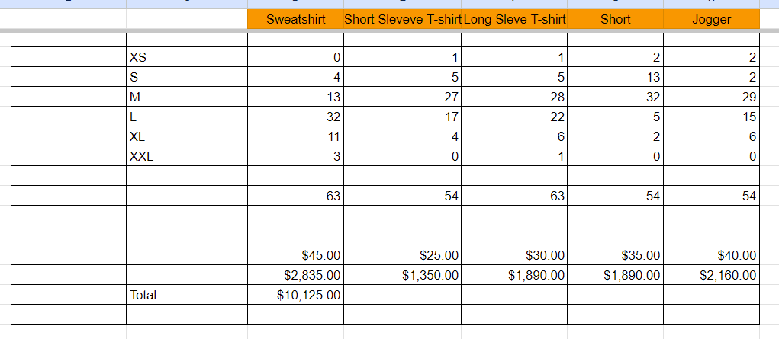

FHS Girls’ Program Liaison: (Allison Fuller) they’re wondering how they pay for the signs (SSC): Ryan will have him split the invoices between us and the girls.
- Updates

Team Building/Community Outreach Coordinator/FYHA Liaison:
(Shavon, Allison, Jen, Joleen)
- United Heros League set for 11/23 Shavon
- MN Hockey Fights Cancer Night JEN MILLER, JOLEEN B Jan 31st to Jan 11th spit costs if it comes to it – will send communication to Rosemount. Special flag bearer along with normal flag bearers.
  - Email sent to Lakeville North Booster to see if they would like to be involved. They responded and would like to be.
- Flag Bearer (Mites) Shavon
  - signup genius sent to FYHA
- MENTORSHIP (APPROX 23-26 TEAMS BOYS, 10 TEAMS GIRLS)
- Charity even on December 21st?

Fundraising Coordinators
- (David Rodgers / Mike Budde)
- Parents Night Out - Gun Raffle
  - Current Income standing, estimate $22-25k.
  - Blitz night sold 158 tickets, $3,160.
- Beer Bash ( Jen, Stacey, Mike, Jolene) “Parents’ night out” tickets available pre-sale through Mike if needed. Rambling River certificates are available. Disclaimer will be announced prior to drawing (7pm). Drawing 1-10 then drawing 2 alternates for top 2 prizes. THEN we will announce 10-1. Guest drawer: Dapper in tiger suit. Update on tickets: 30,500 collected. $10k short of our potential goal – SAT sales will assist! Board members will arrive approx. 5pm.
  - Sign-up genius has been communicated 10 spots OPEN yet – one more email push
  - $10 ticket sales at the door, cash box will be available.
  - QR code for those that want to buy Raffle tickets.
- FYHA Tryouts sign-up Sept 16-22 and Sept 23-28 STILL open slots available

Sponsorship Drive / Jersey Sponsorships
(Dave Marsh) couple more checks keep coming in $13k has come in and $19k will be what comes in.
- Sponsor drive update.
  - Look to have about $15k in sponsor dollars committed.
- Will order Sponsorship warm-up Jersey after teams are determined.
- Sponsor social media, beginning to create for returning and new sponsors.

Game Day Production / Rink
(Ryan Bjorkstrand) will investigate the spotlight (under stairs perhaps) and see if it operates.
- Rink updates - Spotlight and ability to turn off lights are possible for the season.
- SSC Signs, girl’s booster will pay half. $1,010 total cost. Farmington sign will be fixed, not sure about the other two. Ryan will manage getting them put up in the rink once ready.
Game Day Programs Coordinator
(Stacy Farrell)
- Who are we going to use next season?
  - Dave looking into printer and designer.
  - Combine with Girls
- Rachel Acari put them together for Boys/Girls ($500 split with girls)
- Jeff Lewis @ Total Source Printing printed 75 nice copies.
  - $5.45/per copy (408.00)

Photography Coordinator
(Stacy Farrell, Keith Bridgeman)
- Picture this (Terri Ann)
  - Date of pictures? Pictures will take about 30 minutes to complete.
  - Takes individual photos and merges them for team picture. Full dress with sticks
  - Vinyl 4x6’ banners are available for seniors; her most common banner size is 24x36”
  - She cannot laminate but can print pictures on more durable paper.
  - She would need to know what we want to come up with a price.
- Athletica Sports Media. Pricing is available for action shots and team shot if we want.
  - Action shots the morning of departure for Brainerd scrimmages Nov 15th

Senior Night Coordinators
Allison, Katie, Joleen
- Thursday 2/6 vs. Mankato
Social Media/Webmaster/Communications Coordinator:
(Keith Bridgeman) no updates
- 24-25 Schedule put up on all social sites.
  - When all game-times are finalized, will print posters for business and rink.
- Redirect the old site to the new one. Work with Macho to get this transferred.
Team Meal/Snack Coordinator:
(Jason / Allison) come back later to this
- Team meals at peoples’ houses
- Breakfast provided after pictures.
- Subway, Noodles, Culver’s, Chick Fil-A have been used for out-of-town games.
- Snacks and Drinks purchased at Sams for home/away games.

Alumni Liaison/Legacy Fund:
(Jen Miller) no updates
- College Photo Wall

End of Season Banquet Coordinator:
(Keith, ????)
- Contract has been signed and $100 deposit sent.

Open forum for new/existing issues/things to keep in mind:
- Managers KALLIE BRUBAKER has confirmed, WORKING ON FINDING OTHERS
  - Up to four managers (2 each JV, Varsity)
  - Up t0 $200 each for apparel voted Unanimously.
- Sparks wheels PAID
  - Coach is putting together a list of things needed.
  - Tape
- Coaching staff
  - $300 for coaching apparel spend.
- New items? New captains (C on jerseys) – Kristin P can toss them on

Approval of Minutes: not completed (Aug)
MEETING ADJOURNED: 8:22pm

Future Meetings
- Oct 23rd FHS Conf Room 1201
- Nov 20th FHS Conf Room 1201
- Dec 18th FHS Conf Room 1201

