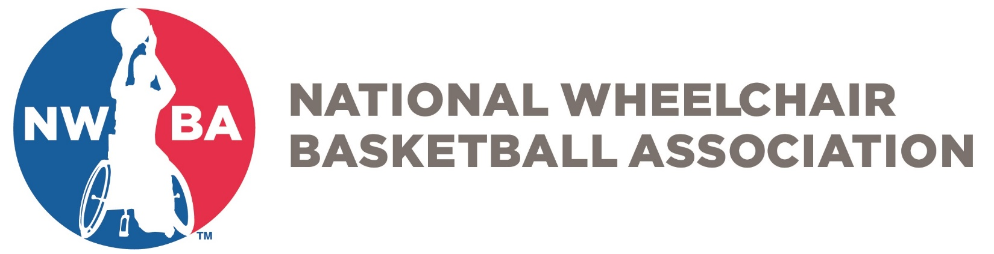

JUNIOR DIVISION
PREP EXEMPTION CONSENT FORM
Prior to completing this form please submit a Prep Exemption Form on the NWBA website. Please click on the following link to complete and submit a Prep Exemption Form:

https://nwba.sportngin.com/register/form/894761816
At the start of their first competition, the following player must be reviewed and have consent from at least two coaches of opposing teams to remain in the Prep Division. This form should be submitted to NWBA national office at brandonmcbeain@nwba.org within two days of the competition.

NAME:___________________________________________________________________________
Last First Middle Nickname

ADDRESS: _______________________________________________________________________
Street City State Zip

AGE: __________ BIRTHDATE: _______________ GENDER: _______

TEAM: __________________________________________________________________________

ALL SIGNATURES REQUIRED:

__________________________________________________ _____________________
Signature of Team Representative Date

__________________________________________________ _____________________
Signature of Head Coach Date

__________________________________________________ _____________________
Signature of Consent #1 – Coach/Team Representative Date

__________________________________________________ _____________________
Signature of Consent #2 – Coach/Team Representative Date

