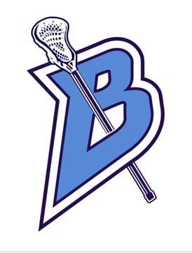
Meeting Agenda
February 6, 2024

Attendees: Amy Davidson (President), Nicole Neis (Vice-President), Amy Pierpont (Secretary), Chris Letourneau (Equipment), Others:

- CALL TO ORDER:

    - Date: February 6, 2024 Time: 6:00p.m.

- PRESIDENTS REPORT:

- SECRETARIES REPORT:
  - (Review last meetings minutes)
  - Approved Nicole, second Alex

- TREASURERS REPORT:
  - (Financials)
  - Review of financials (see attachment)

- NEW BUSINESS:

- Beer Bust (Mar 2)
  - Sell t-shirts at Beer Bust. Sell @$20 a t-shirt. Order 60
  - Volunteers needed (shifts) DIBS
    - 2 for check-in
    - 1 50/50 raffle
    - 1 silent auction-split shifts
    - 1 runner
    - 1 will call
    - 1 t-shirt seller
    - 2 clean up
- Chipotle Fundraiser (March 19 5-9)
  - Week of Adrenaline practice
- Pancake Breakfast (March 23)
- Vertical Raise March 25 start date (hold meeting)
- Player Fee - $150
- Team Bonding Event Movie Night New date- Alex to pick a date, maybe Captains practice day
- Easter egg delivery March 30, sometime during the week before, players fill the eggs
- Apparel orders- open at Parent meeting. All orders optional.
  - Public order
  - Captains/Team order
- Bags order form will go out 2/7. Optional $75/each. Order now as it takes 6 weeks.
- Reviewed Player 2024- Payment Form
- Will have Sibling Discount (2 Families). Buy one get 2nd half off.
- Youth Night- May 6, 2024 tentative until we figure out Parent night
- Parent Night- TBD would like to have this on a home game with the B squad. Alex will work to figure out a date.
- Senior Night –May 22, 2024
- Bank stuff transfer to Nicole
- Set 2024 Budget (see attachment)
- Helmets will be $400
- Parent meeting
  - Amy will use slide show from last year, update $ amounts
  - Alex will speak first
- Reserve room for equipment handout by grade, April 4th. 6p.m. starting with Seniors…..Freshman meeting for the parents 7p.m.
- Tryouts April 1-3

- OLD BUSINESS:
  - Parent meeting (Feb 26)
  - Fundraising – Vertical Raise, Texas Roadhouse, Pancake breakfast, Easter Egg Delivery, Chipotle
  - Team Bonding Event to stuff egg
  - Off Season Training (Mar. 18-23)
  - Player Fee
  - Player packs
  - New Volunteer spots (Volunteer Coordinator, Special events coordinator, Easter egg Chair)

- COACHES CORNER
  - When does registration open for the school? February 12, 2024

- ADJOURNED:

Date: February 6, 2024 Time: 8:00p.m.

