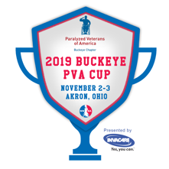
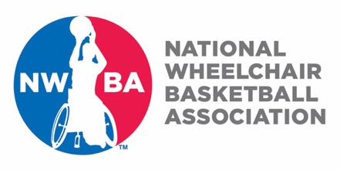
NWBA Classification Clinic
Registration Form

November 2-3, 2019 at Akron University

Participants Name: (Mr./Mrs./Ms.)

Address:

City: State: Zip Code:

Home Phone: Cell Phone:

Email Address:

Date of Birth: (Month/Day/Year)

Team Affiliation (if applicable):

NWBA Membership Number:

Registration Fee is $100.00. Cash Check Credit Card (circle one)

Registration fee covers class material/training and lunches during training.

Please fill this form out and email to Tim Fox at timfox@nwba.org. Upon receipt of this completed form, you will be contact for payment information (if Credit Card is circled; and processing fees will apply). You will be responsible for your transportation to and from the facility and your hotel accommodations during the clinic. A list of local hotels can be provided if requested. For questions contact Tim at timfox@nwba.org.

Clinic will be held at the University of Akron Recreation Center
450 Carroll Street, Akron, OH

