Fernie Alpine Ski Team 2024/25 Sponsorship Program

At FAST, our mission extends beyond the slopes. We are dedicated to fostering a love for ski racing and outdoor activities among local youth while promoting community spirit, health, and well-being. We invite you to join us, as a valued sponsor, to help us achieve our goals and bring our community closer together through the shared passion for ski racing.

Our Community Focus
- Youth Development: We work to empower young athletes through athletic training, mentorship, and education, instilling values of perseverance, teamwork, and respect.
- Community Engagement: We organize community events such as our ski swap, dryland training workshops, and fundraising events to engage families and promote the love of outdoor recreation.
- Diversity and Inclusion: We are committed to making ski racing accessible to all children in our community offering a comprehensive training program with competitive registration fees.
- Environmental Awareness: We emphasize the importance of protecting our local environment, promoting practices that reduce our ecological footprint while skiing and engaging in outdoor activities, and by providing team transportation for athletes to away races.

Benefits to Your Business
- Brand Visibility: Your company’s logo will be prominently displayed on team uniforms, team vans, sponsorship banners, online presence, and promotional materials distributed at local events and races.
- Community Connection: Show your support for local youth and community initiatives, thereby building goodwill among customers.
- Networking Opportunities: Connect with other local businesses, families, and community leaders at our events.
- Positive Brand Association: Align your business with healthy lifestyles, teamwork, love of sport, and community engagement.

By partnering with FAST, your business can benefit from increased visibility, community goodwill, and the opportunity to showcase your commitment to youth development and wellness. We deeply value the partnerships we create with our Friends of FAST Sponsors and work hard to provide opportunities to share your corporate branding and unique message.

Here are a few sponsorship levels to consider:

Level | Olympic | Downhill | Giant Slalom
Commitment | $10,000 + | $5,000 - $9,999 | $1,000 - $4,999
Naming rights / Title Sponsor for a Race
Opportunity to host a community event in collaboration with the team
First Tracks morning for 6 employees joined by two FAST athletes
Featured sponsor recognition on FAST website and social media channels
Logo placement on team uniforms and promotional materials*
Individual banner with corporate logo displayed at FAST races
Corporate logo on the FAST Sponsors banner, recognition in newsletters, website, and social media platform
*Deadline is October 20th to allow sufficient time to have corporate logos put on jackets before the start of the season.

In-Kind Sponsorship
- Provide equipment, services, or goods valued at $1,000 or more
- Recognition based on the equivalent value tier (Olympic, Downhill, GS)
The Fernie Alpine Ski Team (FAST) is a dedicated team of young athletes ranging from beginners to advanced ski racers, participating in various competitions throughout the season and year-round training opportunities locally and abroad. Our team emphasizes skill development, teamwork, and sportsmanship, while also encouraging community involvement and environmental stewardship. Our young athletes gain purpose by developing their talents through athleticism and leadership opportunities.

FAST is one of Western Canada’s most accomplished and comprehensive Alpine Ski Racing Clubs. Based out of Fernie Alpine Resort in British Columbia’s Kootenay Zone, we offer a variety of ski programs for children and youth aged 4-19 from across southeastern B.C. and Alberta. FAST is a registered non-profit alpine downhill ski club and boasts a roster of over 220 athletes competing at the local, provincial, and national level.

Our coaches have instructed for the Canadian National Team, Canada Ski Cross Team, are former Olympians, and all are focused on helping individual athletes reach their full potential on and off the slopes. The FAST community has served generations of athletes as many of our former racers continue to be involved in the program as coaches, volunteers, and parents. FAST provides our athletes with year-round training opportunities, summer camps, dryland training, and pre-season training camps abroad. Our community thrives because of our coaches, athletes, volunteers, and sponsors.

Your sponsorship will help ensure FAST remains one of the best ski clubs in Western Canada. Sponsorship dollars help us to create a positive change to the on-hill infrastructure that transforms the level of learning we can provide for our athletes.

Capital expenditures for FAST are aimed at improving the team's performance and overall experience.
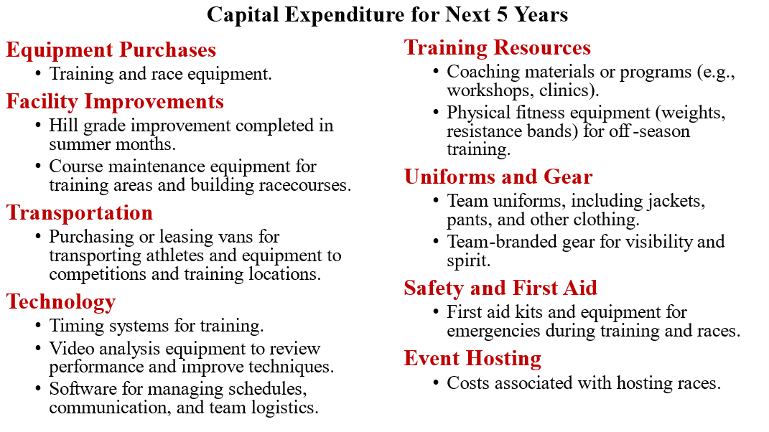

We invite you to partner with FAST as we foster a love for ski racing among the youth in our community. Your support will not only enhance our athletes' experience but also promote a positive and active lifestyle for all. Together, we can make a lasting impact on our community.

For more information on sponsorship opportunities please contact:

Claire O’Connor
Sponsorship Coordinator
Fernie Alpine Ski Team
403-607-0809
claire@aeonian.com

Thank you for considering this opportunity to support local youth and the sport of ski racing! We look forward to the possibility of partnering with you.

