Step one log into your Gotsport account:
Click on Team Management:
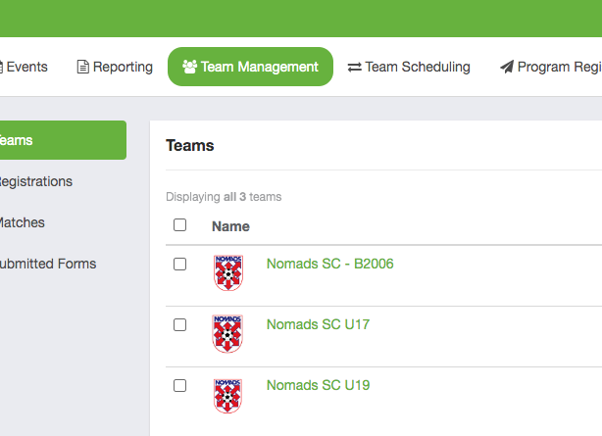

Step two: click on Registrations:
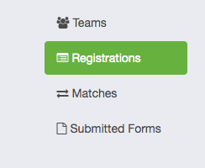

Step three: find your team and the event Nomads Thanksgiving Tournament
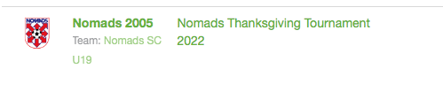

Step Four: you are now in your team app for the tournament
Click on “schedule” tab – you will see your games listed

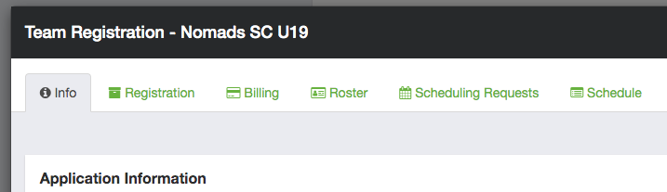

Step five: to the right of each game you will see “rosters” button click on that
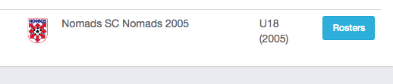

Step six: Print Match cards for each game
You will see these options (top right of your roster).
MATCH CARD – this will create match card with both teams listed for the game along with rosters

** NOTE** IF YOU DO NOT HAVE PLAYER CARDS PLEASE PRINT “PHOTO MATCH CARD” this will be your roster with pictures and does not include the other team
roster – you will need to print MATCH CARD AND PHOTO MATCH CARD.
PHOTO MATCH CARD will be used as your player cards for the ref to check in the players etc.

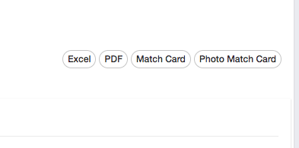

EXAMPLE:
MATCH CARD

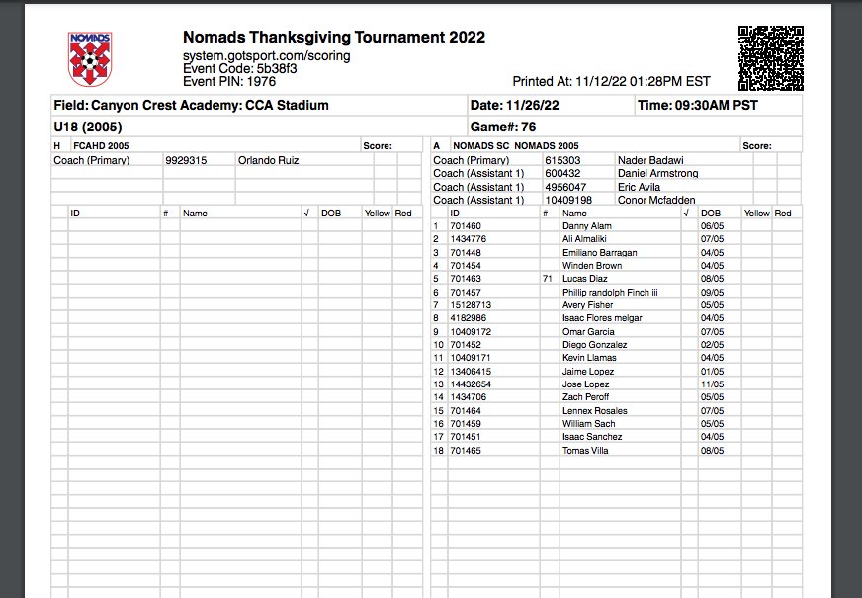

PHOTO MATCH CARD:
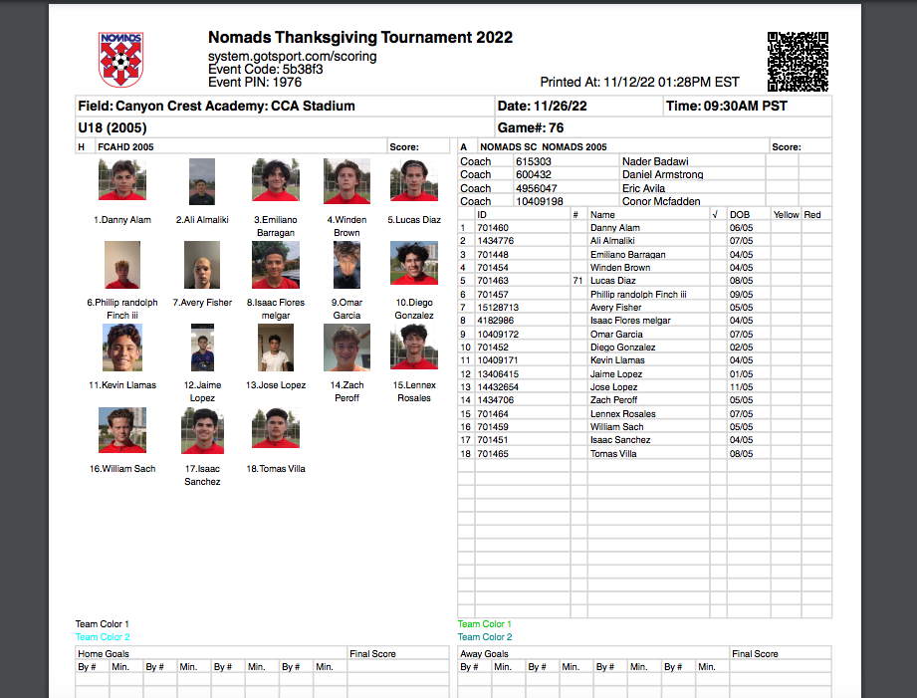

REPORTING SCORES:

The score reporting information is listed at the top you’re your Match Cards
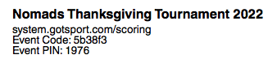

HOME TEAM REPORTS THE SCORES PLEASE AS SOON AS POSSIBLE WITHIN 15 MINUTES OF MATCH ENDING.

GO TO: SYSTEM.GOTSPORT.COM/SCORING AND ENTER EVENT CODE

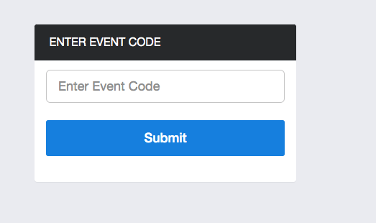

ENTER EVENT PIN #:

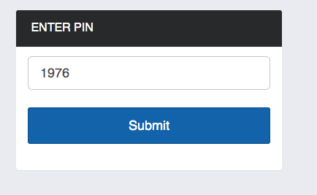

ENTER MATCH NUMBER AND AGE GROUP TO FIND THE GAME

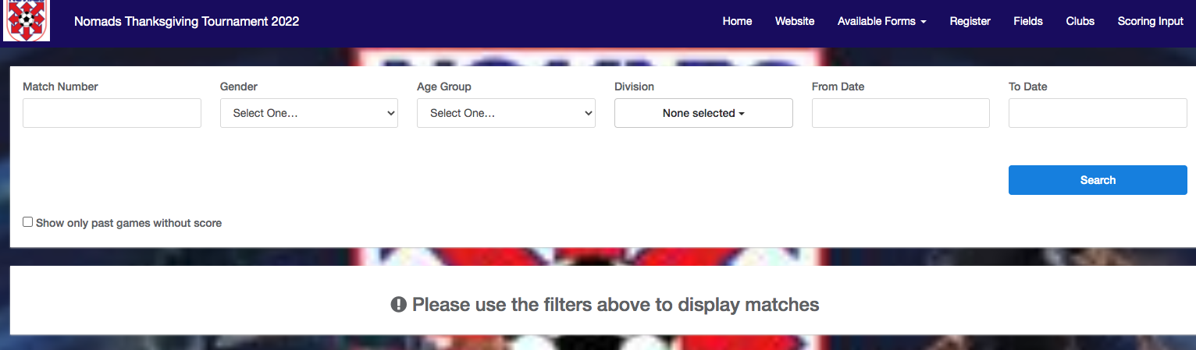

ENTER THE SCORE INFORMATION AND SAVE
YOU CAN ALSO ADD YELLOW CARDS, RED CARDS AND ANY OTHER INFO ABOUT THE GAME HERE

