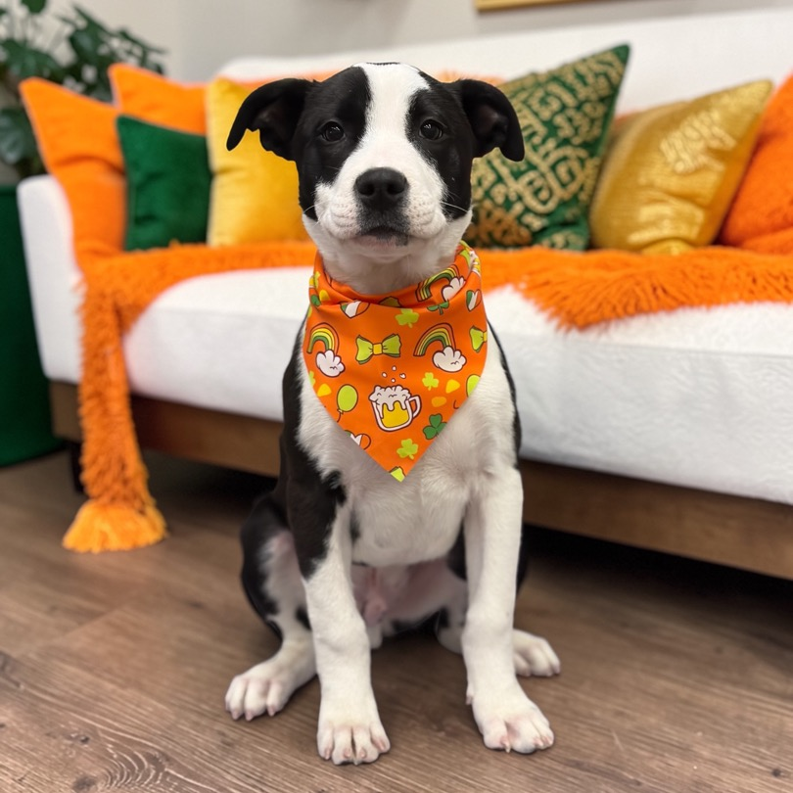 Halpert
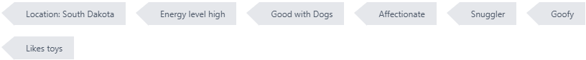

Breed – Mixed Breed (Medium)
Sex - Male
Weight - 20 lbs
Age as of April 2026 – 3 Months
Adoption Fee - $450.00

Halpert (aka Spot) is a big, lovable goofball with a heart just as large as he is! This affectionate boy has a high-energy level and loves to jump into life—literally—so he’s always ready for fun, playtime, and adventure.
He’s great with other dogs and enjoys having canine companions around. His experience with cats and younger children is still unknown, but due to his size and bouncy personality, he may do best in a home with older kids who can keep up with his enthusiasm.
Spot is about 90% housetrained and continues to improve every day. He’s a total snuggler at heart and loves his toys, but more than anything, he loves being close to his people—he’ll happily follow you around just to be near you.
This sweet boy would thrive in a home where someone is around often and where he has access to a big, fenced yard to burn off his energy and explore safely.
If you’re looking for a loyal, playful companion who will keep you laughing and shower you with love, Spot is your guy!

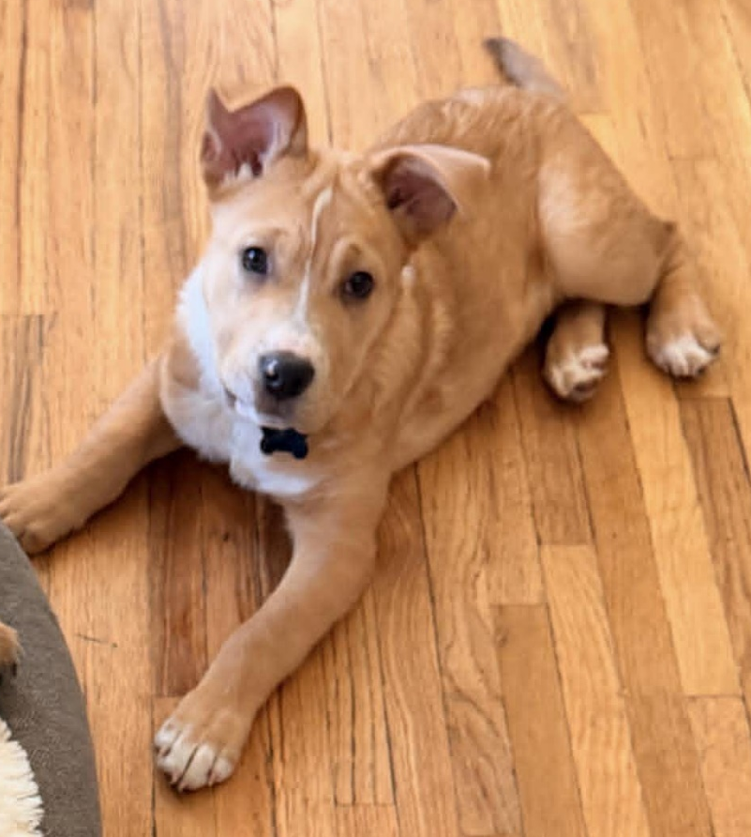 Corrine
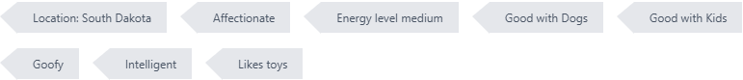

Breed – Mixed Breed (Medium)
Sex - Female
Weight - 15 lbs
Age as of April 2026 – 3 Months
Adoption Fee - $450.00
Corinne is a mixed-breed pup with a big personality packed into a small body. This sassy little girl isn’t afraid to let you know how she feels—especially if you tell her “no.” She may talk back a bit, but it just adds to her charm and makes everyone around her smile.
Corinne is doing wonderfully in her kennel and sleeps through the night like a champ. She’s friendly with every dog she meets, even though she’s usually the short stack of the group. She loves running with the big dogs to prove she can keep up—until she realizes she might be in a little over her head and makes a quick U-turn straight back to her person.
She’s still learning how to “dog,” but she’s already discovering the joy of toys, cuddles, and being held. Corinne is very food motivated and incredibly smart, which means she’s going to shine with continued training. She’s currently working on potty training and doing well, and with a consistent routine she’s sure to succeed.

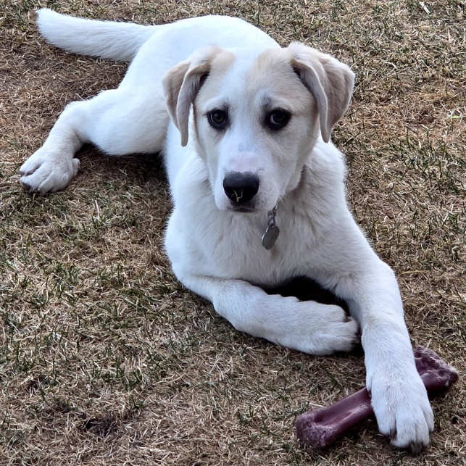 Ensley
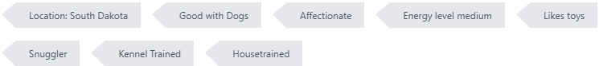

Breed – Great Pyrenees / Labrador Retriever
Sex - Female
Weight - 25 lbs
Age as of April 2026 – 5 Months
Adoption Fee - $450.00

Ensley is a Great Pyrenees/Lab mix with a gentle heart and the sweetest soulful eyes. She may be a little timid when you first meet her, but give her a little patience and kindness and you’ll see her true personality shine. Once she feels safe, Ensley absolutely loves her people and wants to be right by your side.
She enjoys playing with other dogs once she’s had a proper introduction and time to get comfortable. She hasn’t been tested with cats yet.
Ensley is potty-trained and kennel-trained. She sleeps quietly in her kennel overnight and while we are away for work. She does not whine or bark in the kennel. She is learning basic manners and how to walk nice on a leash.
Because of her Great Pyrenees and Lab mix, Ensley will grow into a big, beautiful girl who will likely be both loyal and affectionate. She’ll do best with a family who understands that shy puppies blossom into incredibly devoted companions when given love and confidence-building experiences.
If you’re looking for a gentle soul who will grow into your loyal best friend, Ensley just might be your perfect match. 💛

Siblings – Eisley

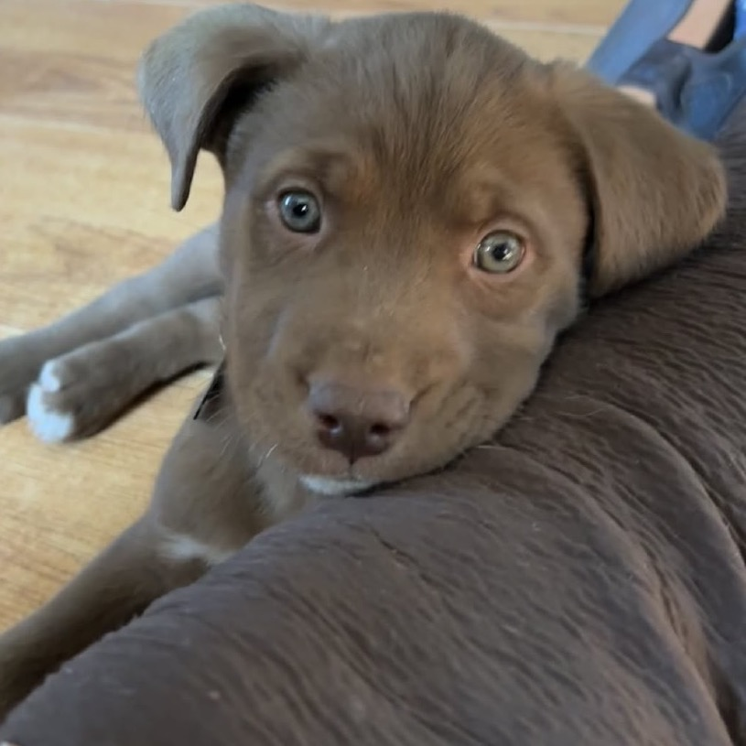 SOL

Breed – Mixed Breed (Medium)
Sex - Male
Weight - 10 lbs
Age as of April 2026 – 3 Months
Adoption Fee - $450.00

Hi, my name is Sol and I am a gorgeous chocolate pup, I love playing as much as I love to be in your arms for a nap. I am a leader by nature so I am not shy when it comes to using my voice! My foster mom says I’m “kennel trained” because I eat my meals in the kennel and sleep in it too. I do not poop inside as long as I am let out after every meal but I am too little to hold anything so I will have pee accidents here and there, I know that if you give me the chance and keep up a good routine I will be potty trained in no time! I am really cool so I get along with everyone!

