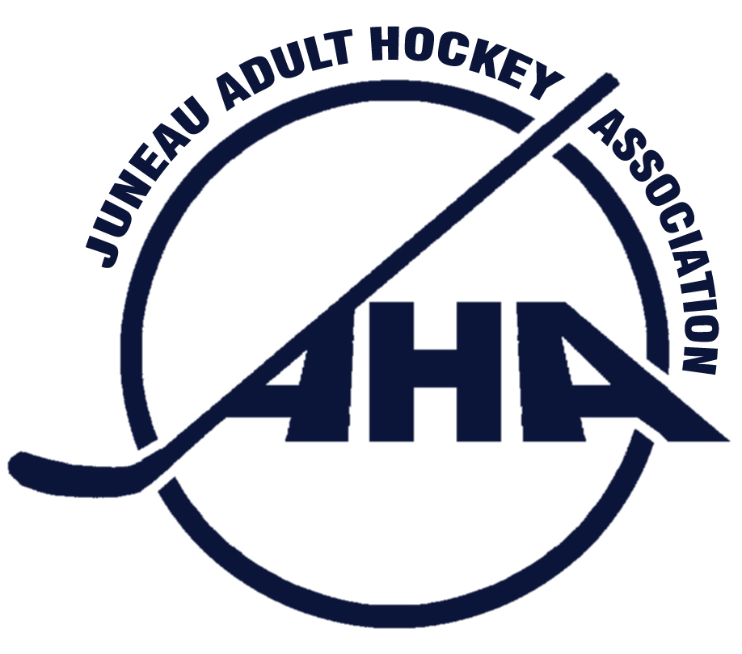

Juneau Adult Hockey Association
PO Box 21046 Juneau, Alaska 99802 * City & Borough of Juneau Tax Exempt # 582

To: Juneau State Delegation

From: Laine Durgin, JAHA President
Date: October 17, 2012
Re: Additional Sheets of Ice Study
On behalf of the 245 current women and men who participate in the Juneau Adult Hockey Association, our board of directors supports construction of additional sheets of ice in the City and Borough of Juneau.

Additional ice availability in Juneau supports JAHA’s mission to promote the growth of adult competitive and recreational hockey and to provide the best possible experience for all participants by encouraging, developing, and advancing the sport.

Additional sheets of ice will develop skating ability, not only for adult hockey players, but also for youth hockey players, figure skaters, and recreational skaters through increased ice availability. It will also increase participation in existing hockey tournaments such as the Juneau Jamboree, the King Salmon classic, and the Rainforest Classic. It may also advance Juneau’s potential for hosting high-profile tournaments such as the Arctic Winter Games.

Furthermore, the JAHA board of directors believes there is sufficient demand and support in Juneau’s community to support construction of additional sheets of ice in Juneau.

JAHA Board believes the City and Borough of Juneau should work in a cooperative manner with the Juneau Community Foundation and all the skating user groups in order to design additional sheets of ice in a cost effective manner. We encourage the Assembly to go forward with the planning of a second sheet of ice in an expeditious manner that looks at not only the facility itself, but also how it will be operated, staffed, and scheduled.

With a bit of creativity, additional sheets of ice in the City and Borough of Juneau will be a splendid addition to our community.

CC: Senator Dennis Egan
Representative Cathy Munoz
Representative Beth Kerttula
Arnold Liebelt, JDIA President
Sigrid Dahlberg, JSC President
Parks & Recreation Advisory Committee
Juneau Assembly

