SLPYHA Board Meeting Agenda
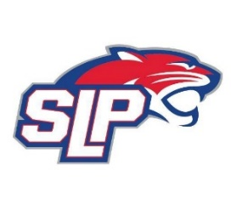
Date: 1/31/22
Roadside
7:00pm

Attendees: Scott Lichter, Mike Mliner, Corey Piekarski, Jason Shipman, Adam Kiedrowski, John Pitzl, Mike Fitzpatrick, Kevin Mitties
Guests:

- President Report: Scott Lichter
- Call to order: 7:00pm
- Approve agenda
- Approve minutes from 1/11/2022 meeting, motion: Lichter move: Mliner
- Latest D10 updates
- Fogerty South Rink
- Vice President Report: Michelle Rice/John Pitzl
  - Jerseys
  - Golf tournament
- Treasurer Report/Gambling Report: Mike Mliner
- Secretary Report: Corey Piekarski
- Traveling Director Report: Jason Shipman/Adam Kiedrowski
  - Hockey Lab
- Girls Traveling Director Report: Kevin Mitties
  - Update on girl’s co-op with Centennial
- Mite Director Report: Mike Fitzpatrick
  - Mite Jamboree
- Coaching Director Report: Jeremy Flaten/Bob Roloff
- New/ongoing Business:
  - S.K.A.T.E.
- Motion to dismiss: 9:35 pm, motion: Kiedrowski, move: Mitties

