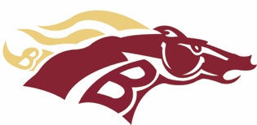

To Whom it May Concern,
The Brookwood High School Lady Broncos softball program is offering a sponsorship opportunity to your company. We are selling 2’ x 3’ and 4’ x 6’ banners to prominently advertise your company. Your company information will be proudly displayed on our sponsor wall/fence outside our beautiful softball complex at Brookwood High School for a full year.
We realize your company has set a mission to give back to the community. Your support of our softball program will help us continue to work hard to build a team of strong, young female leaders.
Please consider a sponsorship by purchasing a banner of 2’ x 3’ for $250 or a 4’ x 6’ for $750. Attached is a simple form to fill out with your company information and artwork. Thank you for your donation!

Sincerely,
Lady Broncos

LADY BRONCOS SOFTBALL SPONSOR SIGNS
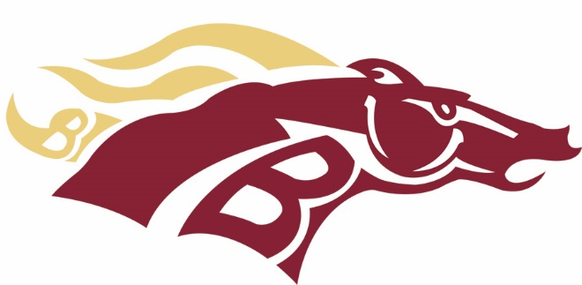
SHOWCASE YOUR BUSINESS AT
BROOKWOOD HIGH SCHOOL

PURCHASE A SPONSOR SIGN TO BE DISPLAYED AT THE BROOKWOOD HIGH SCHOOL SOFTBALL FIELD. THE DONATION FOR THE 2X3 SIGN IS $250.00 or you can purchase a 4X6 sign for $750.00. Signs will remain up for 1 school year. (August to July)
PLAYER NAME:
COMPANY:
ADDRESS:
PHONE #:
CONTACT PERSON:
EMAIL ADDRESS:

Please include a business card or camera ready art of the design you wish to have displayed and email to Cory.L.Bahr@efleets.com and Casey.Parham@gcpsk12.org Please make checks payable to Brookwood Softball Club. Thank you for your support!

