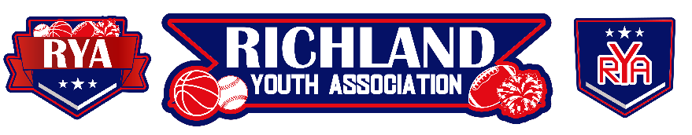
RYA October 2023 BOARD MEETING
Meeting Date: October 4, 2023 – 6:45pm
Board Member Attendees: Mike Cowan, Richard Stutheit, Eric Gomez, Lisa Willis
Absent: Kevin Vorpahl, Erica Stutheit, Tammy Treadwell, Emily Standifer
Non-Board Member Attendees: CJ Bussey

General Board Items / Old News
- Additional bank accounts were requested but was declined by Wells Fargo when applied online.

Basketball: Vacant
- $67 uniform pricing from Zexez
  - Includes reversible jersey, reversible shorts, shooter shirt
- Practices will be at The Link and Games at The Link, North Richland MS (BISD), and Hillwood MS (KISD)
- New basketball director volunteer present at meeting – CJ Bussey
  - Confirmed by a board vote of 5 votes for appointment and 3 abstained.

Rec Baseball: Richard Stutheit
- Rec Baseball received the first half of a $1,400 sponsorship check from Athletico. The second half of the sponsorship will be received at the end of the season.
  - Sponsorship included two social media posts, surveys sent out, and hanging a banner on Saturday game days during the Rec Baseball season.
- There are a handful of uniform items that are still outstanding from Zexez. Richard has been in contact with them to try getting items expedited.

Premier/Tournament Baseball: Kevin Vorpahl (absent)
- 12u/14u Tournaments this weekend, Sat-Sun.
  - 12 total teams signed up for this weekend (7 in 12u and 5 in 14u)

Football: Eric Gomez
- Home games the next two weekends.

Cheer: Lisa Willis
- Cheer Basketball – est. $120 registration
  - Waiting to hear on uniform pricing, keeping it simple.
- Homecoming on October 14th – all football teams at home.
  - Walk-ons before each game, kids getting mums.

Communications: Erica Stutheit
- Basketball registrations opened up - $200 per registration

Special Events: Emily Standifer (absent)
- n/a

RYA Bank Accounts total of $40,795.20 and $3,401.66

Meeting adjourned at 8:02 pm

