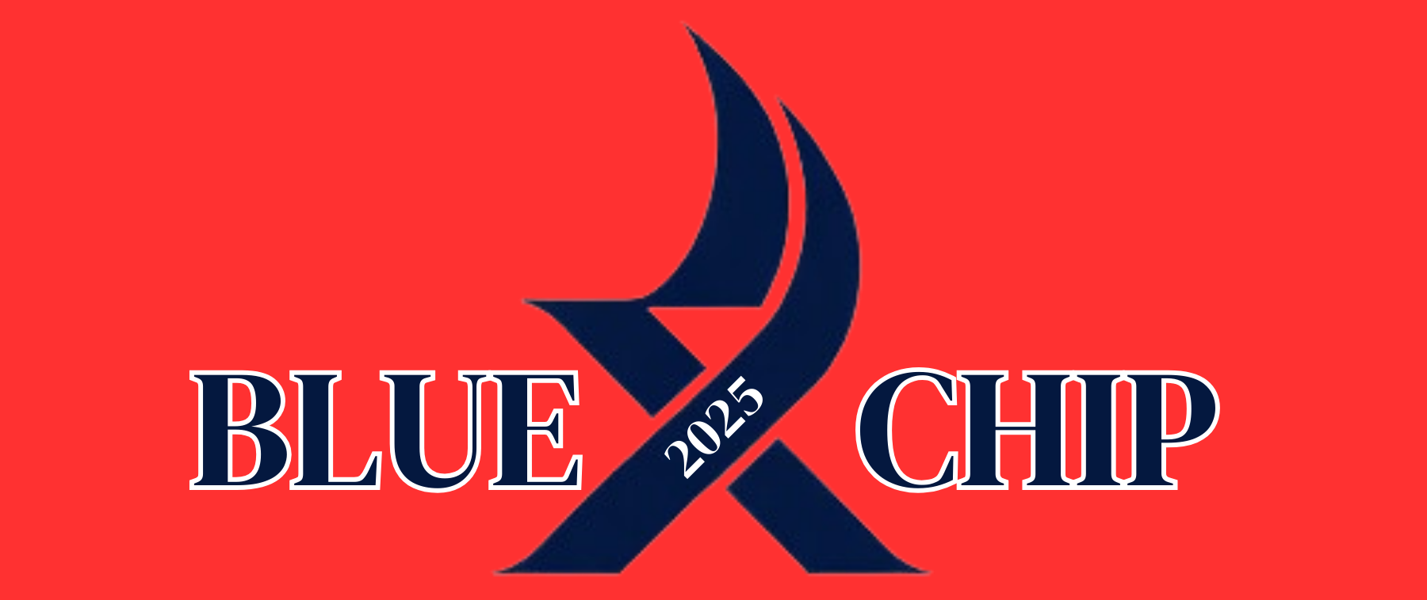

The X Blue Chip Championship is an invitation only regatta with the intent to represent competition among the top ILYA X boat sailors from the sailing season of each year. A competitor will be deemed eligible and receive an invitation to compete in the 2025 X Class Blue Chip Regatta if the sailor meets the following criteria:
- Winner for previous year’s X Blue Chip Regatta if still otherwise eligible to compete in ILYA X events
- Top 10% (rounded down) Junior or Senior at any ILYA X boat sanctioned regatta with at least 20 registered boats, except training/coaching regattas. For example, the following regattas are currently considered to be qualifying events:
  - LaBelle Tune Up Regatta
  - Quad Lakes Regatta
  - Quint Regatta
  - GLSS Dinghyfest
  - X-Treme
  - WYA
  - X ILYA Junior Championship
- Top 15 sailors of the Senior fleet at the X Inland regatta.
- In the event there are less that 50 registered X boats for the X ILYA Junior Championship, the regatta chair (s) may elect to extend invitations to the top 5 sailors at the X Junior Inland regatta.

If a sailor qualifies more than once, regatta chair(s) may extend additional invitations from the Junior or Senior Championship regatta dependent on the fleet classification of such sailor.

In the event no races are completed in the ILYA X Championship regatta, the qualifiers will be chosen based on the results from prior qualifying events as listed above. The qualifying percentage may be extended based on the number of qualifiers already invited with the goal of approximately 30 competitors. In the event a sailor qualifies more than once, regatta chair(s) may extend offers from the qualifying events listed above, at the discretion of the regatta chair(s). In making such determinations, regatta chair(s) may prioritize regattas based on the number of registered sailors.

In the event there are not sufficient races completed in the ILYA X Championship regatta to constitute a series, invitations may be extended based on the total scores of races completed. If only one fleet (Junior vs Senior) completes races, invitations to the fleet that completed races may be extended based on the total scores of races completed. For the fleet that does not complete any races, invitations may be extended based on prior qualifying events as listed above.

**Please Note: Additional invitations may be extended by the regatta chair(s) as necessary or appropriate. A maximum of approximately 30 qualified competitors will be eligible to compete, or otherwise at the discretion of the regatta chair(s).

The regatta chair(s) shall have full and sole discretion regarding decisions of eligibility and all such determinations shall be final and binding on all parties.

Cedar Lake Yacht Club reserves the right to change these eligibility criteria at any time and from time to time in its sole discretion.

